CMPE 100 Lab Report 5

Leonid Shuster

Lab Section 1C

5/17/19

**Description:**

In this lab we were tasked with creating a game called Quick Add in which a randomly generated number is displayed on the leftmost 7-segment display, while two numbers keep repeatedly being randomly generated and displayed on the two rightmost 7-segment display until the user presses a button. The sum of the two numbers on the right would then be compared to the left number, and either flash both numbers or alternate them accordingly. In this lab, we learned how to implement state machines into our sequential circuits. The lab consisted of the following parts:

**Part One: Random Number Generator**

In the first part of the lab, we had to create a random number generator that made use of a Linear Feedback Shift Register (LFSR) to generate a random 8-bit number. To make the random number generator, I used 8 flip-flops that each took in some amount of bits from the bit vector. The first flip-flop was the XOR of four bits from the bit vector, while every subsequent flip-flip took in the result from the previous flip-flop. To ensure that the LFSR output would not always be 0, one of the flip-flops had to be initialized with a bit value of 1. The schematic and code for the LFSR are shown below.

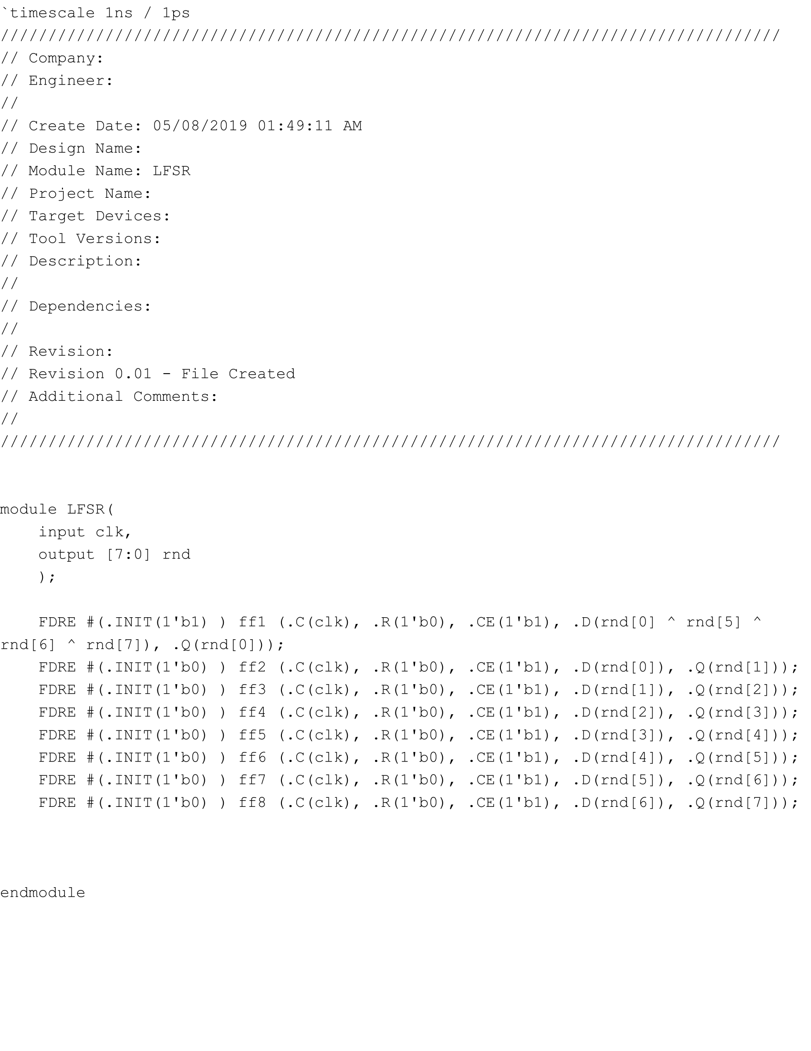

LFSR.v

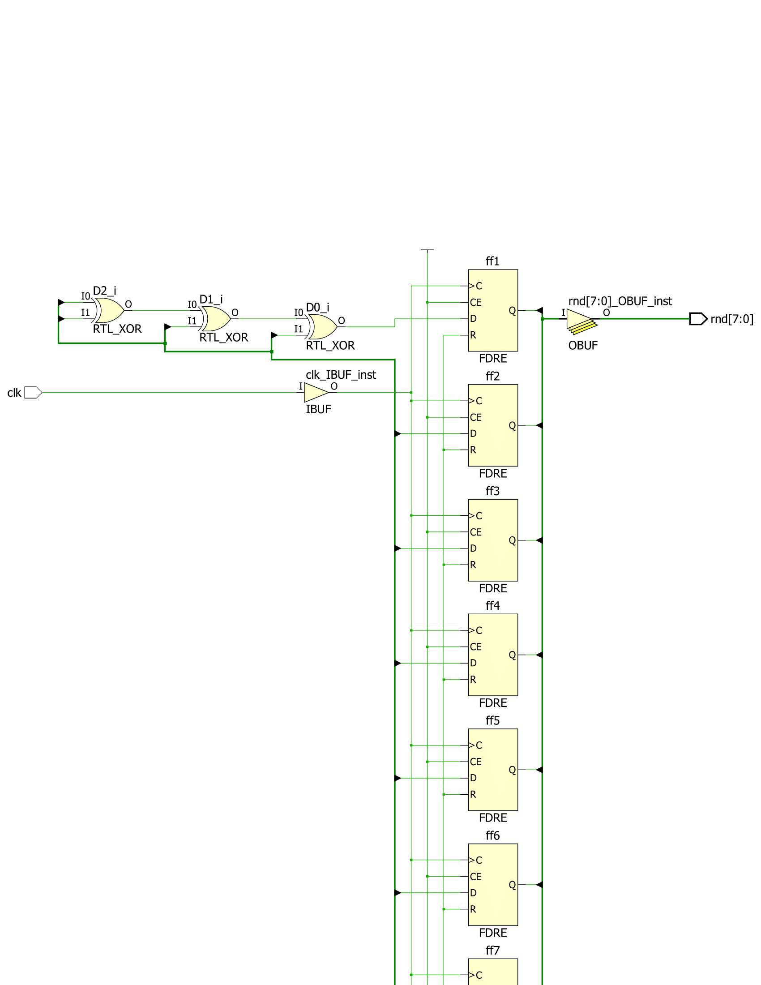

LFSR.v Schematic Part 1

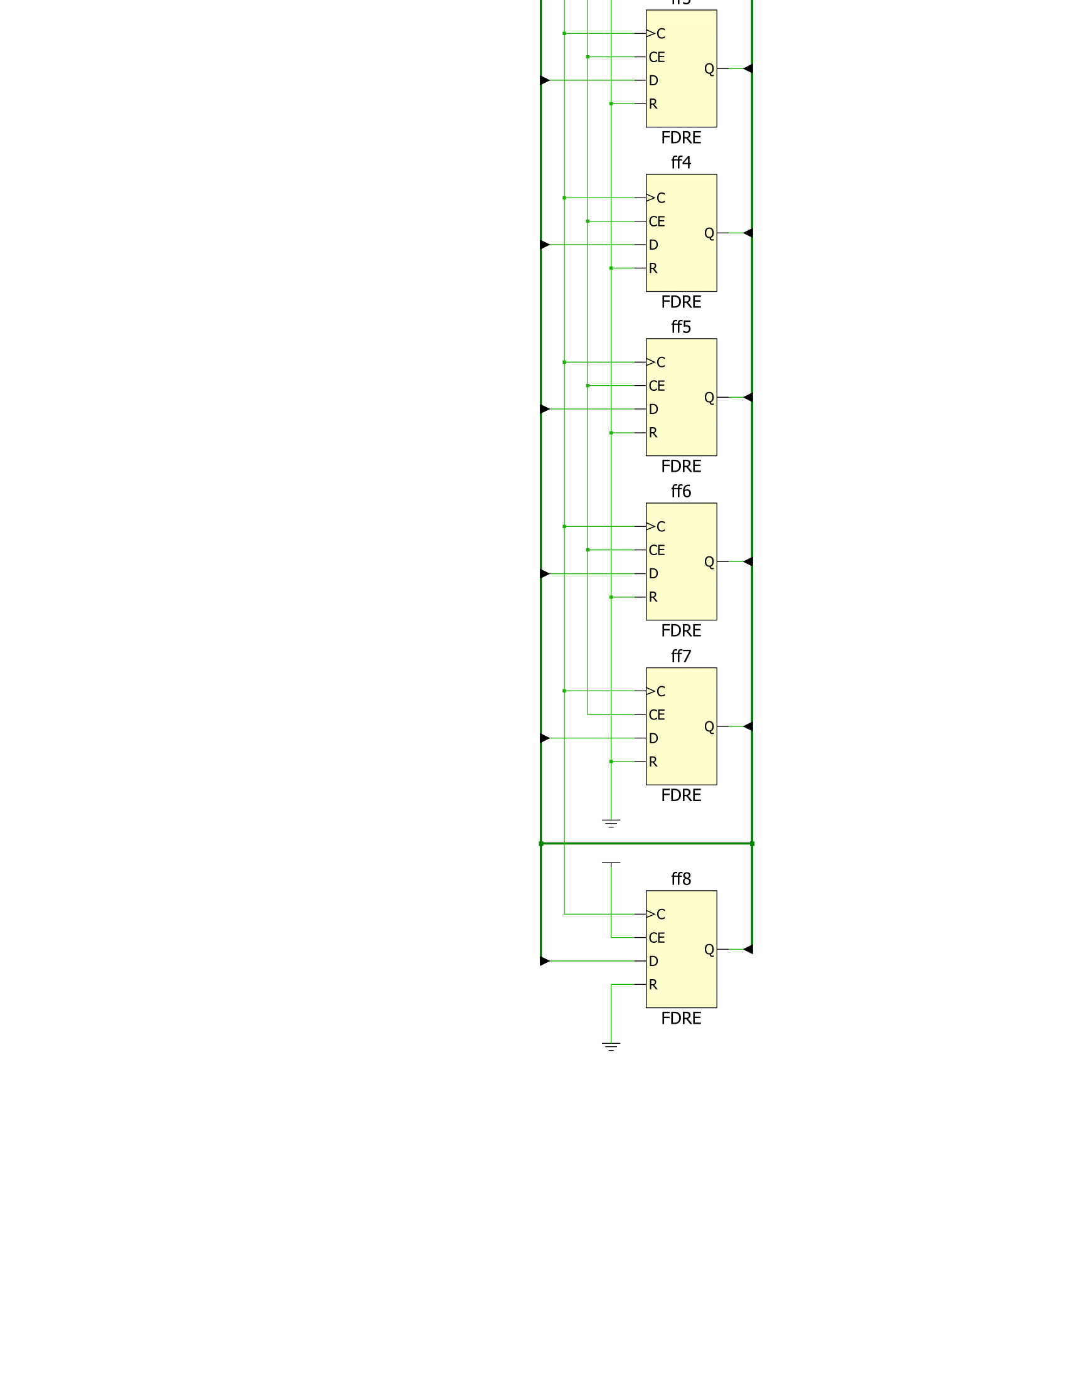

LFSR.v Schematic Part 2

The LFSR 8-bit output was then used for the single number on the left side of the 7-segment displays (Target) and the two numbers on the right side (Numbers). I chose Target to be the four bits that were XOR’d from the LFSR, while Numbers were the LFSR output itself. The code and schematics for both are the following:

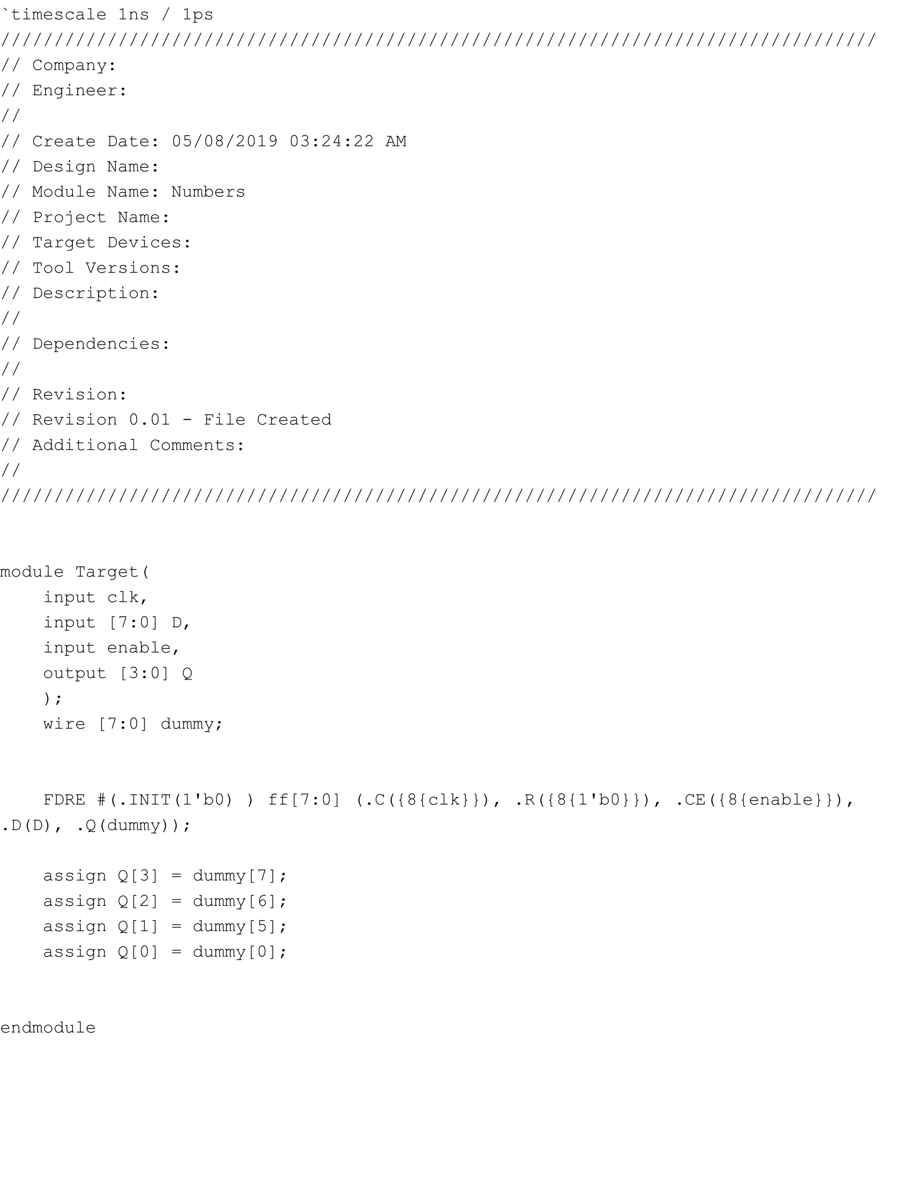

Target.v

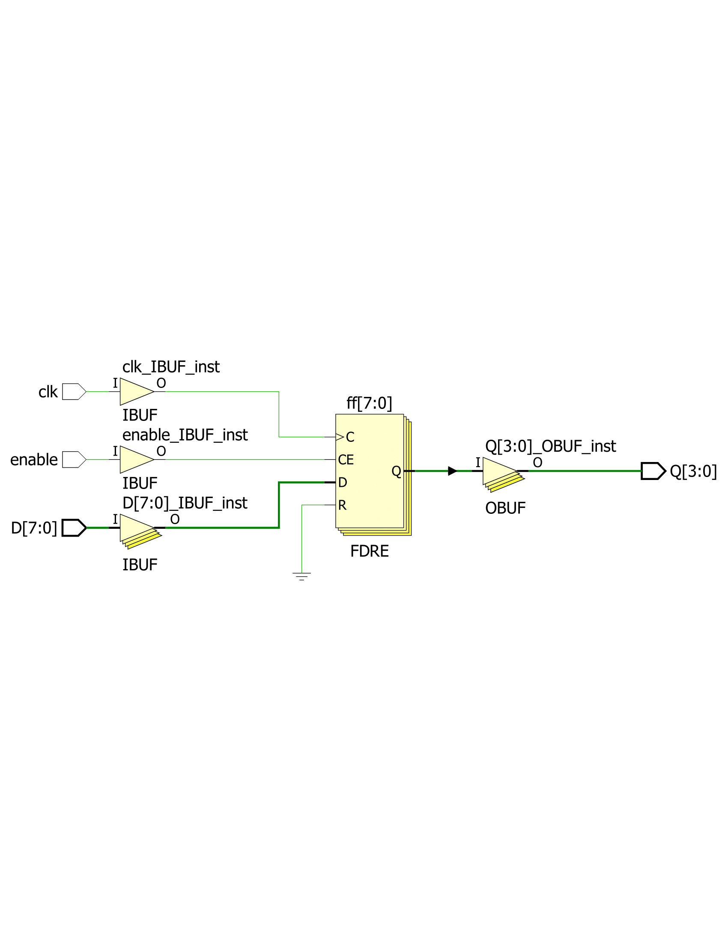

Target.v Schematic

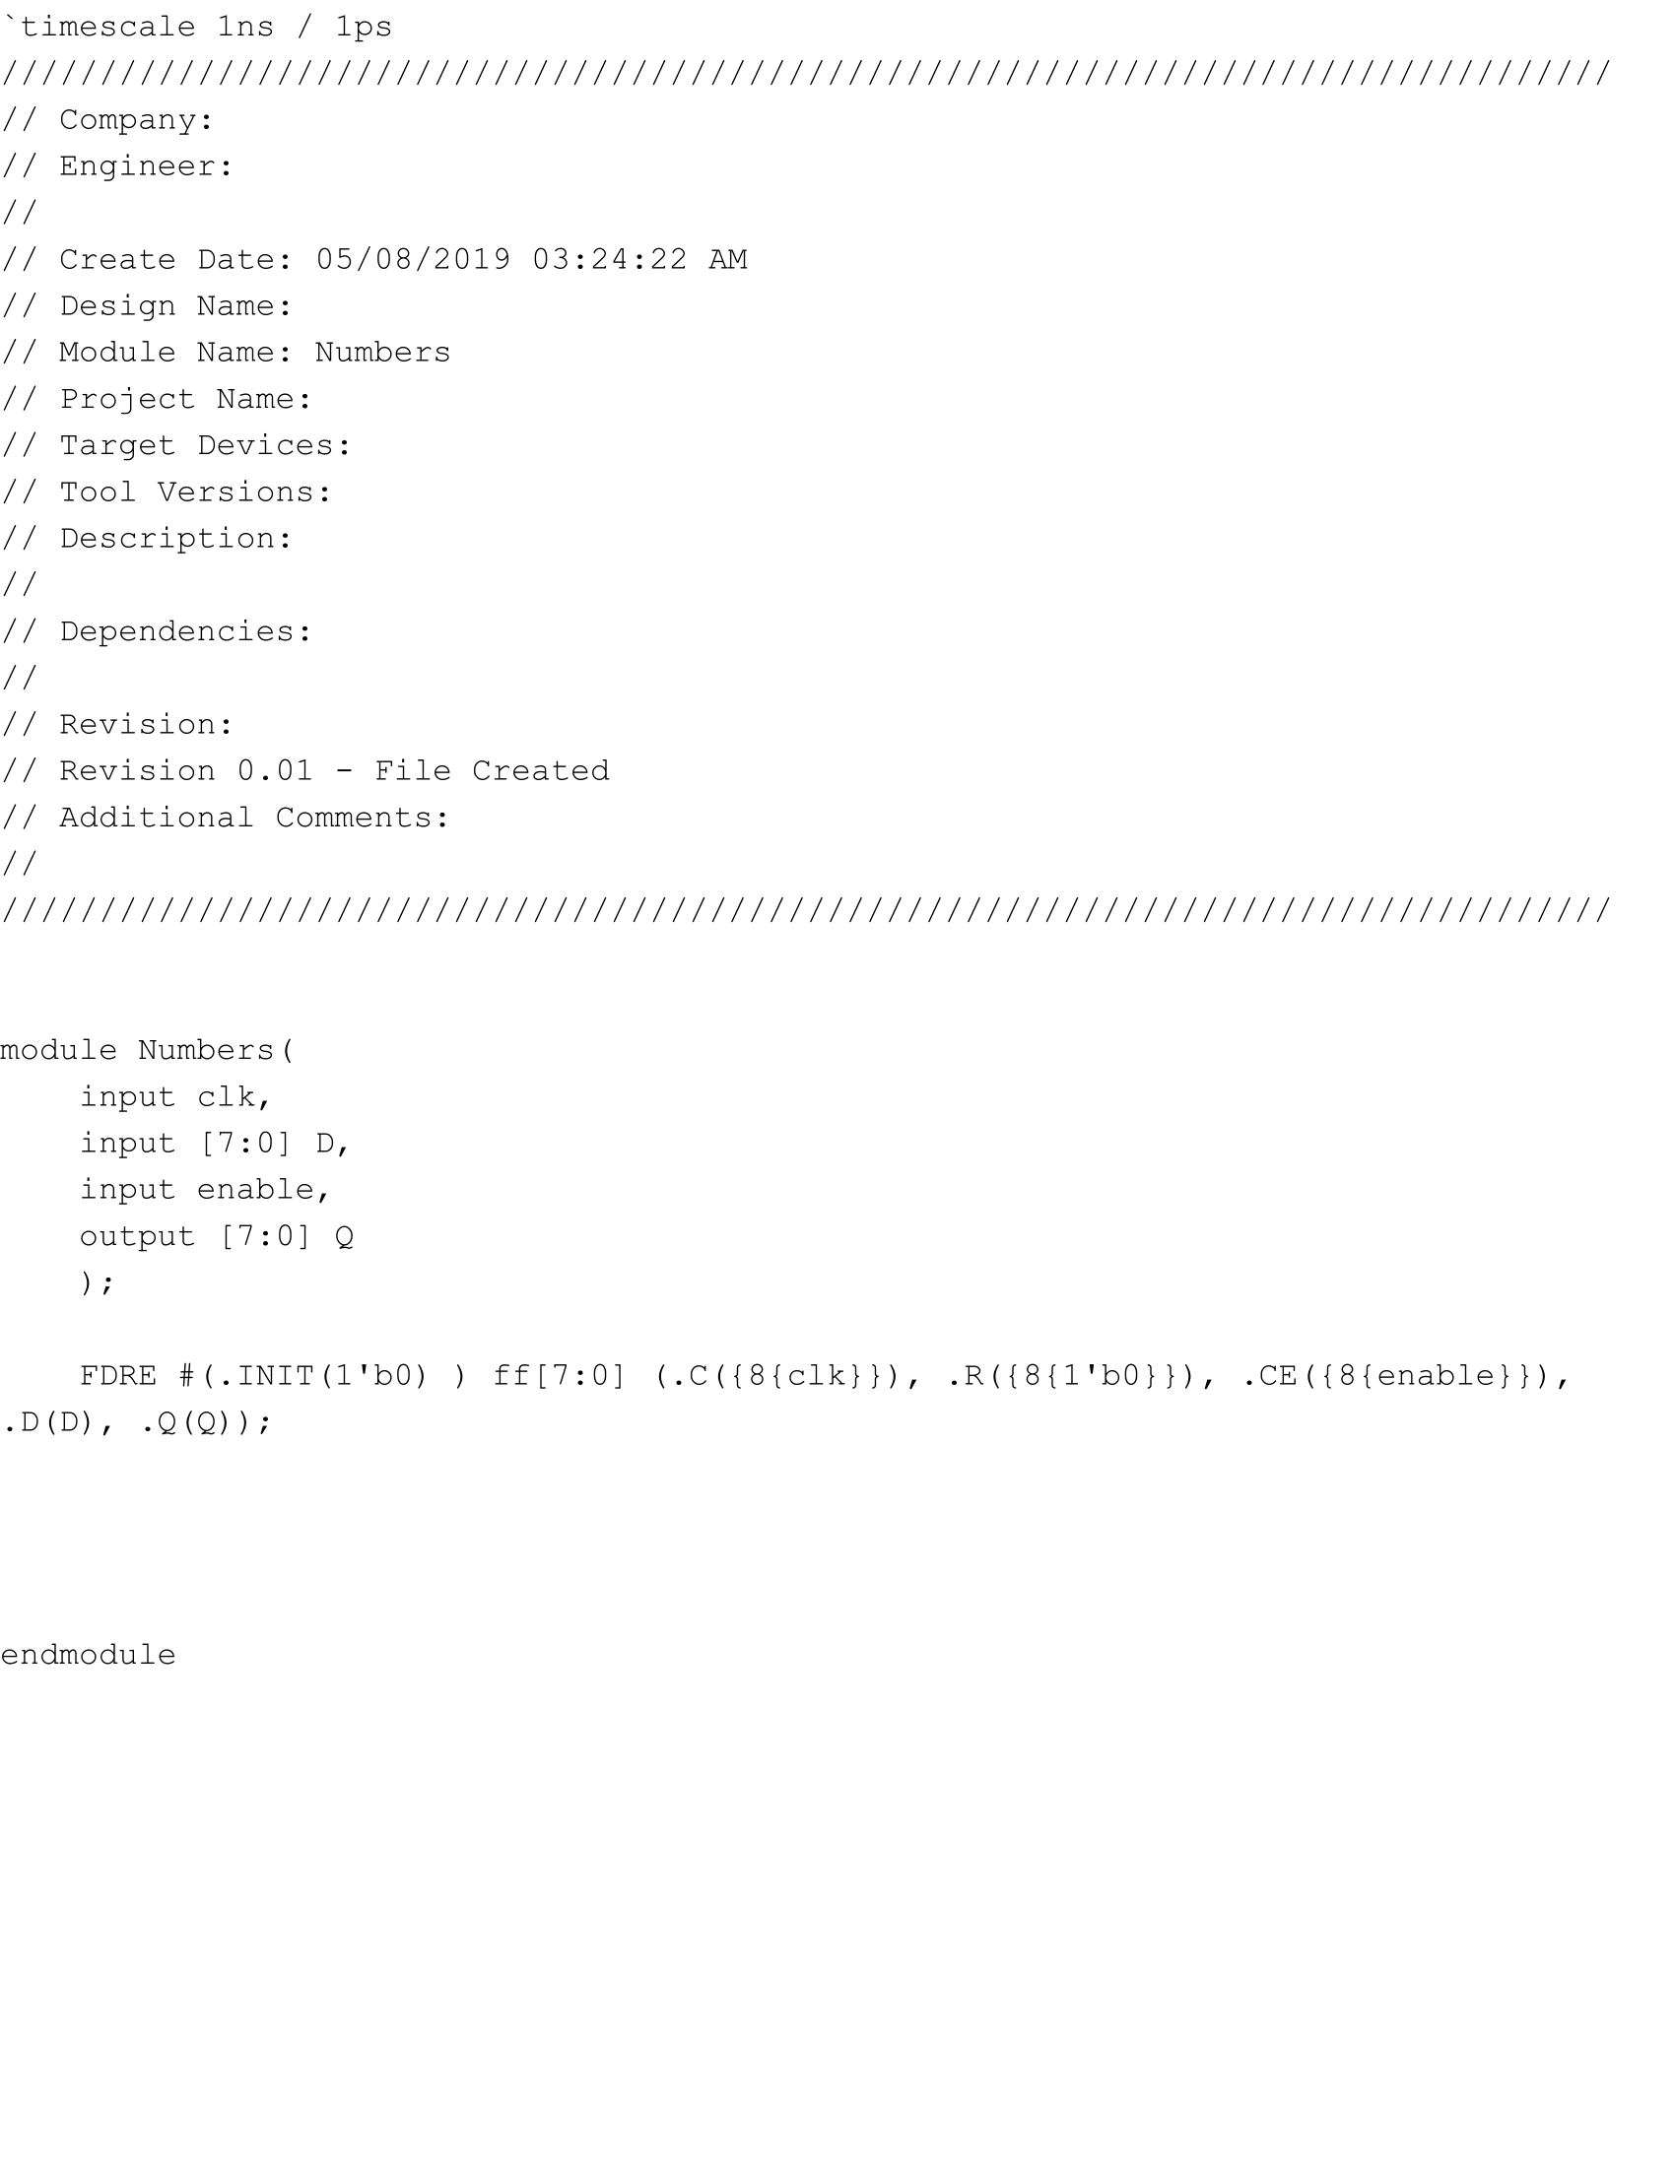

Numbers.v

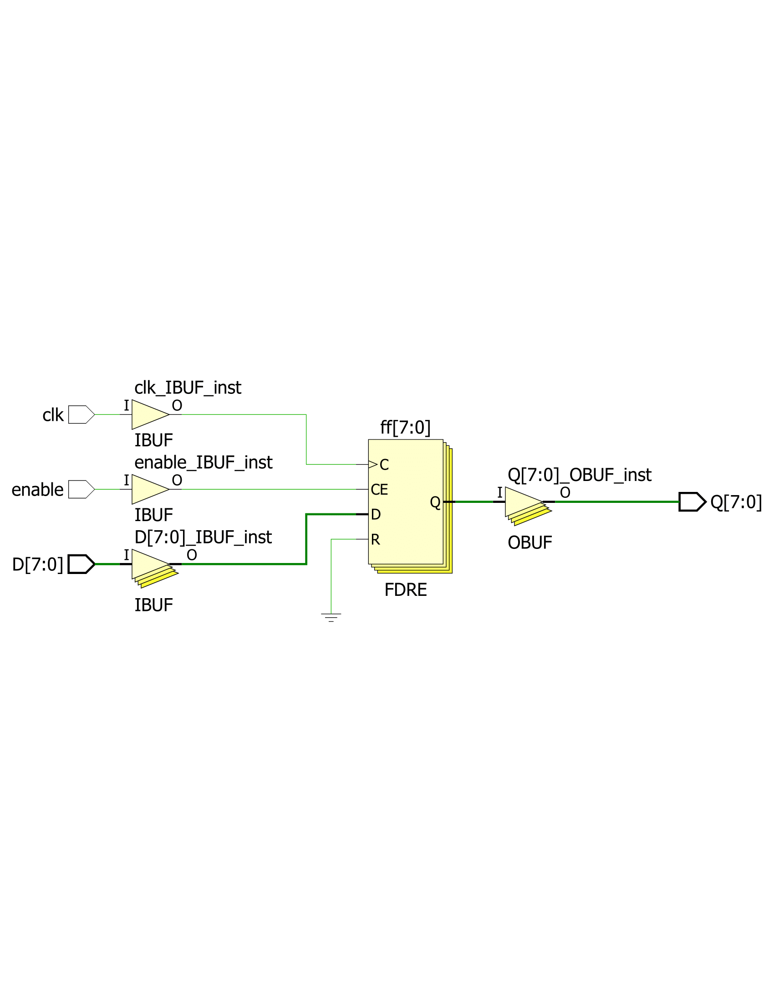

Numbers.v Schematic

**Part Two: Time Counter**

The next step in the lab was to create a time counter that could count how much time has gone by in order to facilitate the length of time between the numbers being generated and how long to flash the numbers. In order to do so, I used the same counter from a previous lab that counted up every quarter second and kept track of when half a second, two seconds, or four seconds passed. This meant that when half a second passed, the counter would be at a value of any multiple of 2, while for two seconds it would be at any multiple of 8, and for four seconds it would be at any multiple of sixteen seconds. The code and schematic for the time counter are shown below.

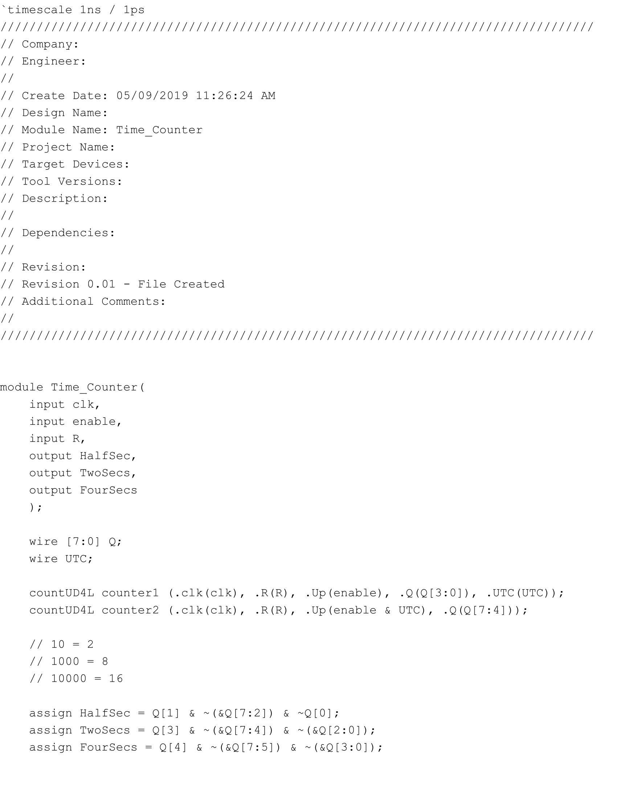

Time_Counter.v

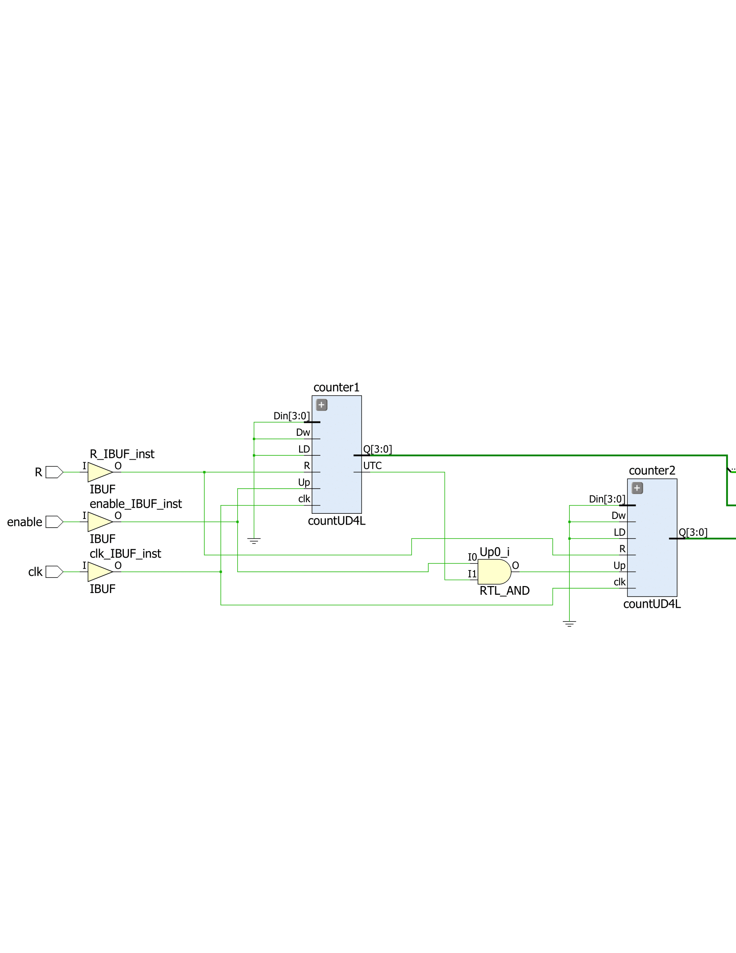

Time_Counter.v Schematic Part 1

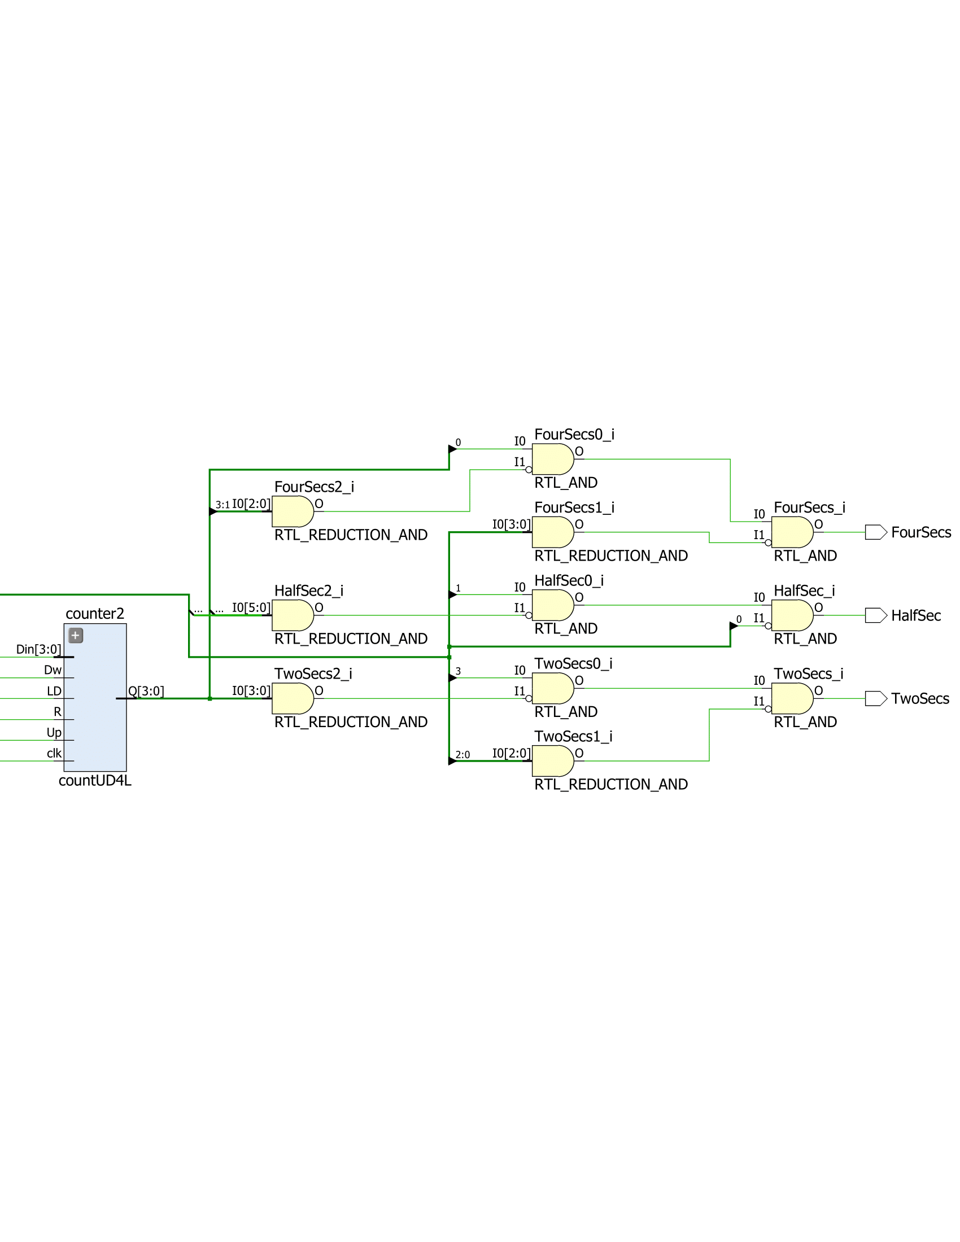

Time_Counter.v Schematic Part 2

**Part Three: LED Display**

In the next part of the lab, we had to create a 16-bit shift register that would cause an additional light on the board to either light on or off. To do so, I used 16 flip-flops for the 16 leds on the board that changed the current bit to either the bit on the left or right. If the lights had to be shifted left, the previous bit on the right would be shifted left and become the new value, while if the lights had to be shifted right, the previous bit on the left would be shifted right and become the new value. This was the case for all the bits except for the first one which only shifted the bit before it to the left, and for the last one which only shifted in 1 to the left and the bit after it to the right. The code and schematic for the LED display are the following:

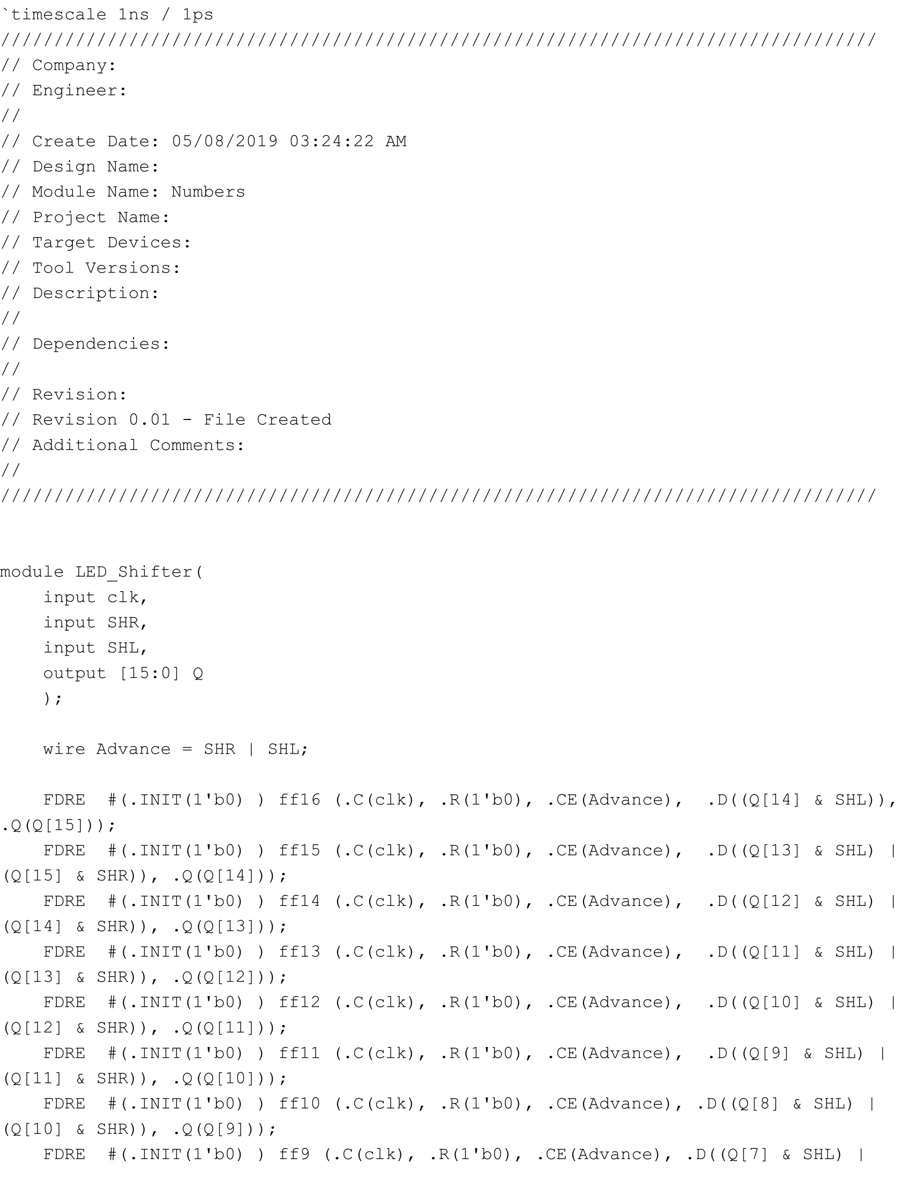

LED_Shifter.v Part 1

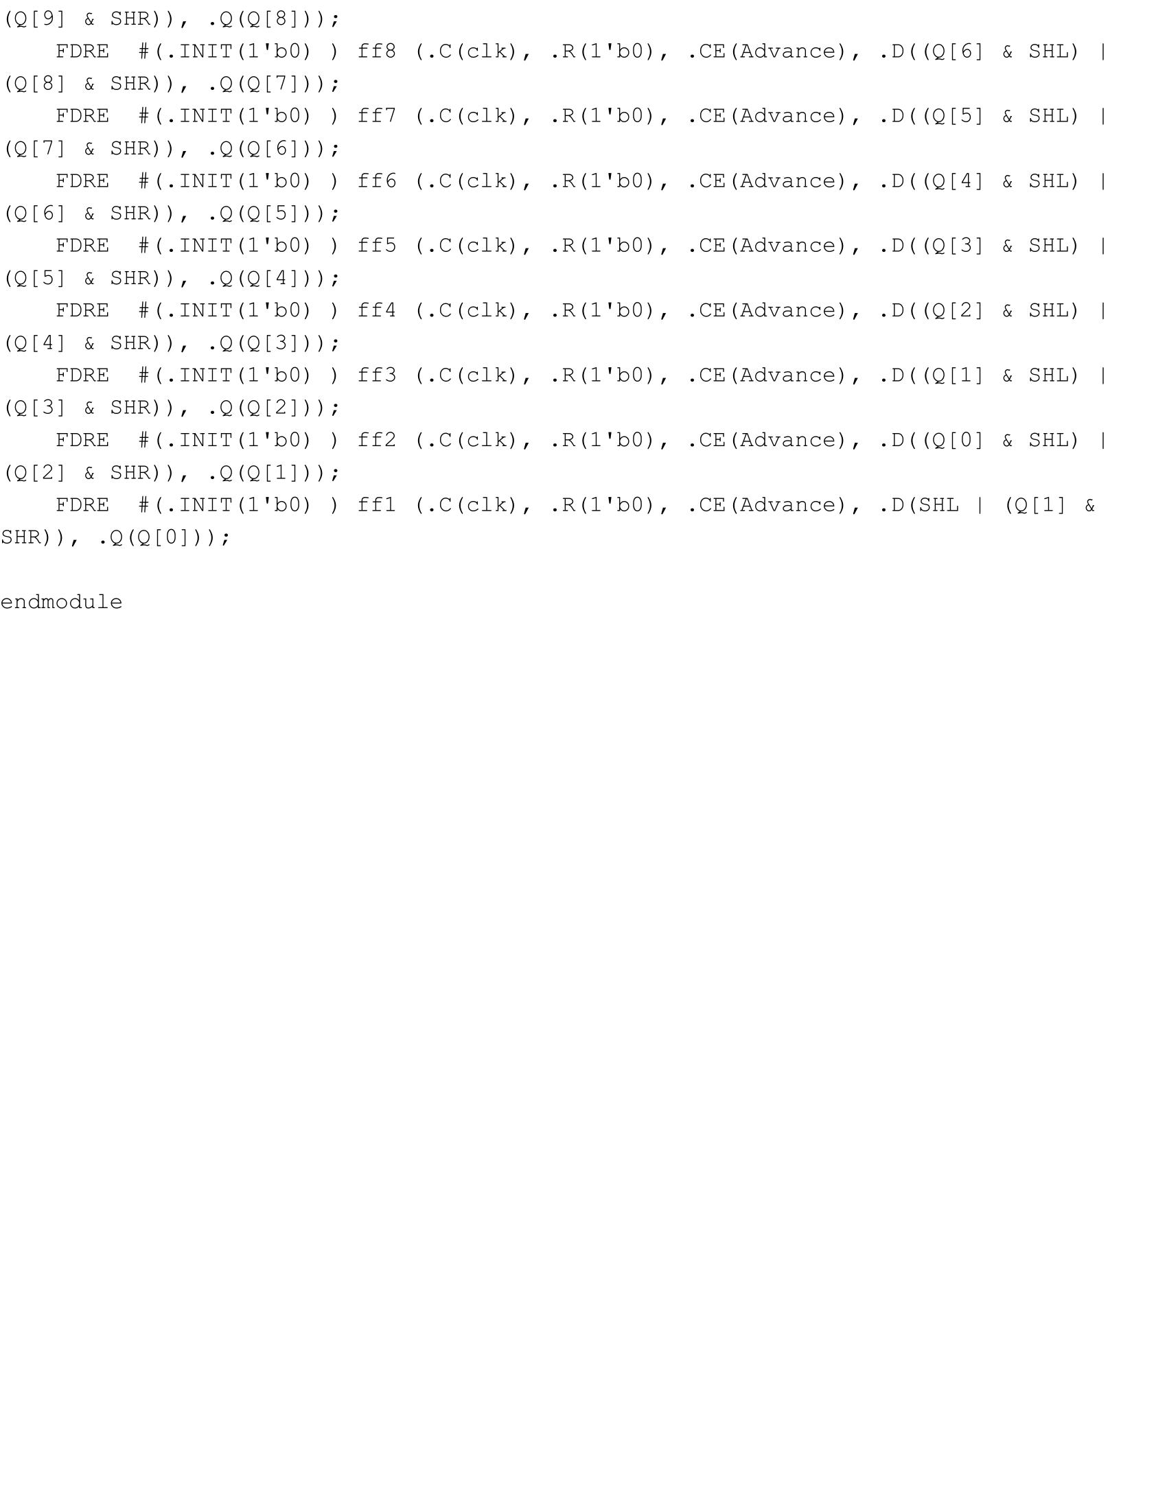

LED_Shifter.v Part 2

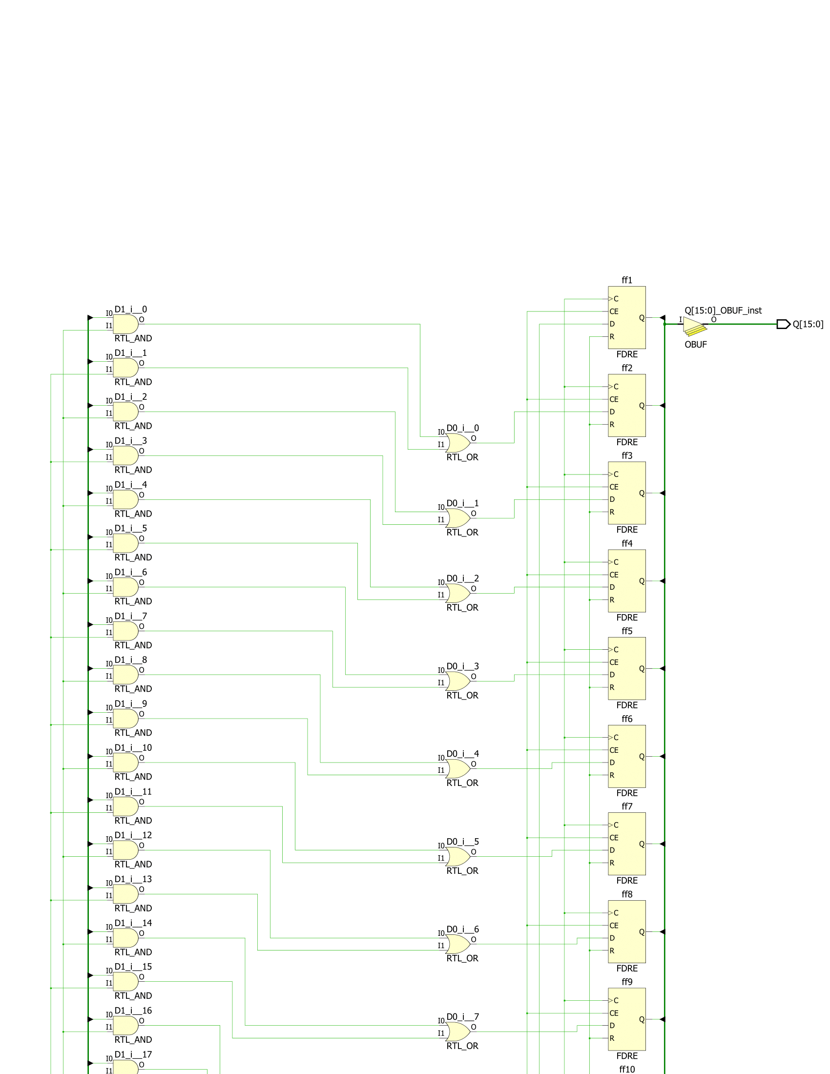

LED_Shifter.v Schematic Part 1

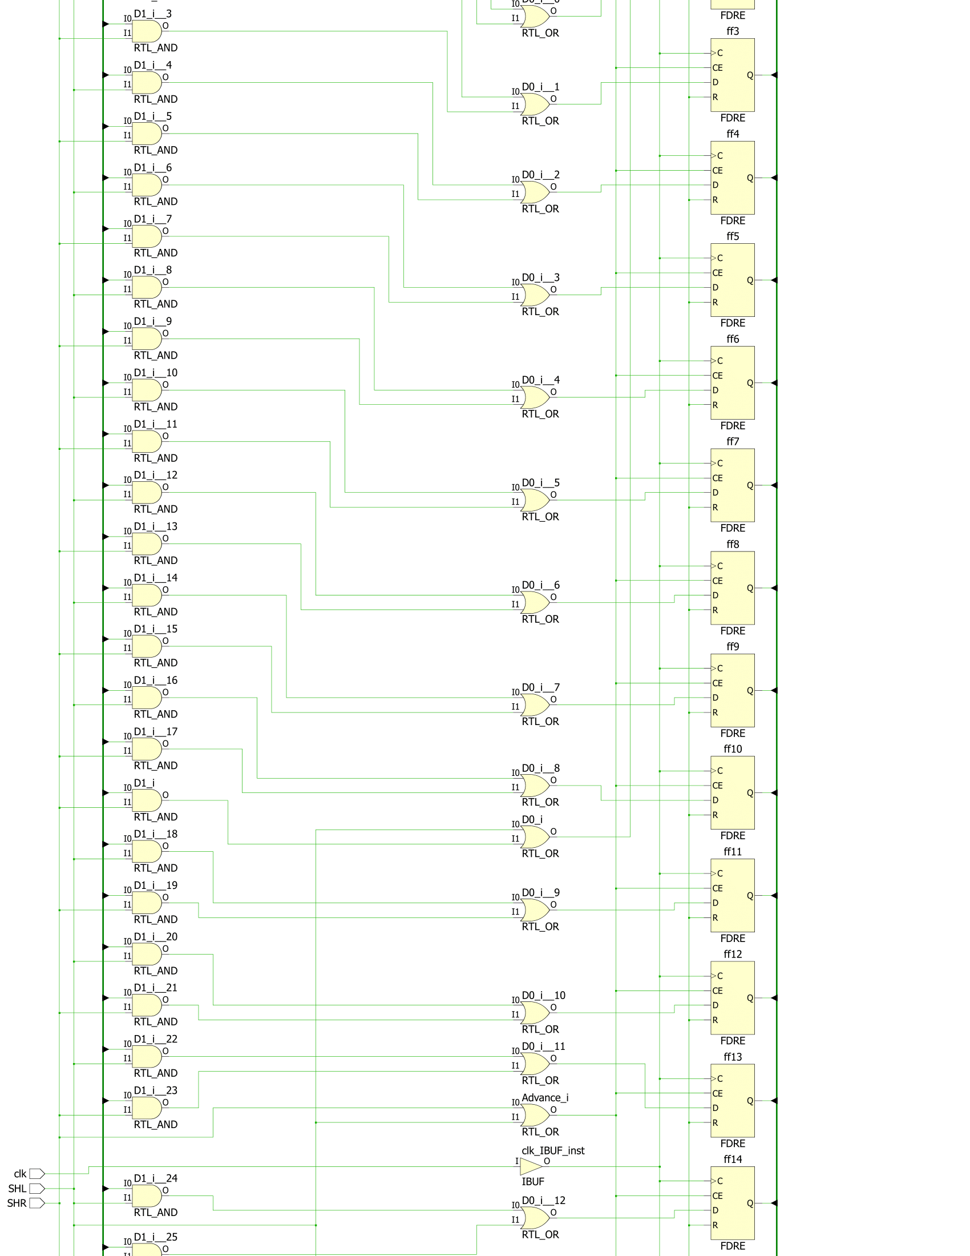

LED_Shifter.v Schematic Part 2

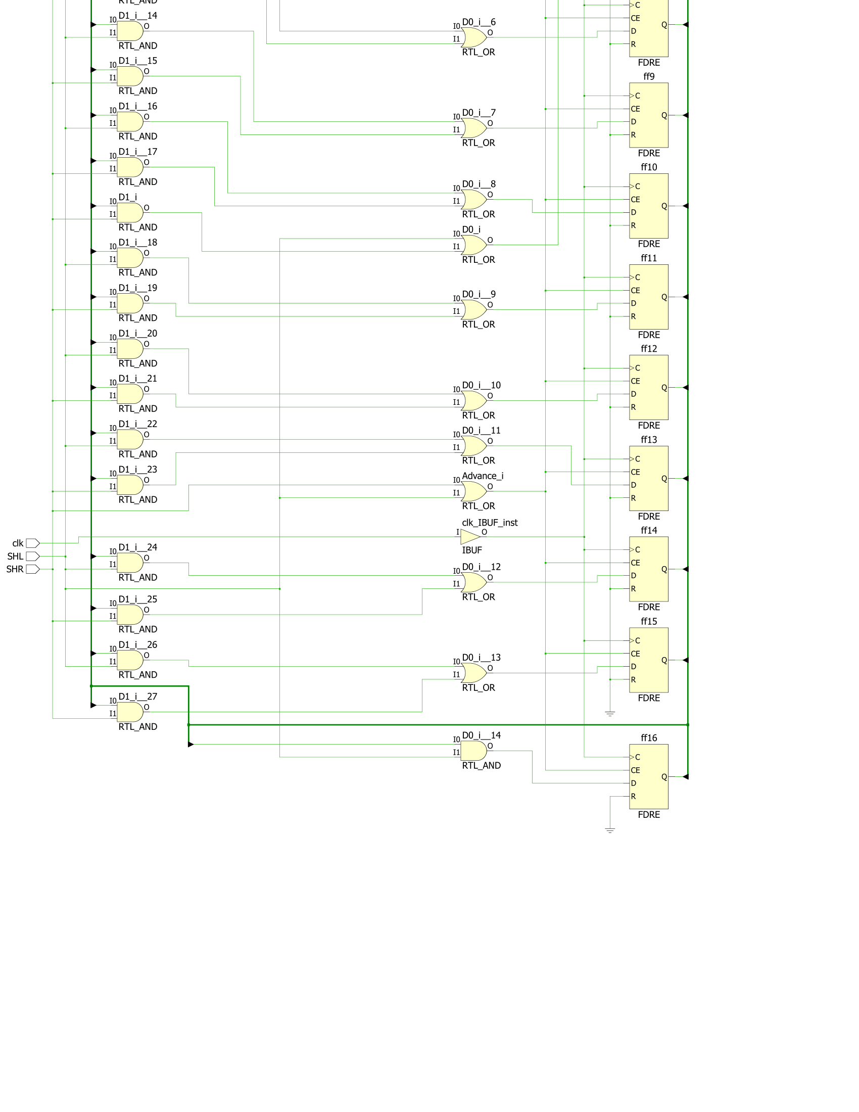

LED_Shifter.v Schematic Part 3

**Part Four: State Machine**

In this part of the lab we had to create a state machine that changed its state when certain buttons on the board were pressed and when time thresholds were met. First, I had to create a state diagram that modeled the states, transitions, and outputs of the system. The following is the state diagram:

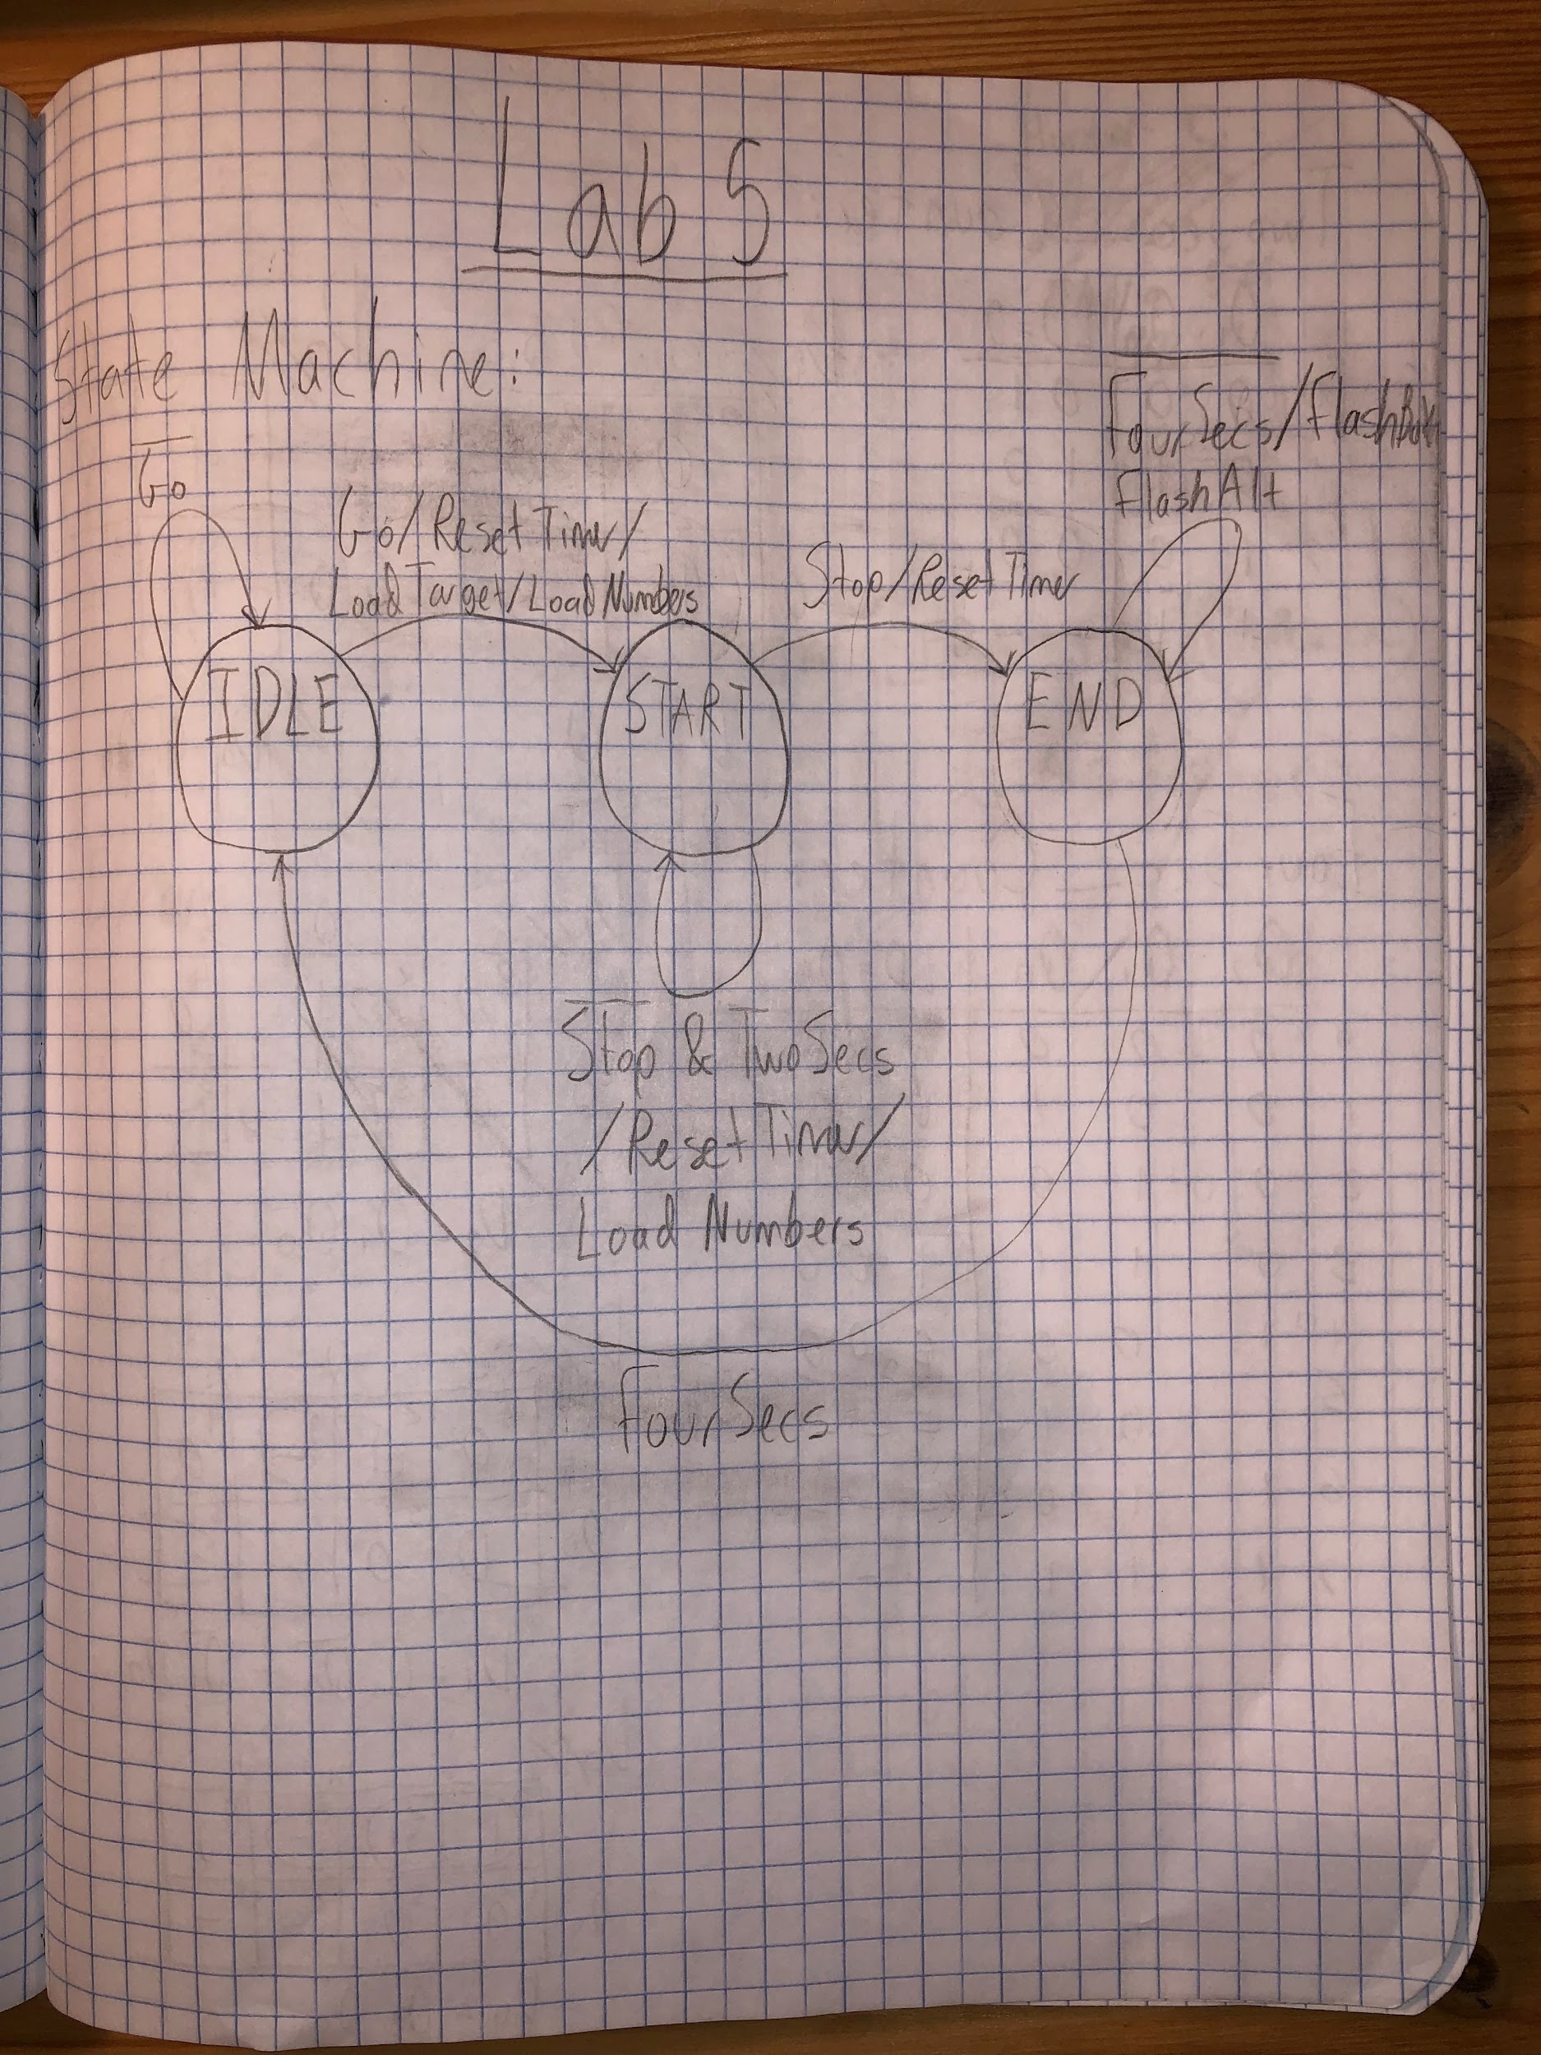

State Diagram

Initially, the system would be in state IDLE. While btnC (Go) is not pressed, the system continues to stay in IDLE. When btnC is pressed, the system goes to state START, the Time Counter is reset, and the LFSR generates random numbers and displays them on the board. While the user has not pressed btnU (Stop), the system stays in START, resets the Time Counter, and changes the random numbers on the right every two seconds. When the user does press btnU, the system transitions to state END and resets the timer. It checks if the sum of the two numbers on the right match the one on the left, and by four seconds it either flashes both numbers if they don’t match or alternately flashes the numbers every half second while staying in END. When four seconds pass, the system transitions back to IDLE. The code and schematic for the state machine’s logic is shown below.

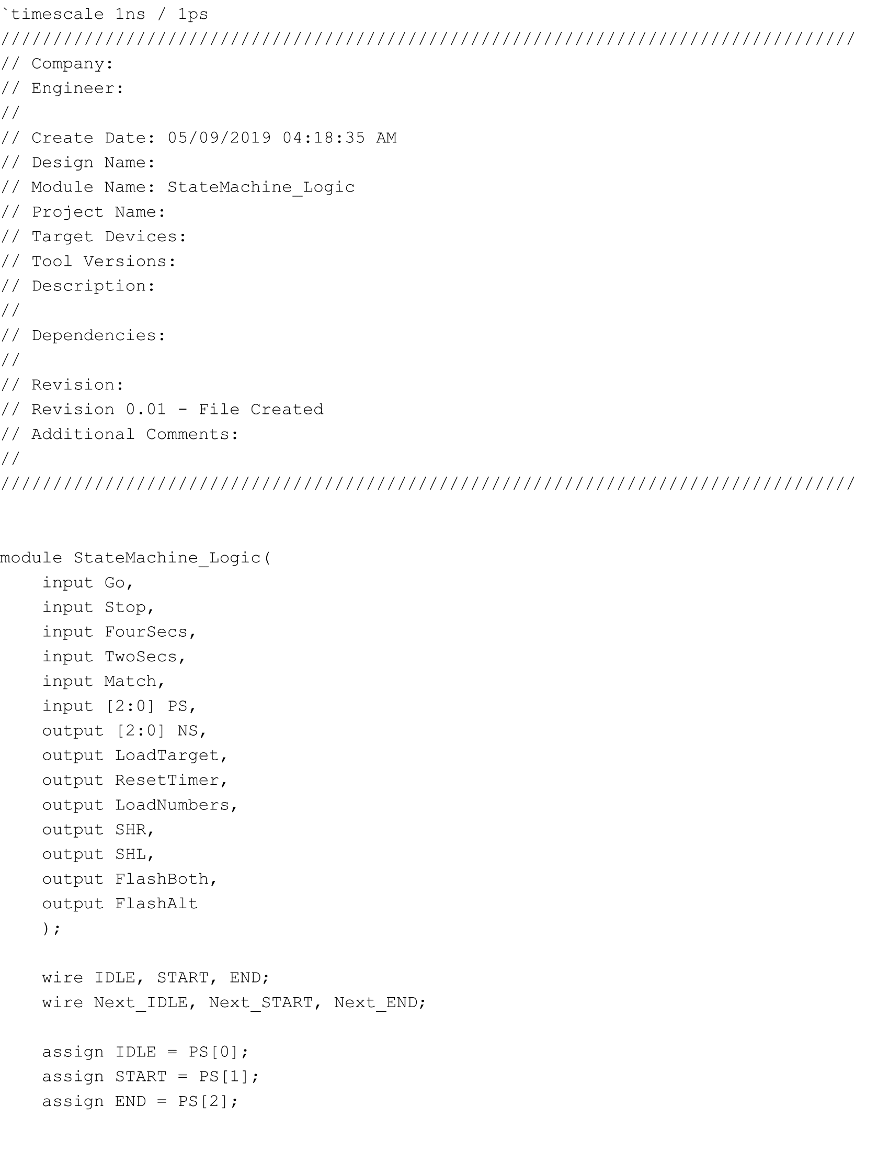

StateMachine_Logic.v Part 1

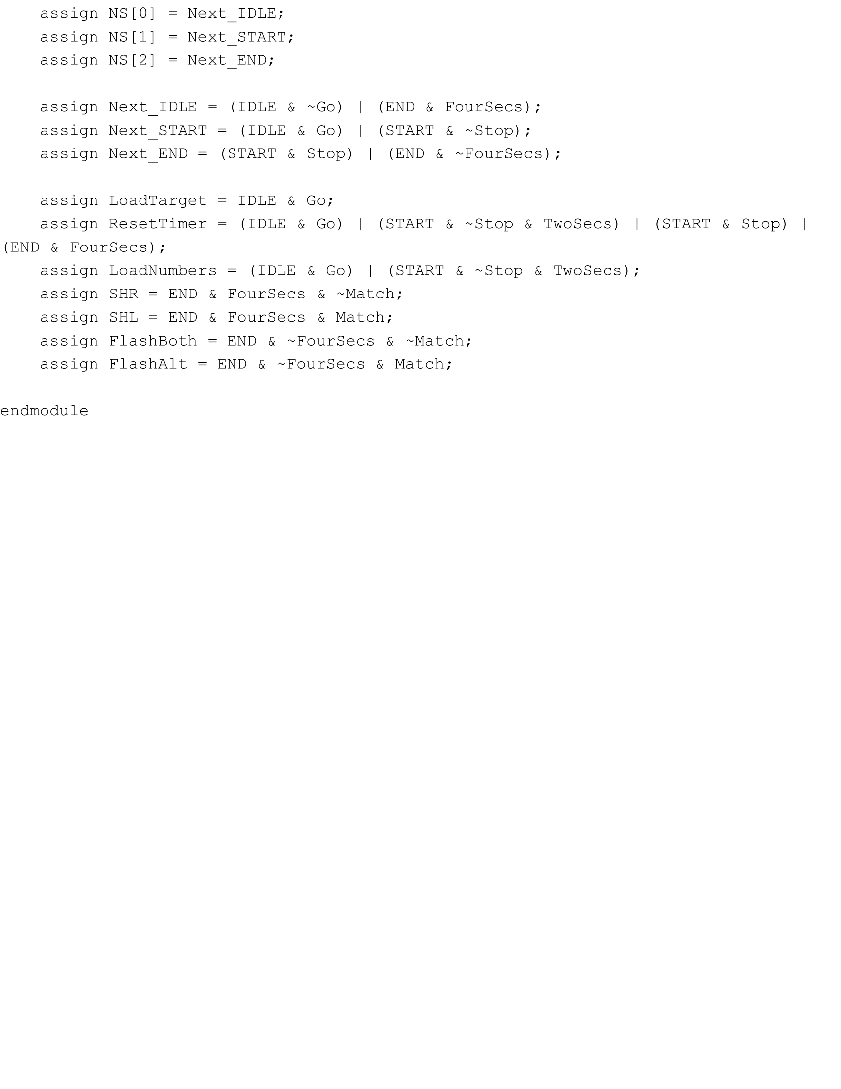

StateMachine_Logic.v Part 2

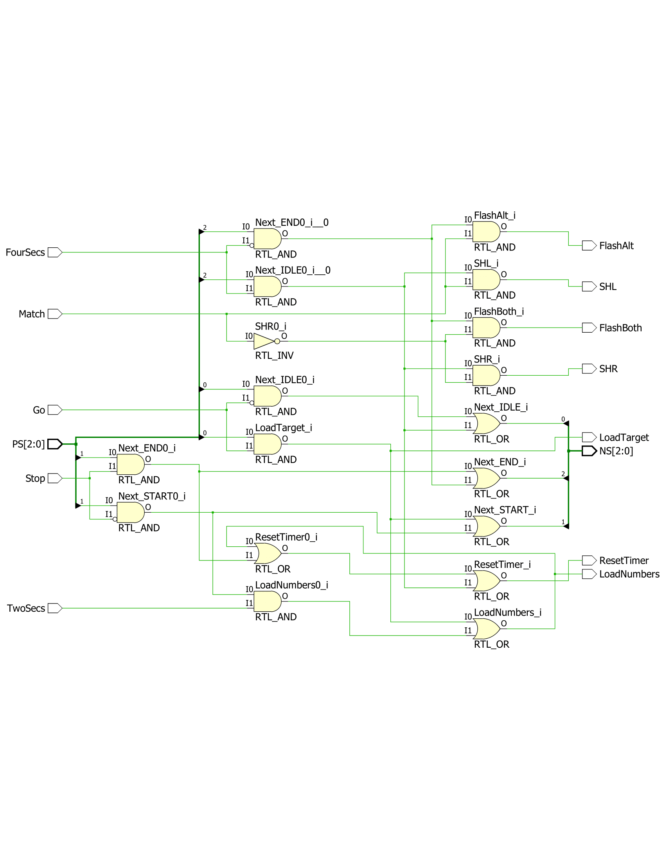

StateMachine_Logic.v Schematic

To facilitate the inputs and outputs of the state machine, I created a module that makes use of three flip-flops and one-hot encoding to ensure that only one state happens at a time. The code and schematic are the following:

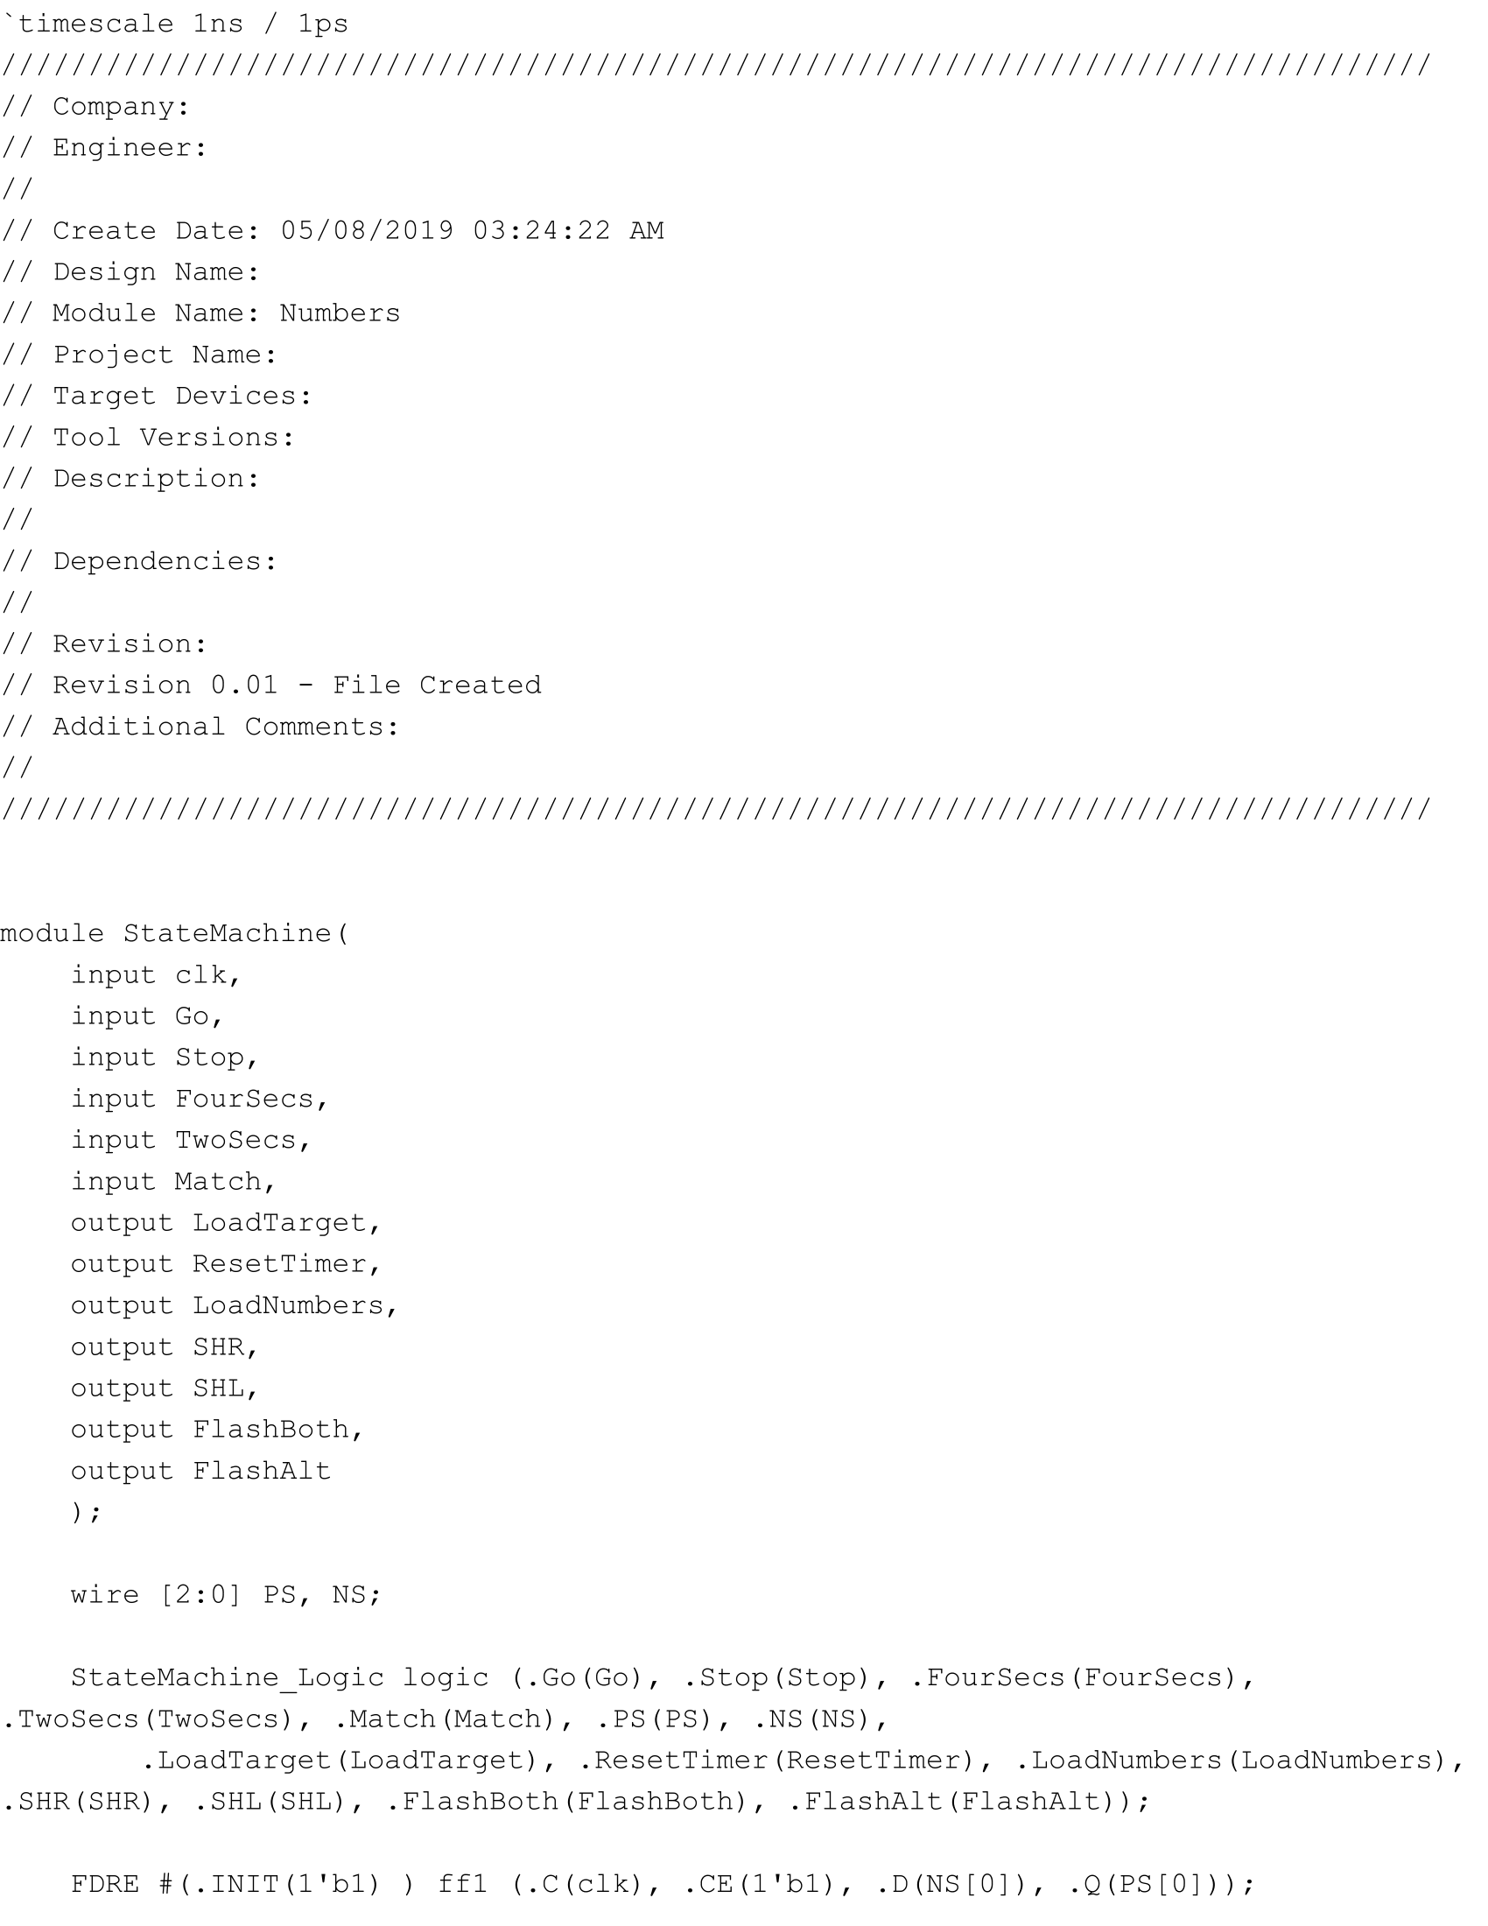

StateMachine.v Part 1

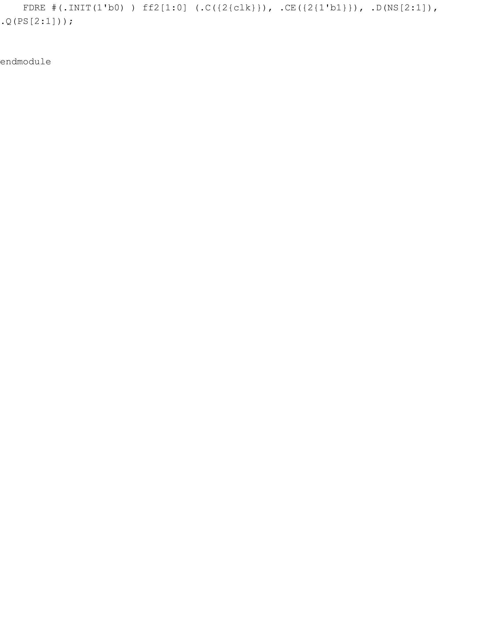

StateMachine.v Part 2

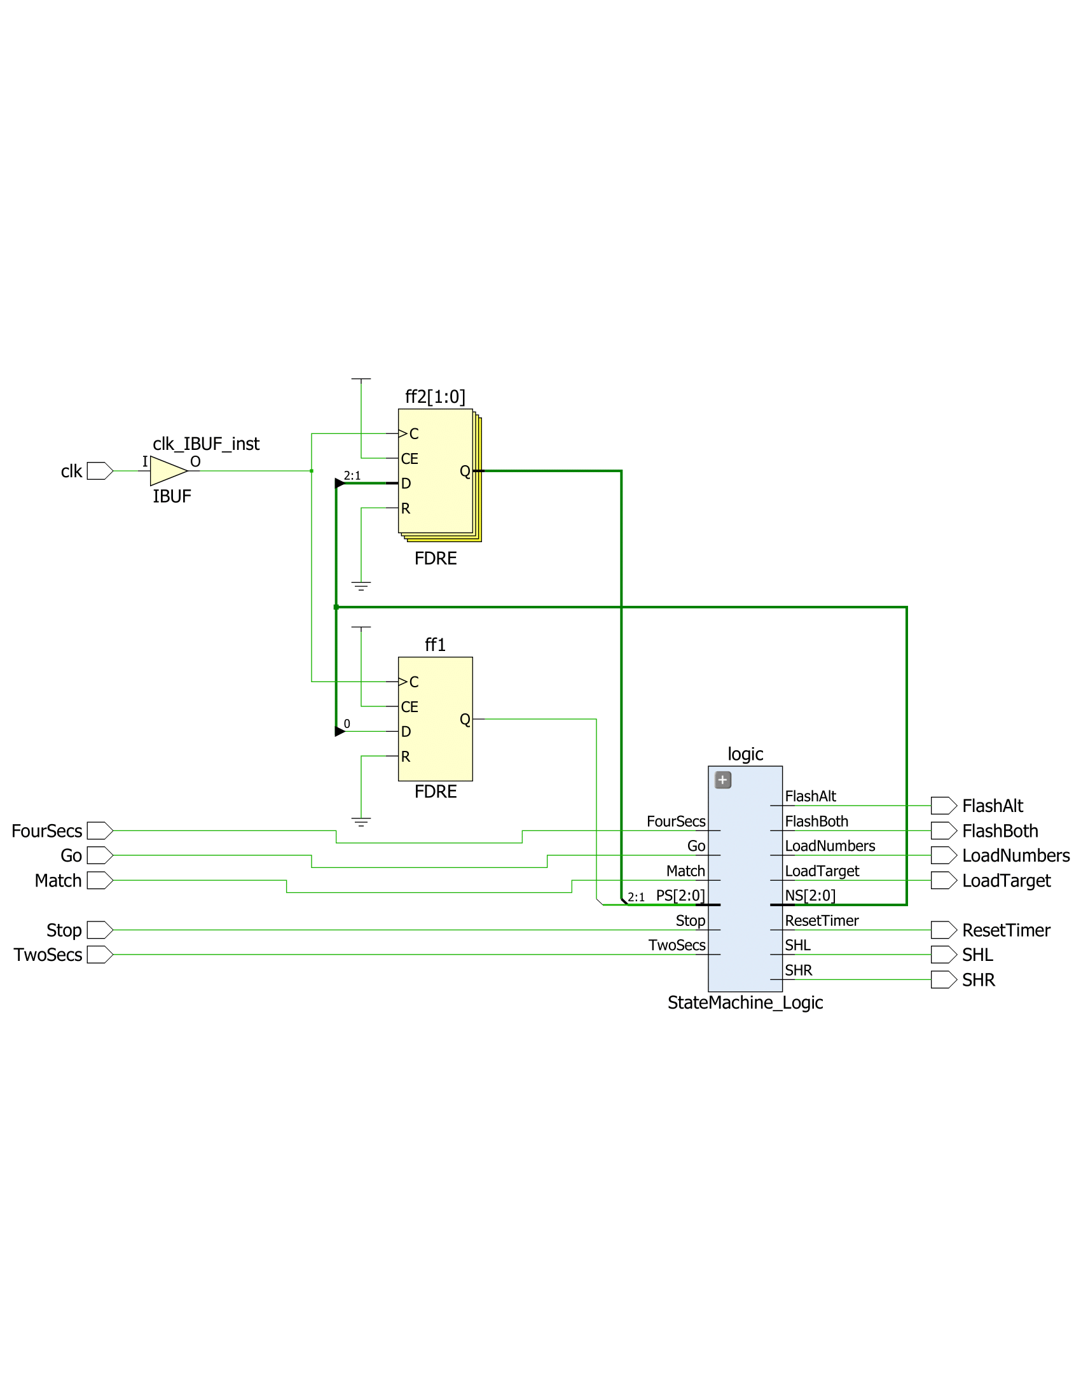

StateMachine.v Schematic

**Part Five: Top Level Module**

In the next part, everything had to be put together into one file that called every other module. First, the Time Counter was set up so that it would start counting every quarter second. The results of the Time Counter were used in the state machine, which reacted to btnC, btnU, and the amount of time that passed by to return the correct actions to perform, such as to reset the timer, load new numbers or a target, shift the leds left or right, or flash the numbers together or alternately. The random number generator was used to generate new random numbers, an adder subtractor was used to add the two numbers on the right, and the ring counter, selector, and hex7seg were used to output the correct numbers at the right time. The an bit vector was assigned to the values of the ring counter along with whether it should be flashing together or alternately, with the second bit of the an vector displaying the result of the sum of the two numbers on the right if sw15 was up. The code and schematic for the top level module are the following:

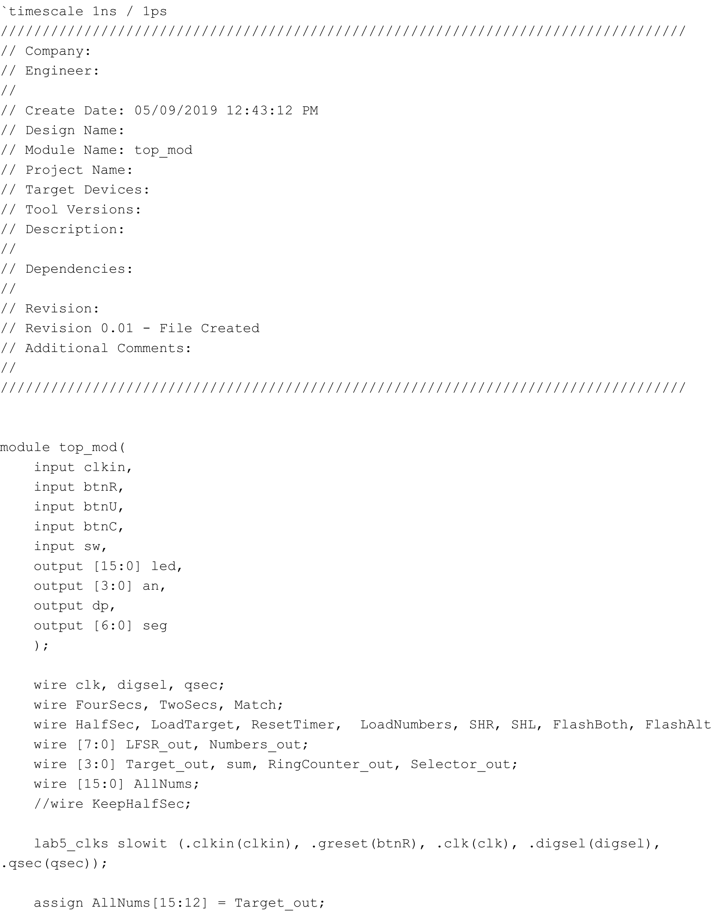

top_mod.v Part 1

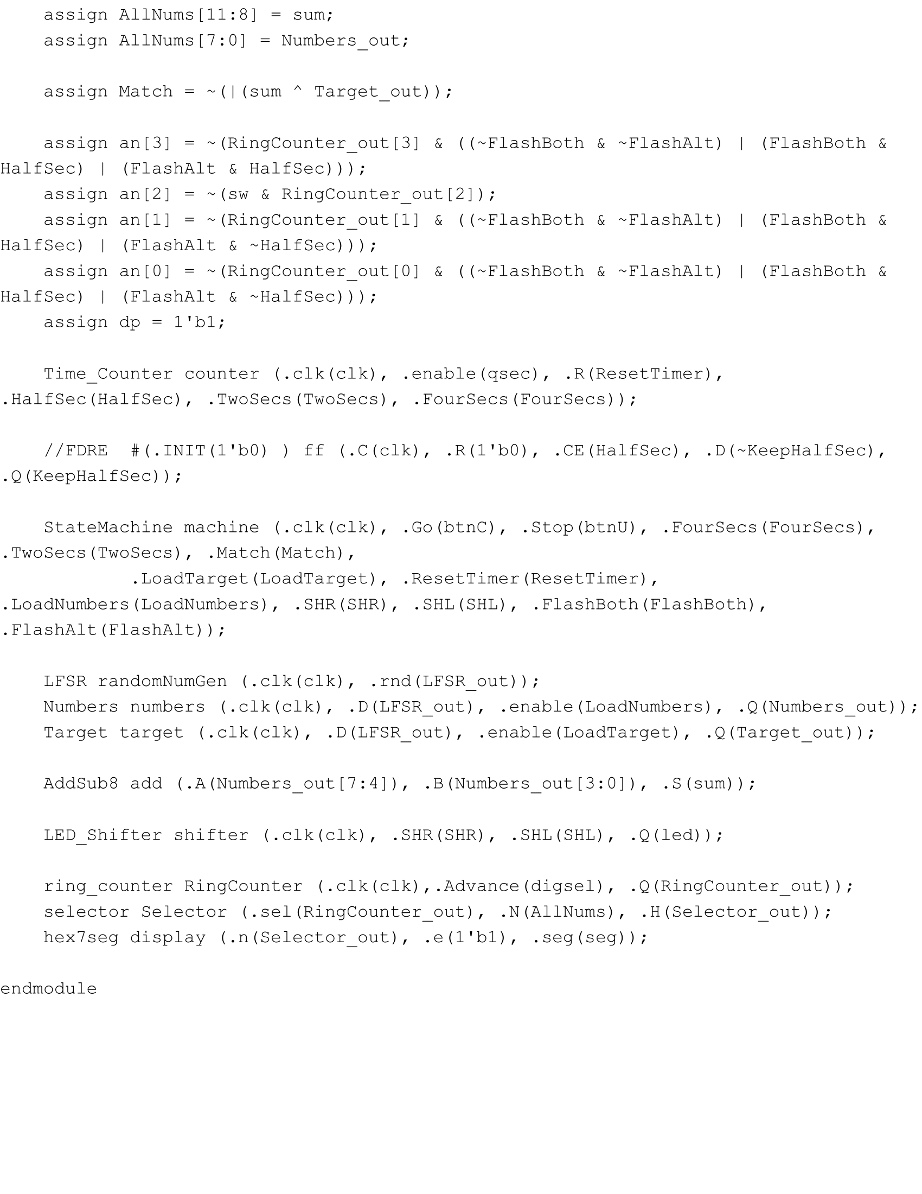

top_mod.v Part 2

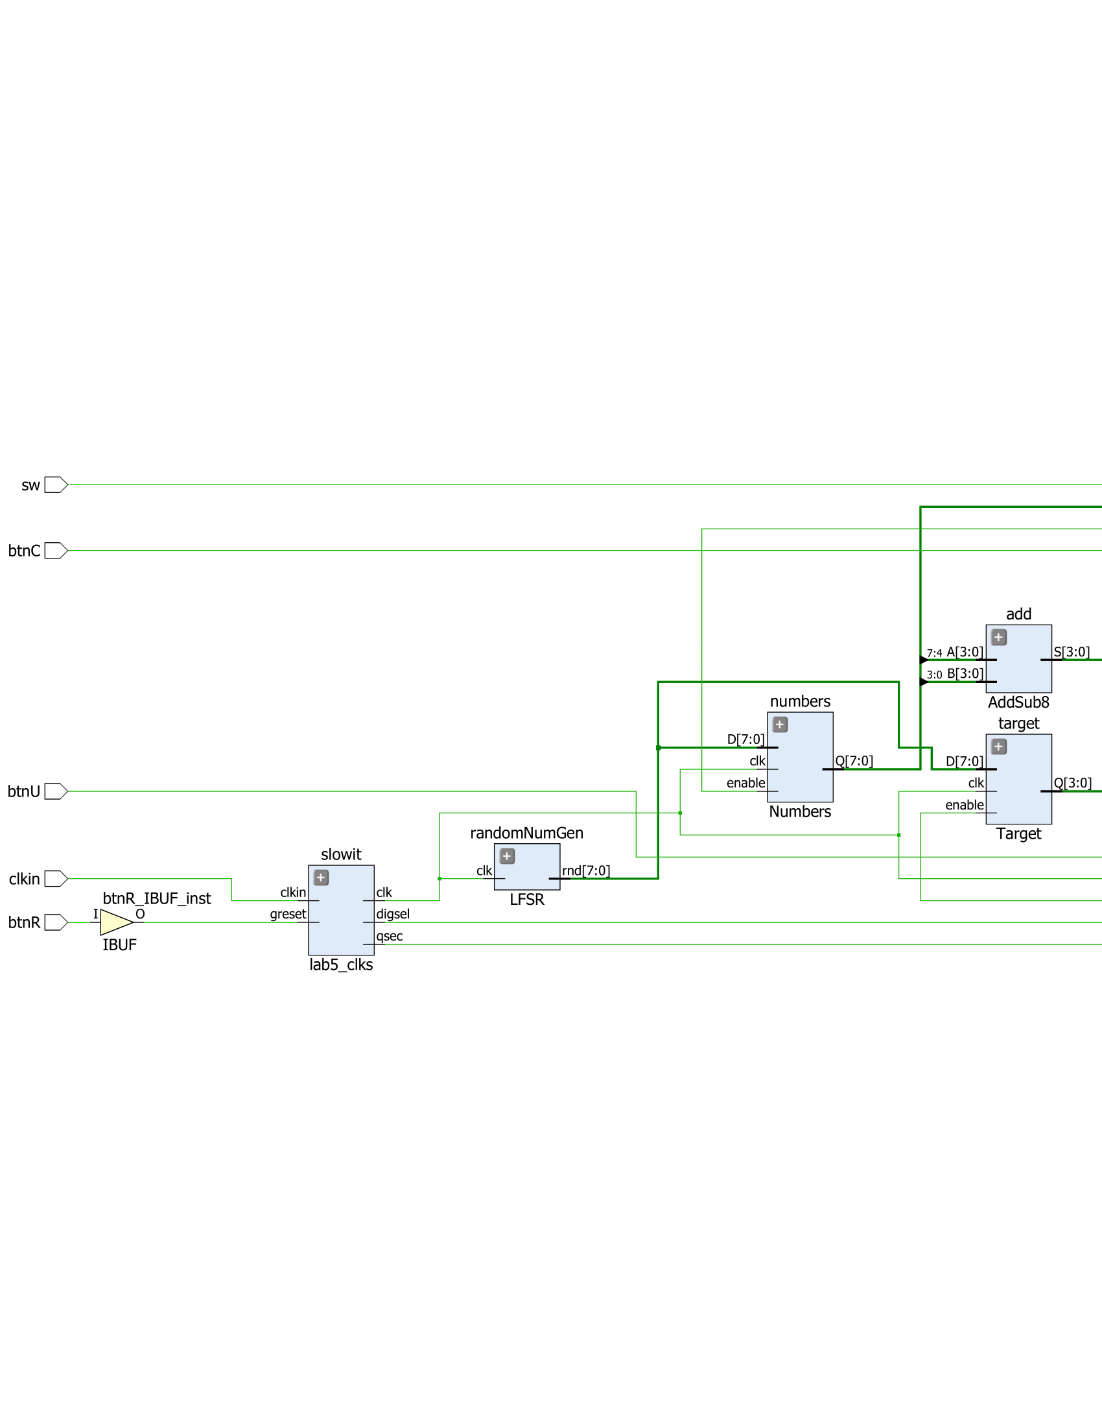

top_mod Schematic Part 1

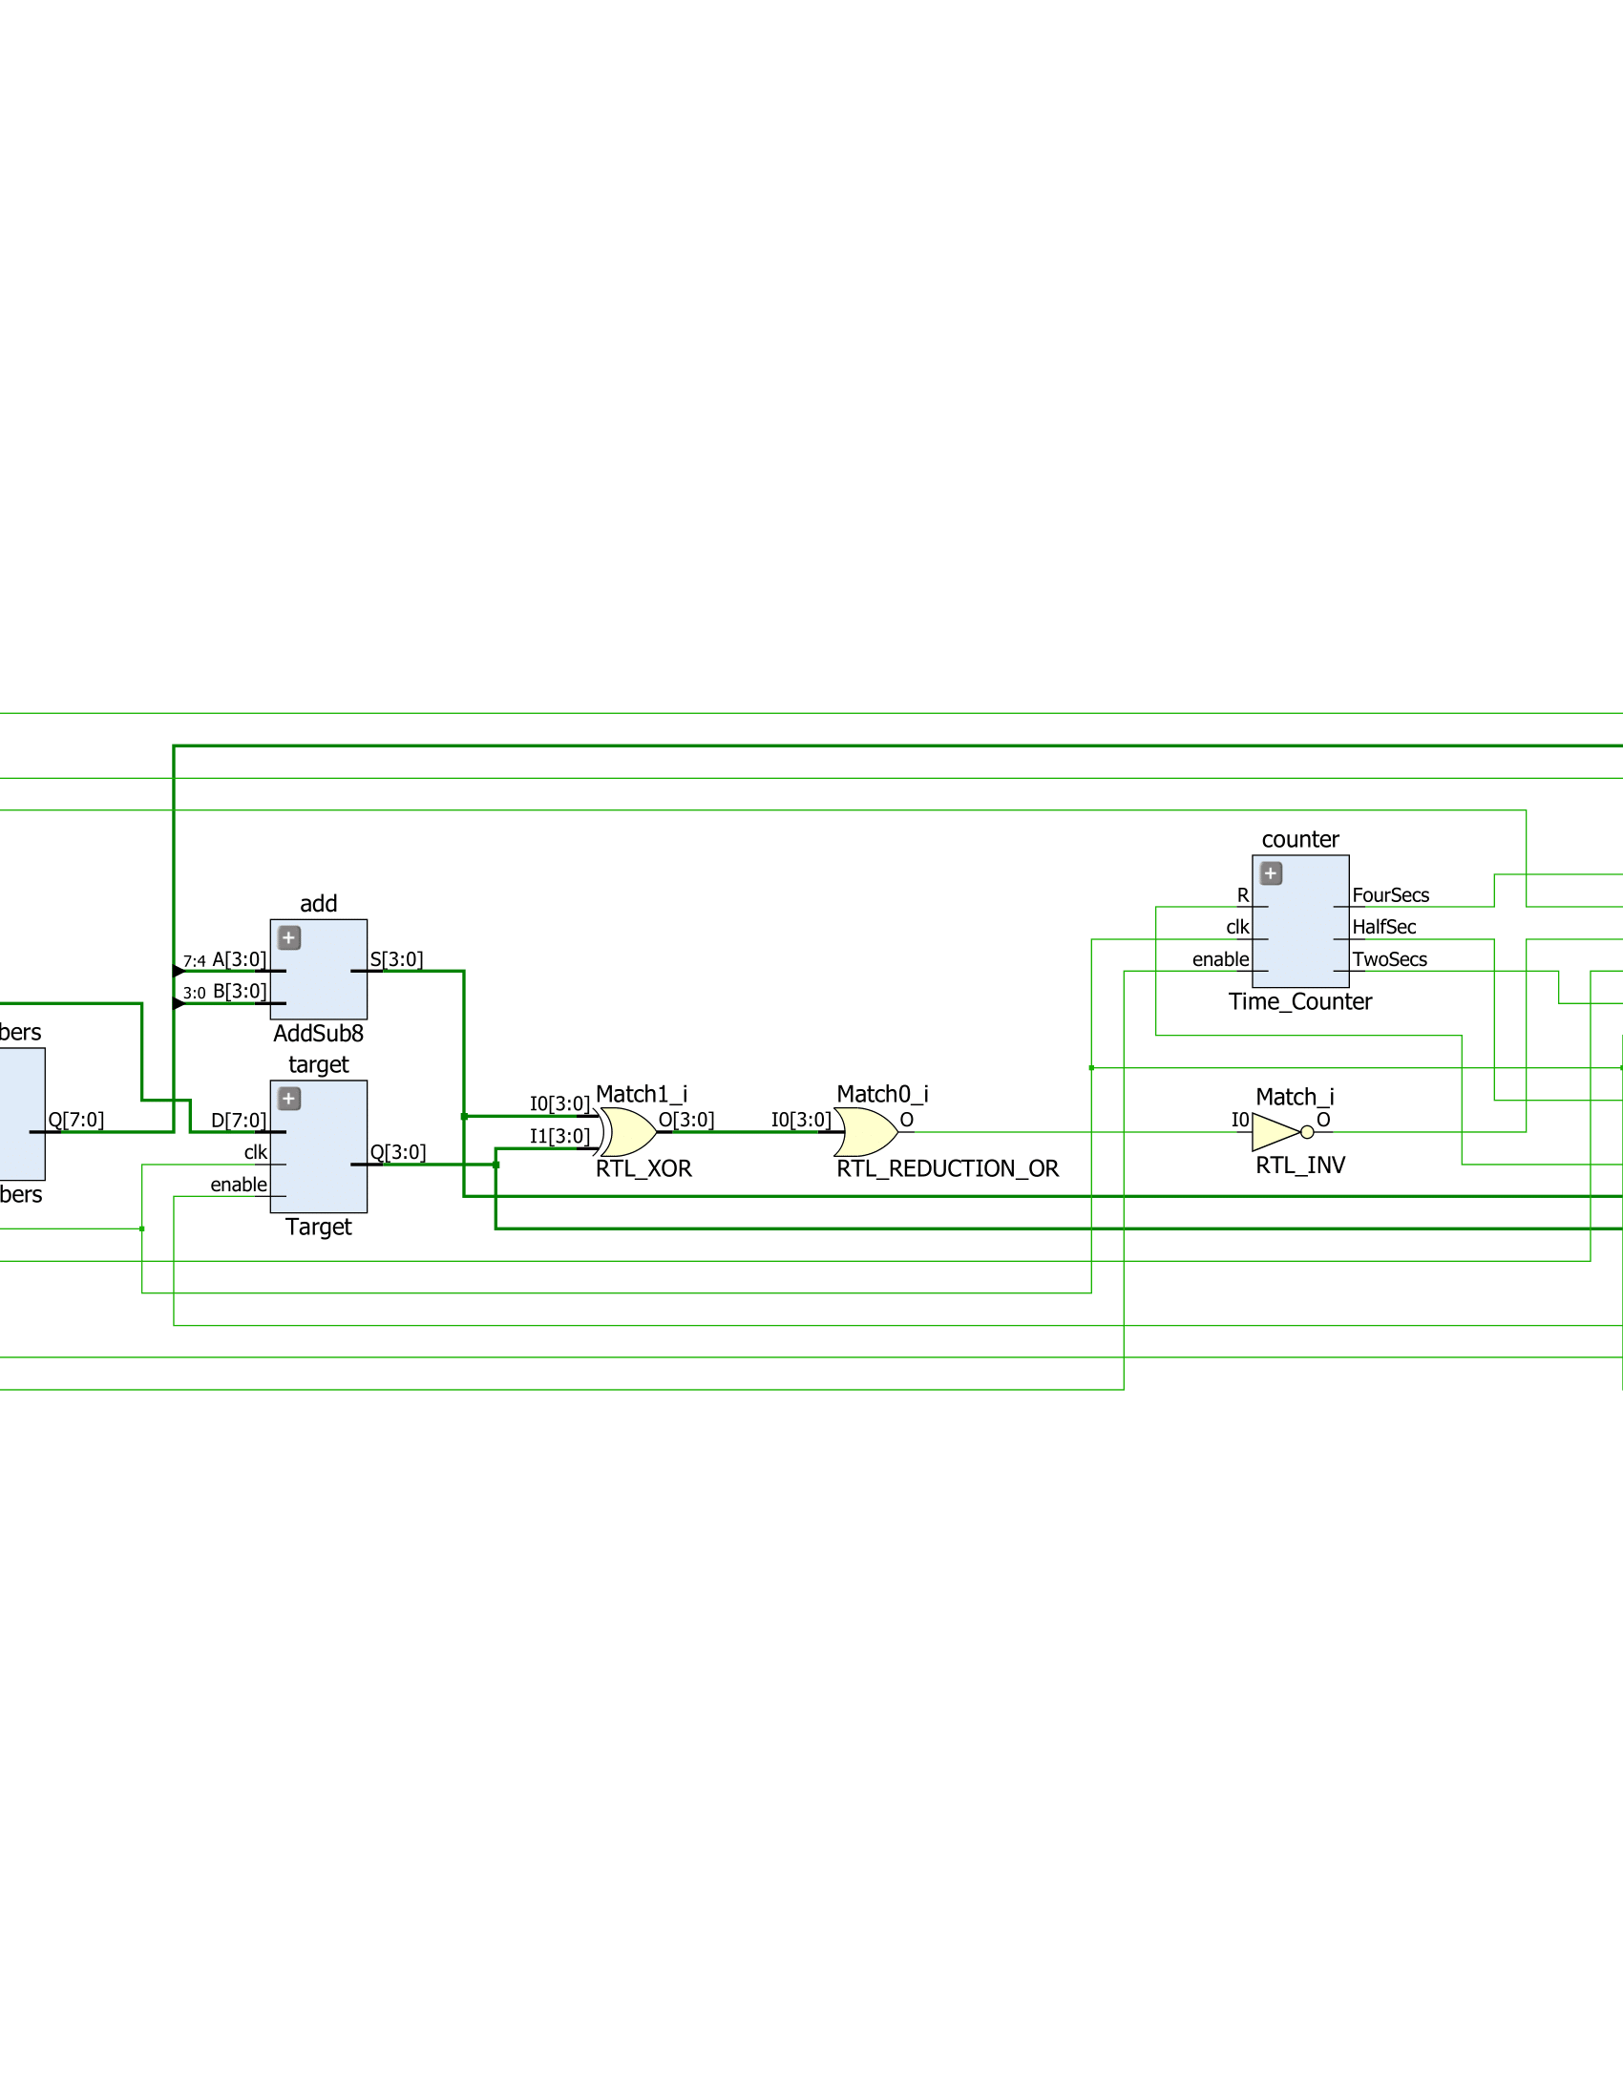

top_mod Schematic Part 2

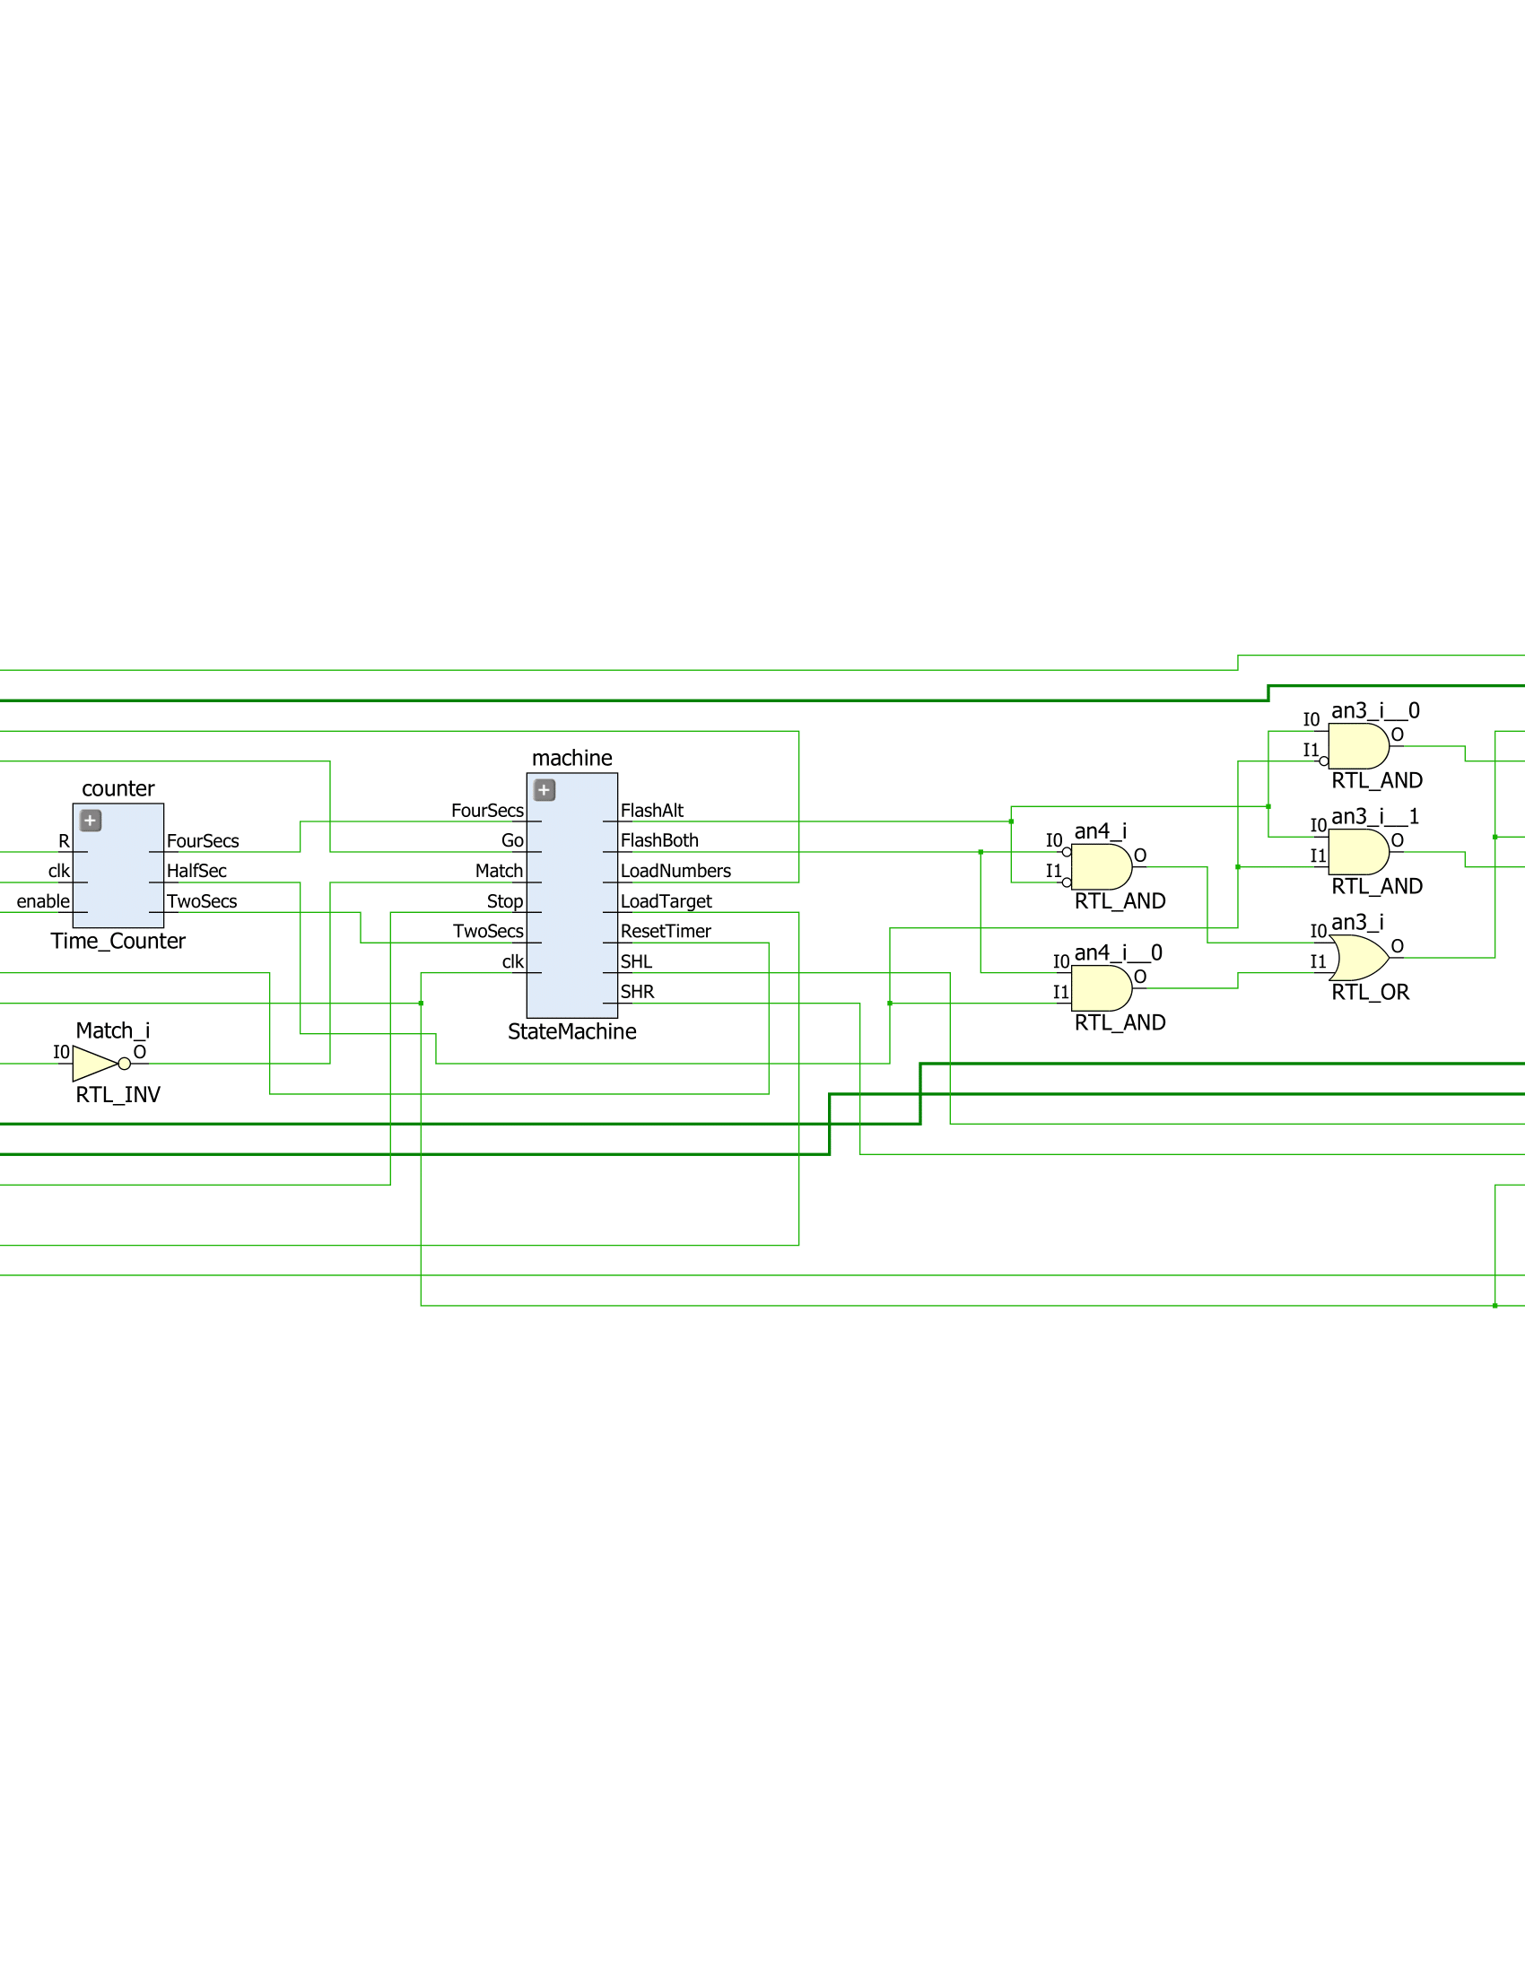

top_mod Schematic Part 3

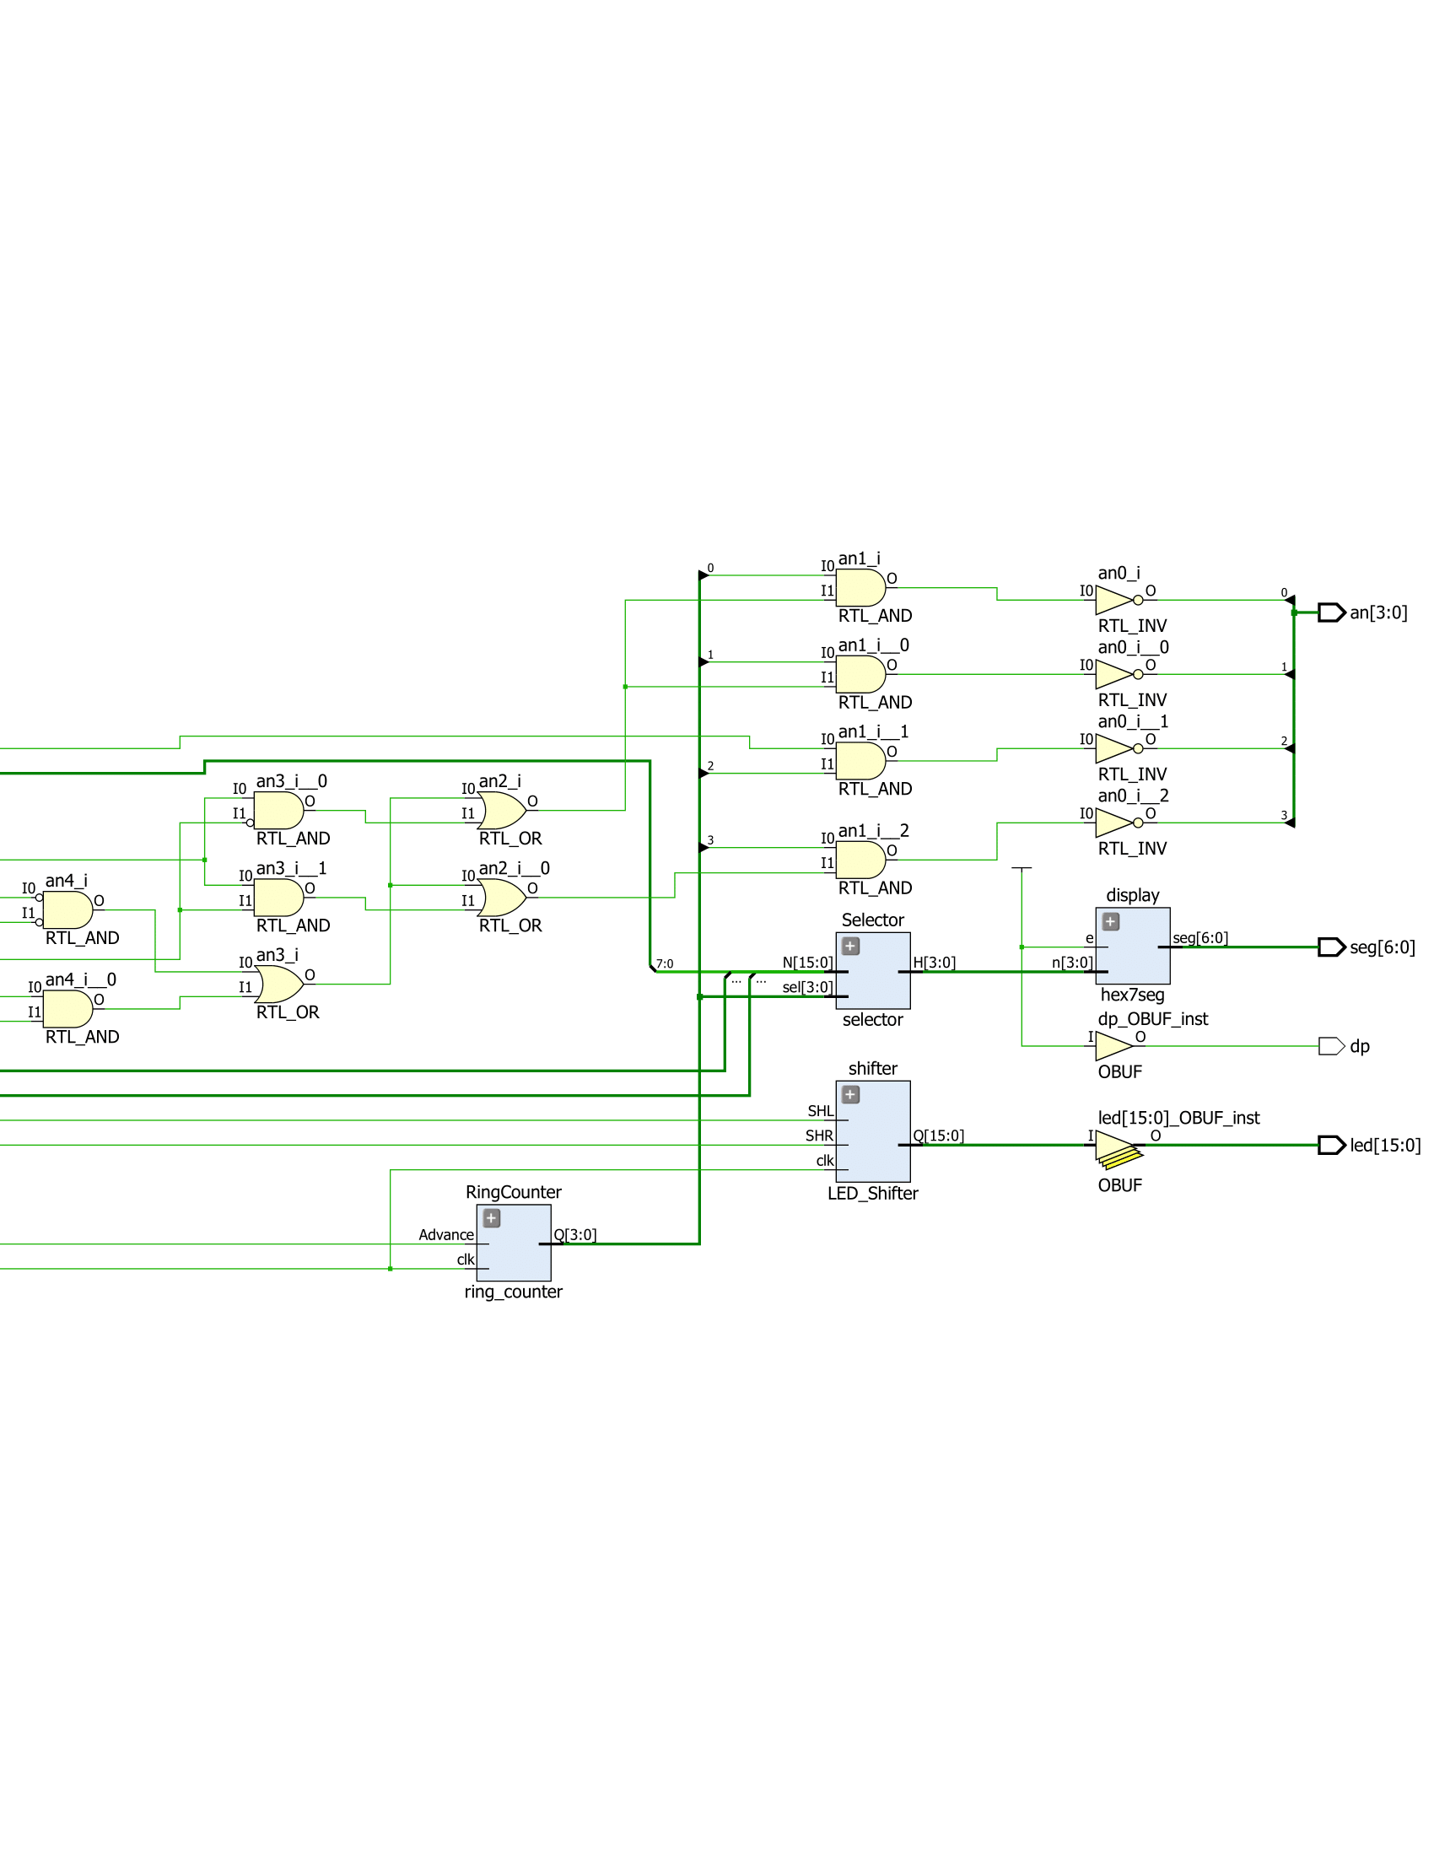

top_mod Schematic Part 4

I then mapped all the outputs of the top level module to the Basys3 board, and verified that Quick Add did indeed work.

**Part Six: Using the Simulator**

The last part of the lab was to use the simulator to make sure that qsec and digsel were high every 16th of clk, which it was. The following is the waveform displayed:

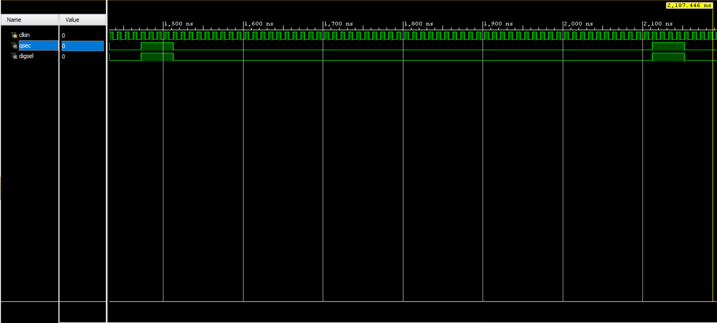

Waveform showing qsec and digsel

**Conclusion**

In conclusion, we successfully built a functioning game of Quick Add that randomly generated numbers and could check if the sum of two of them matched the other, and flashed accordingly. We learned how to implement state machines into our designs in order to react to certain events, and output the correct actions. If I were doing this lab again, I would make better use of the simulator by testing my code as soon as I write it instead of testing it after creating multiple files with code that could be wrong.

**Appendix**



LFSR.v



LFSR.v Schematic Part 1



LFSR.v Schematic Part 2



Target.v



Target.v Schematic



Numbers.v



Numbers.v Schematic



Time_Counter.v



Time_Counter.v Schematic Part 1



Time_Counter.v Schematic Part 2



LED_Shifter.v Part 1



LED_Shifter.v Part 2



LED_Shifter.v Schematic Part 1



LED_Shifter.v Schematic Part 2



LED_Shifter.v Schematic Part 3



StateMachine_Logic.v Part 1



StateMachine_Logic.v Part 2



StateMachine_Logic.v Schematic



StateMachine.v Part 1



StateMachine.v Part 2



StateMachine.v Schematic



top_mod.v Part 1



top_mod.v Part 2



top_mod.v Schematic Part 1



top_mod.v Schematic Part 2



top_mod.v Schematic Part 3



top_mod.v Schematic Part 4



Waveform showing qsec and digsel

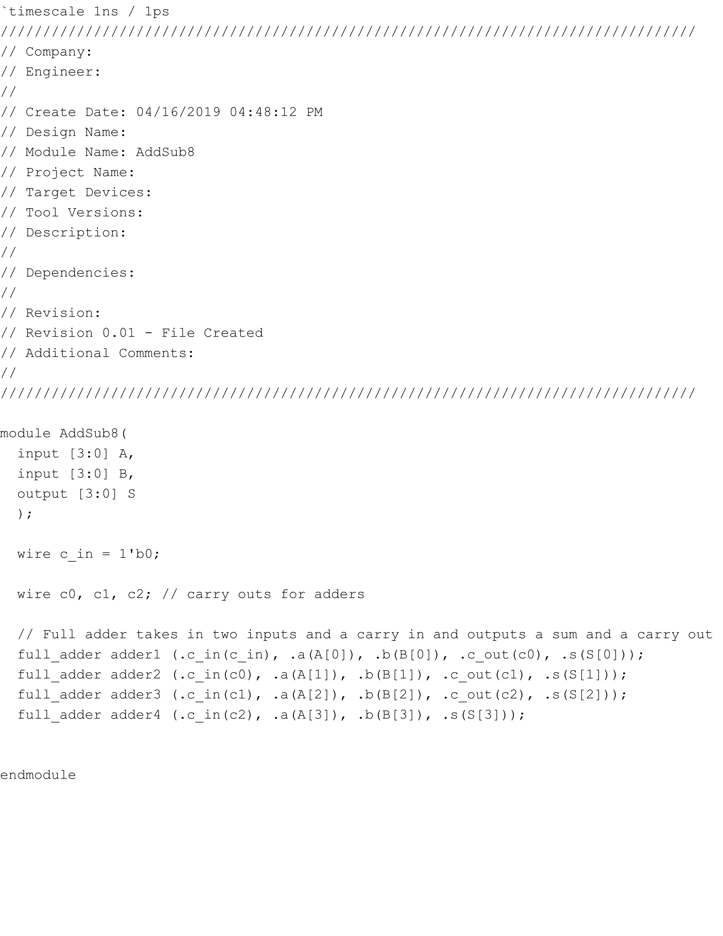

AddSub8.v

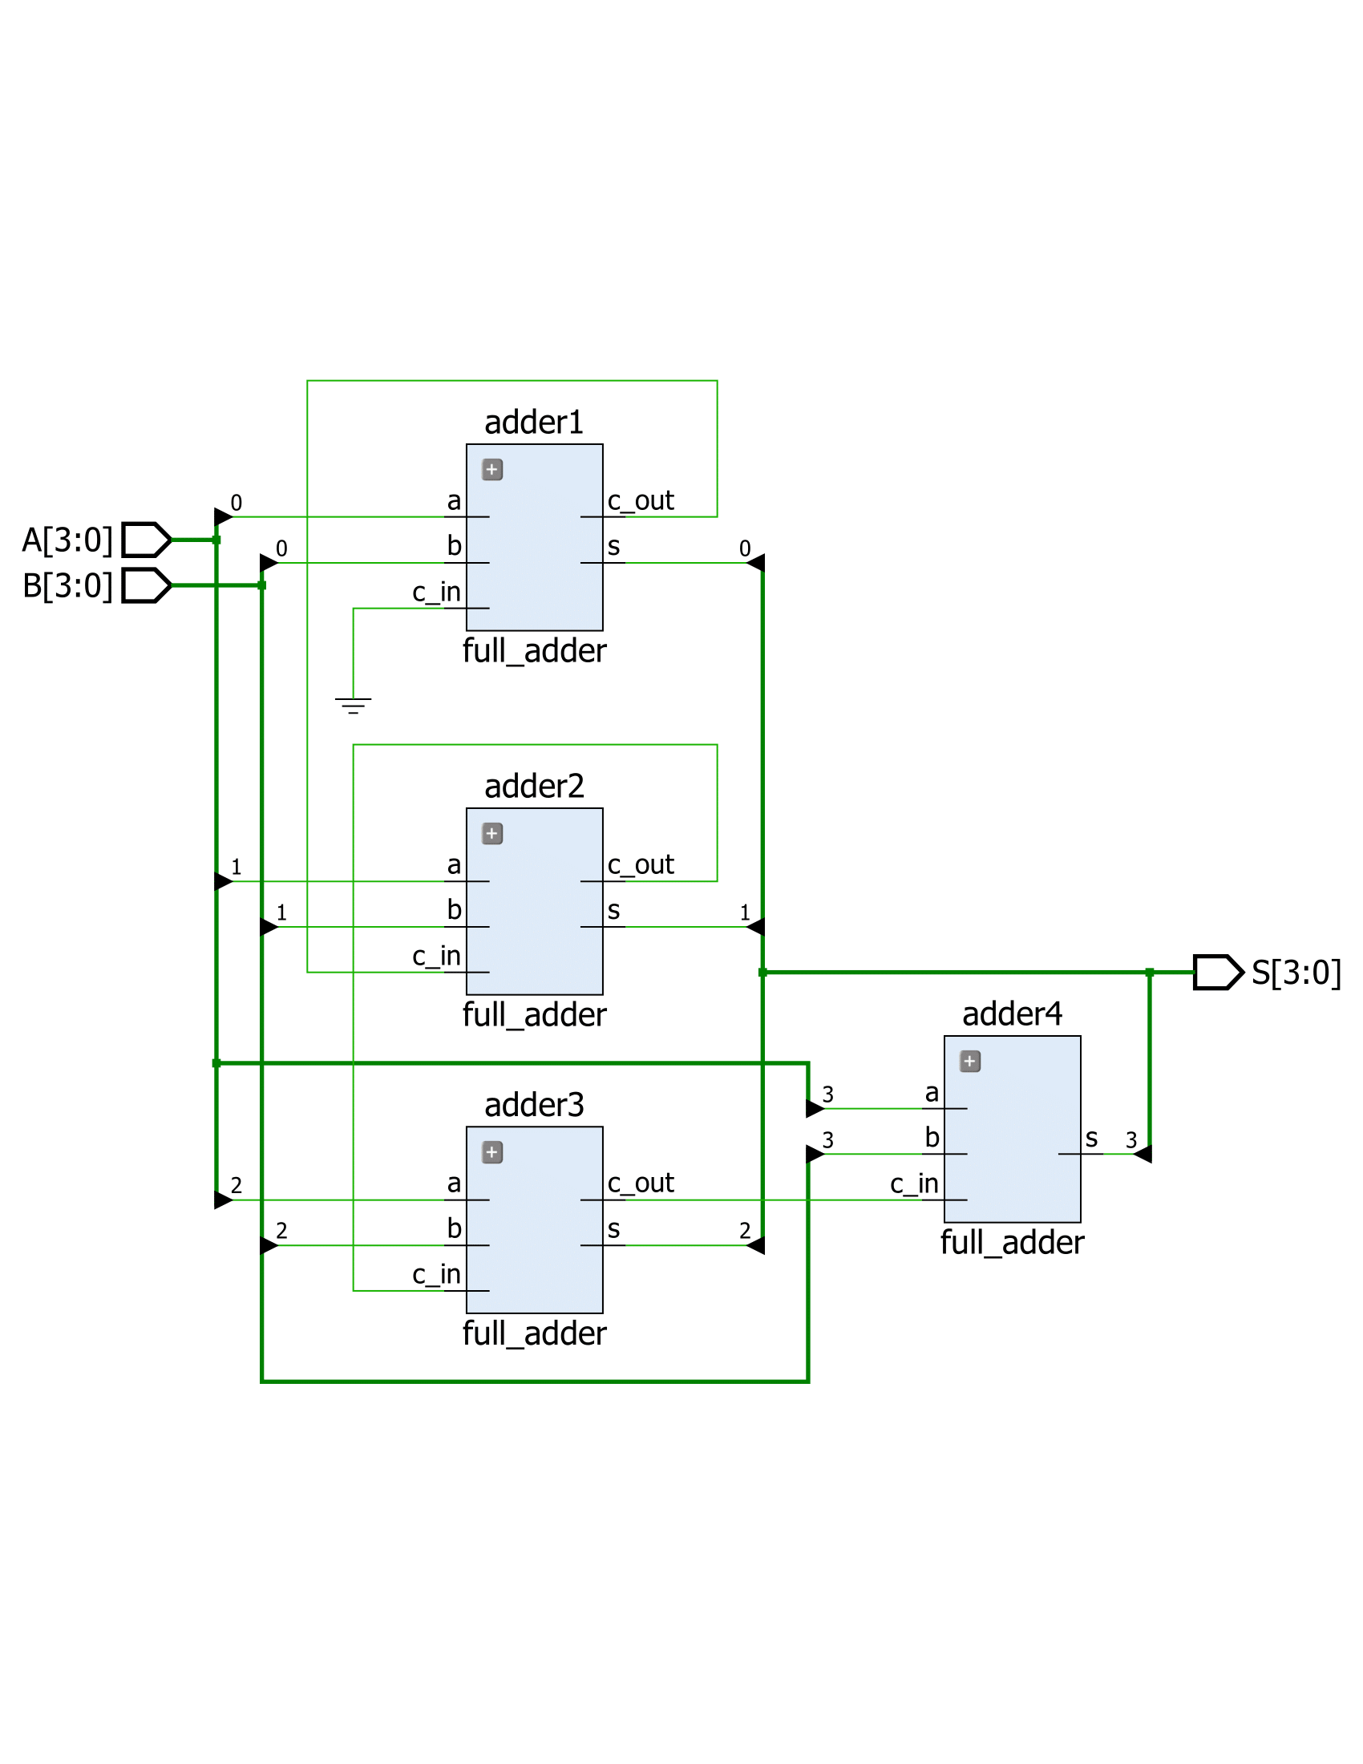

AddSub8.v Schematic

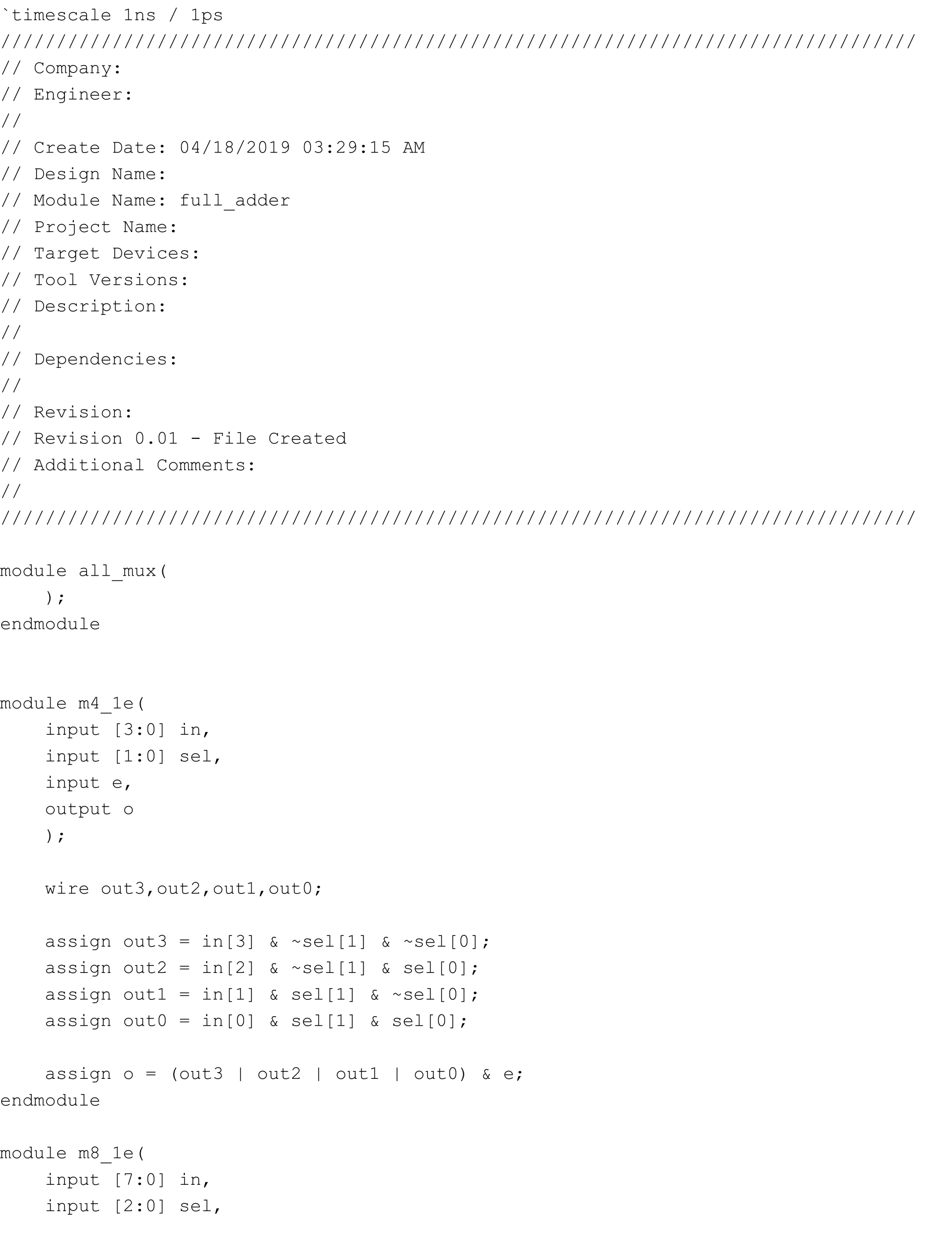

all_mux.v Part 1

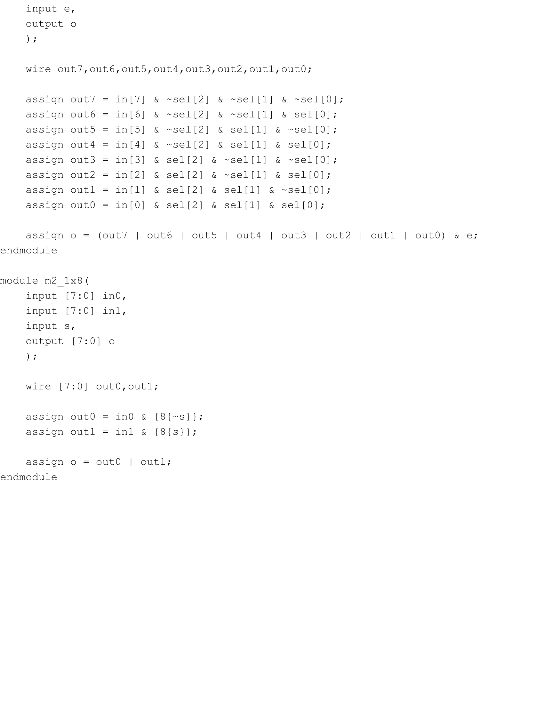

all_mux.v Part 2

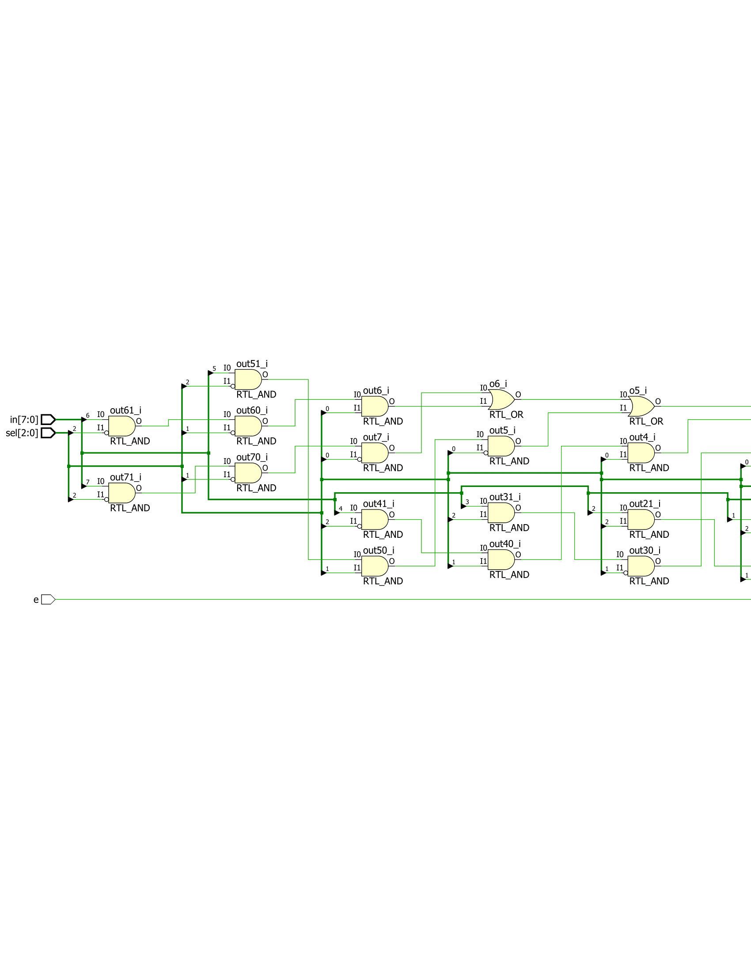

m8_1e.v Schematic Part 1

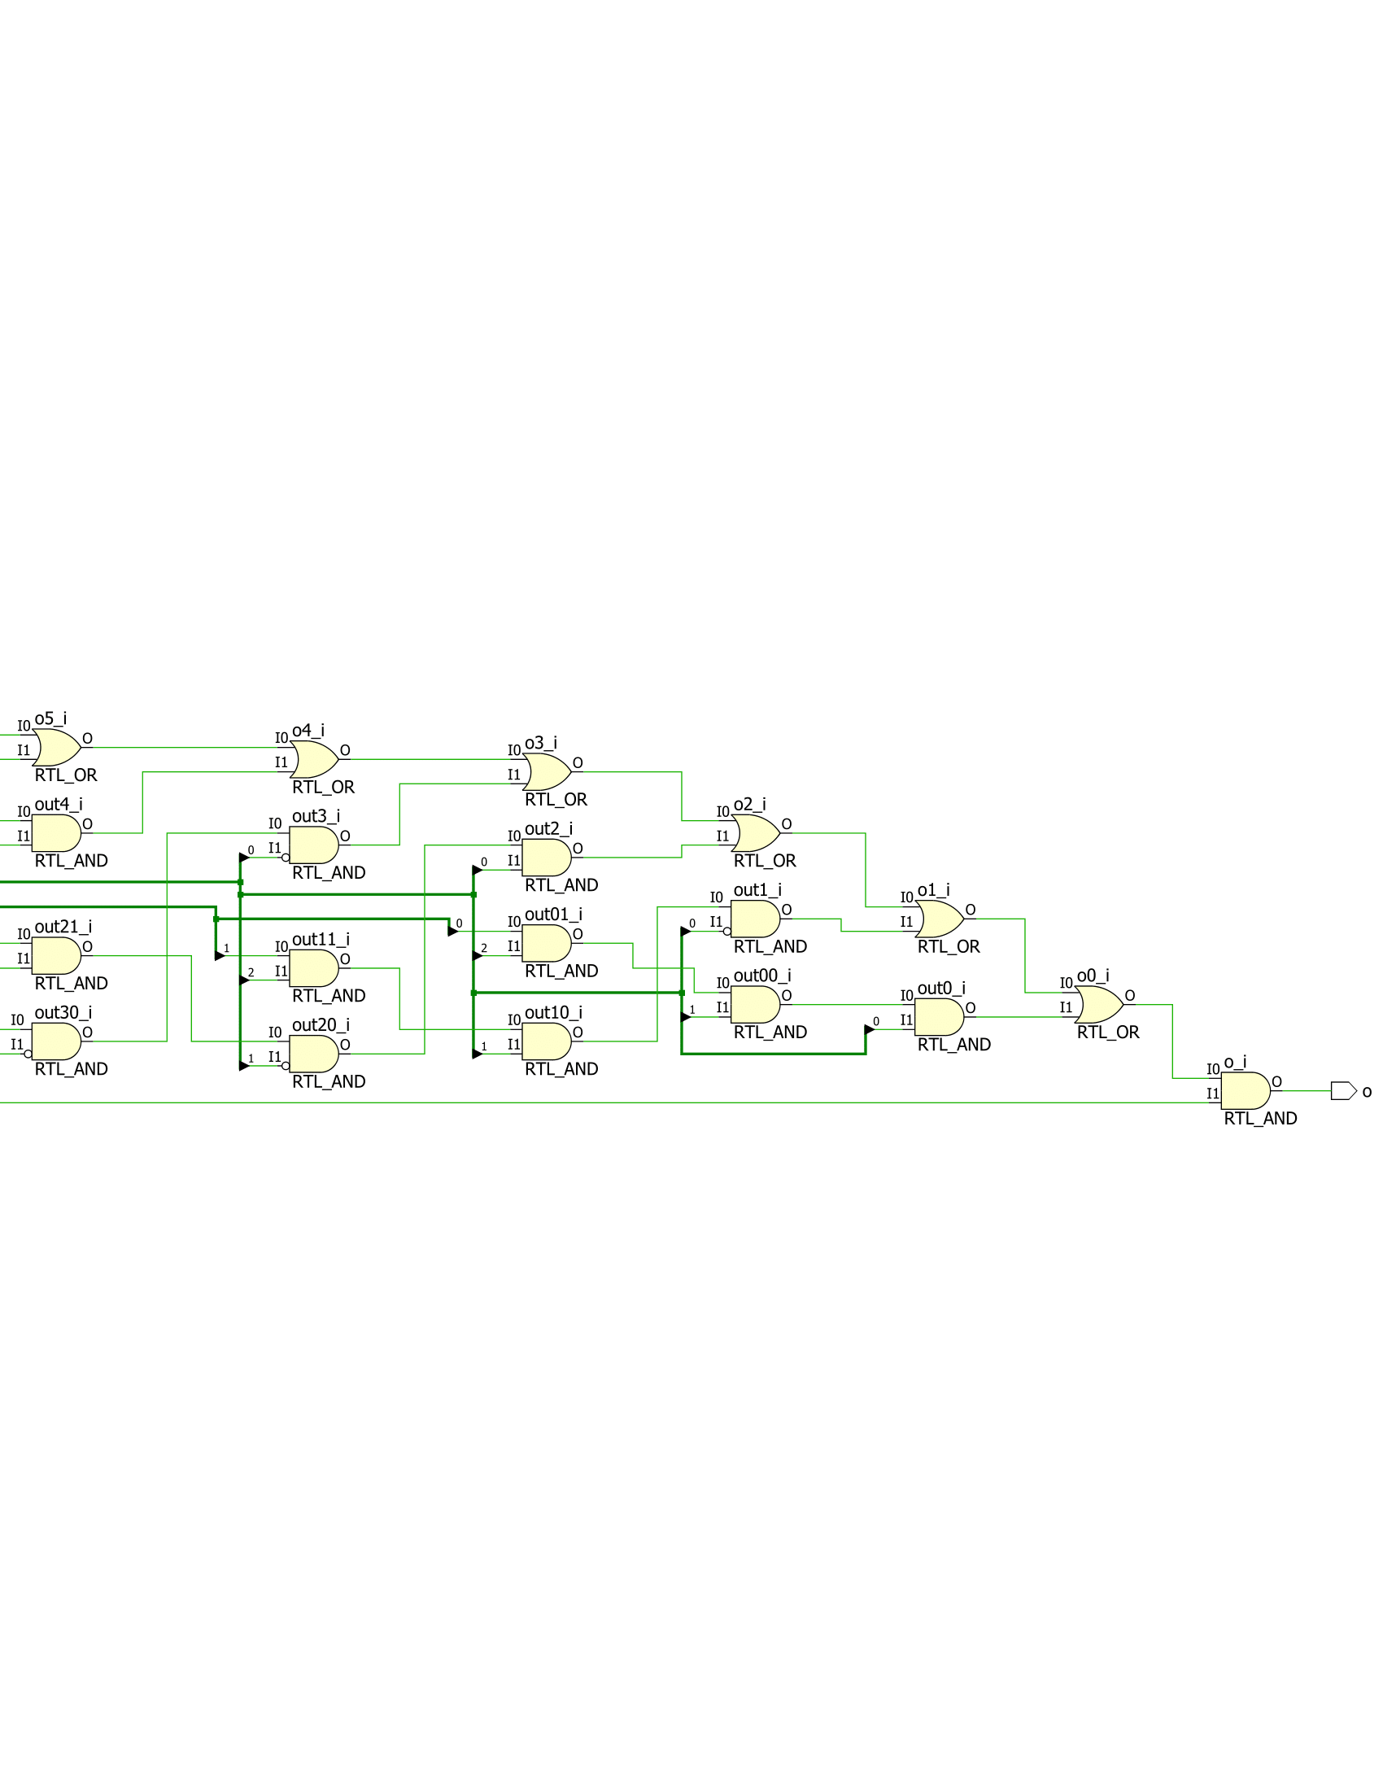

m8_1e.v Schematic Part 2

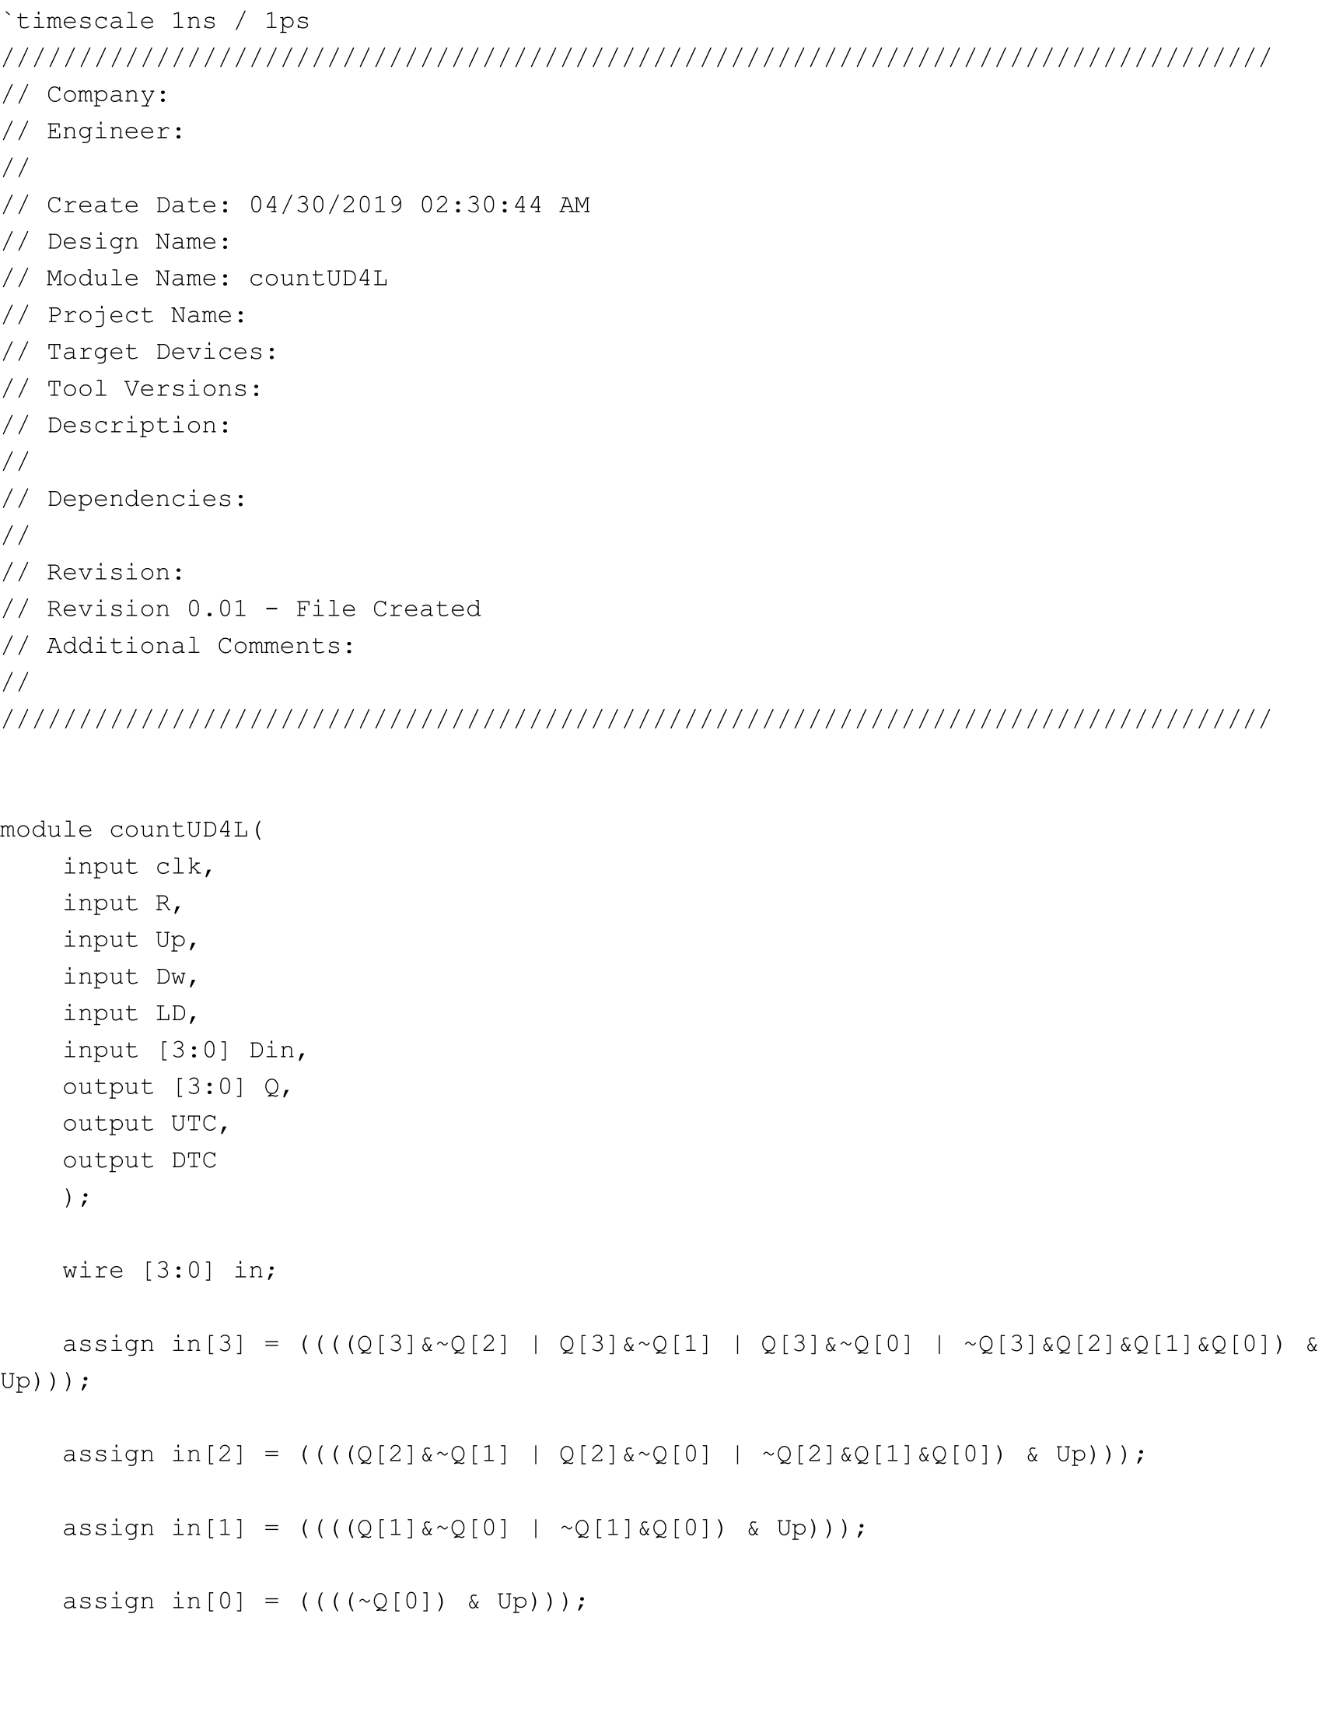

countUD4L.v Part 1

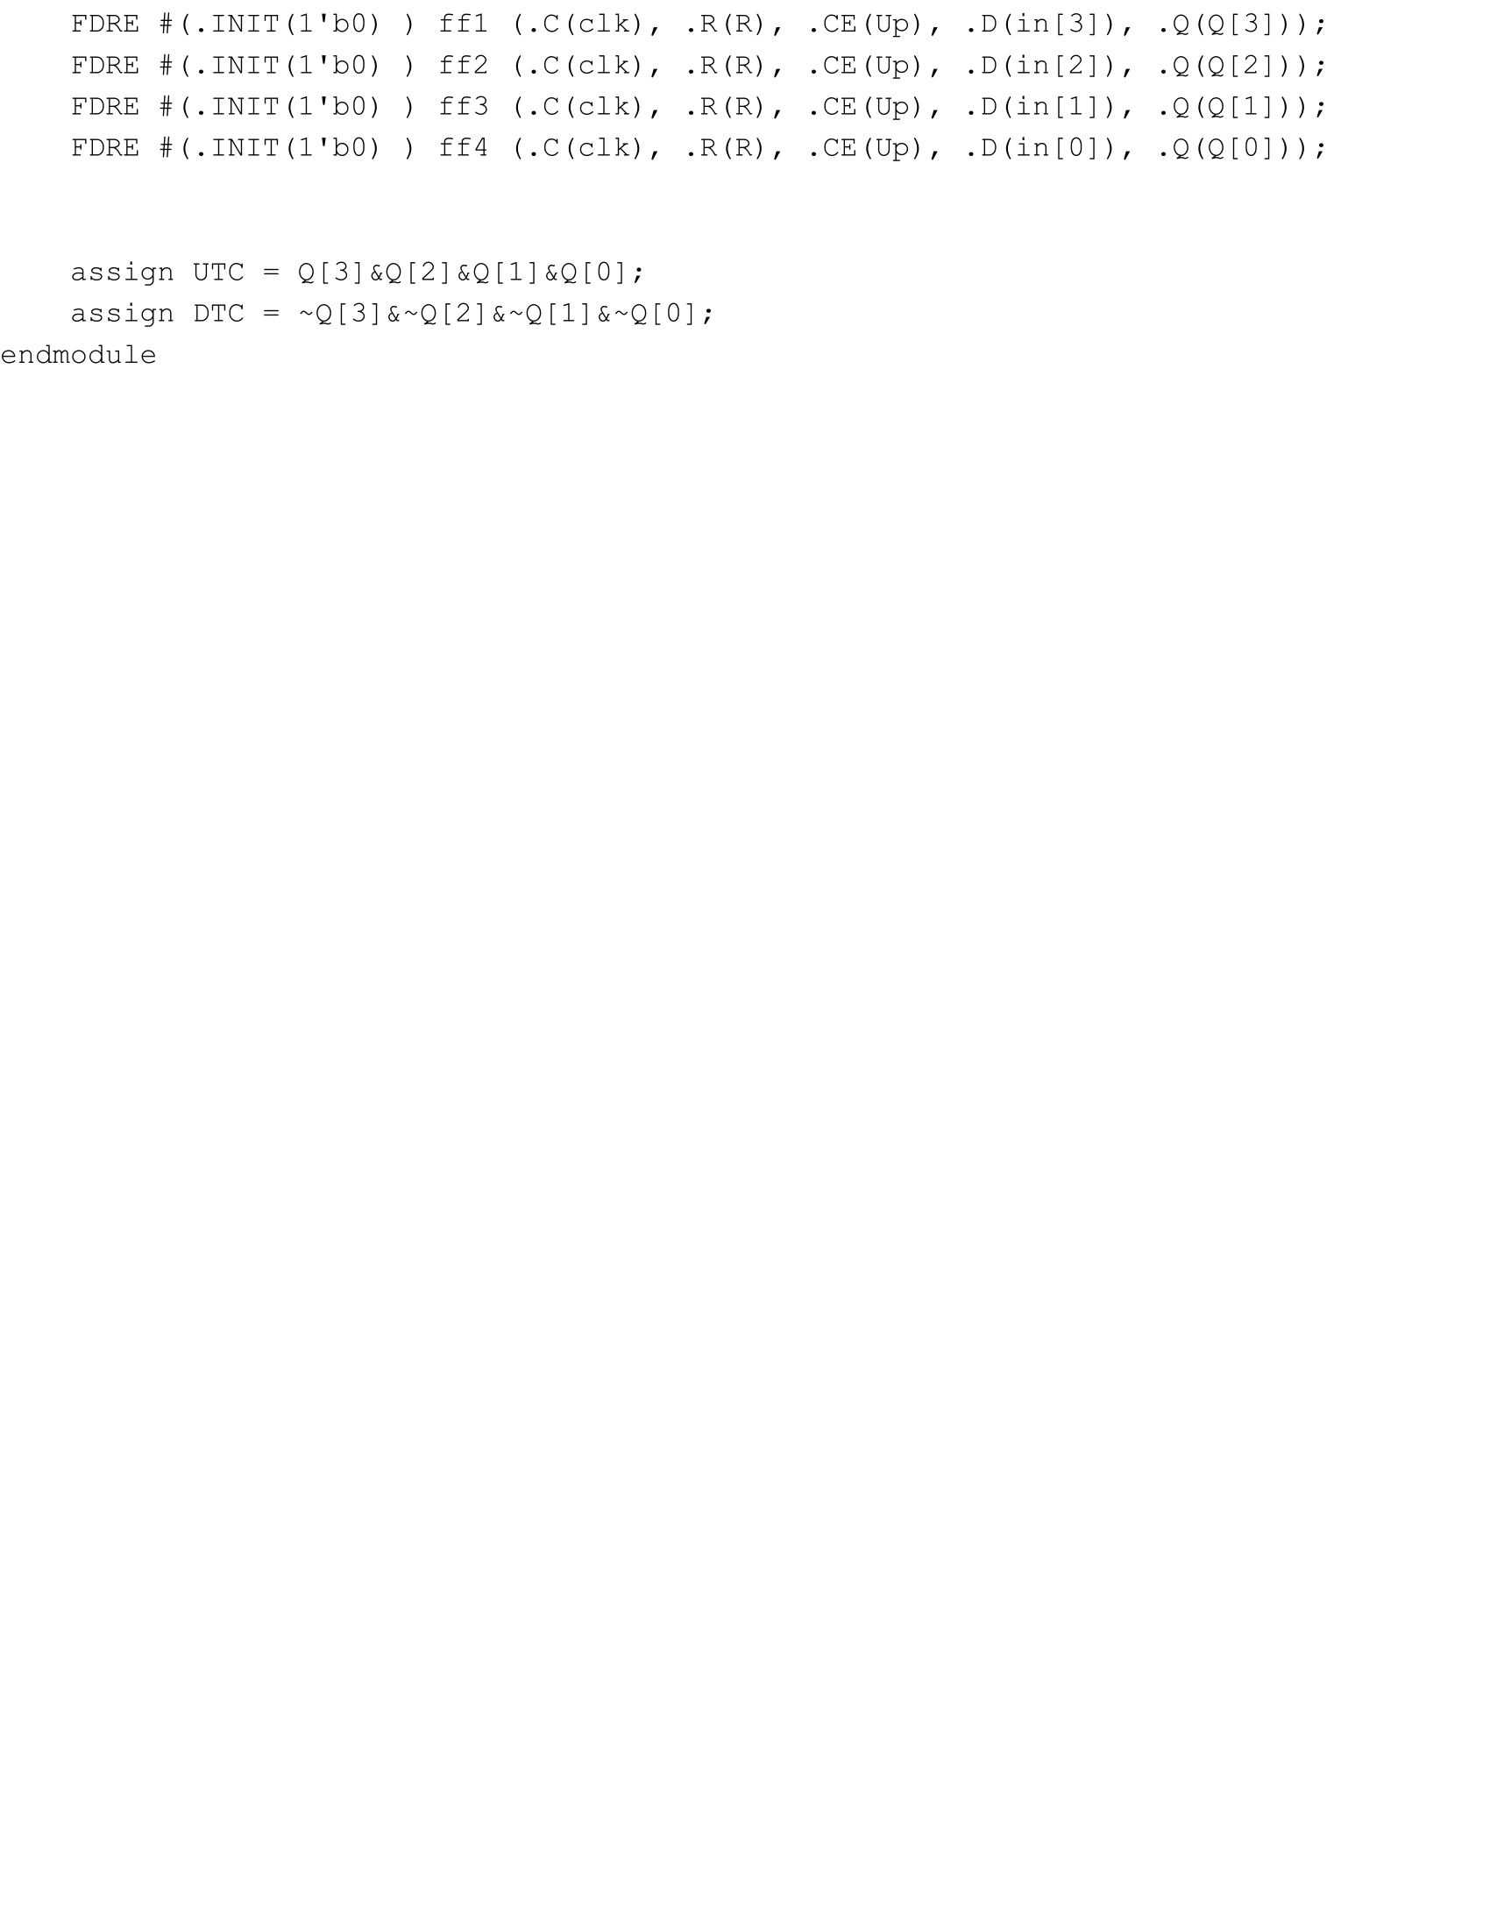

countUD4L.v Part 2

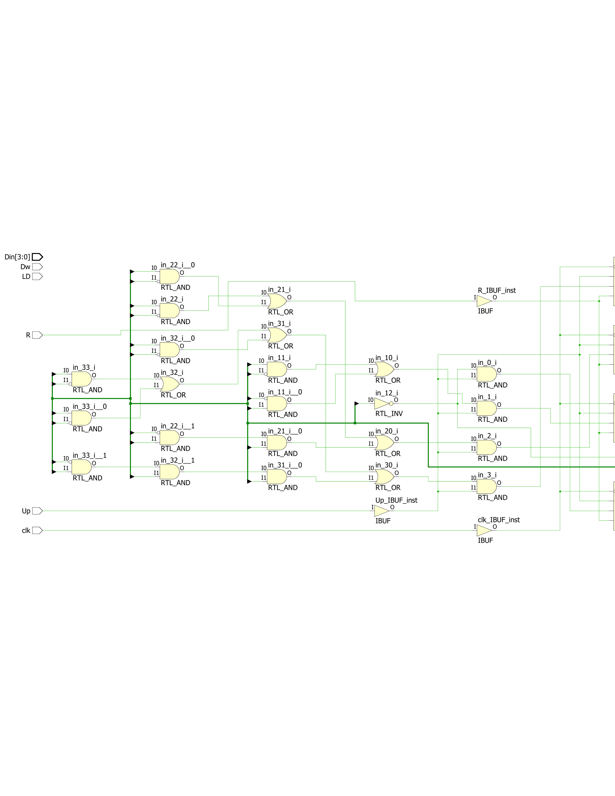

countUD4L.v Schematic Part 1

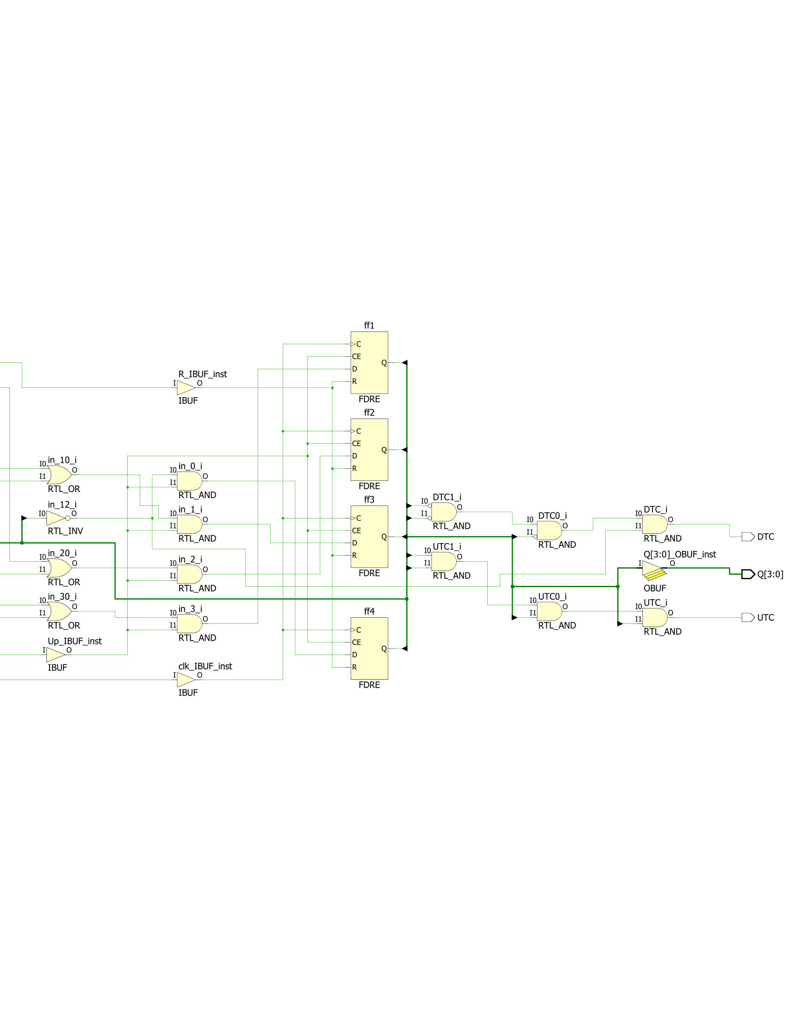

countUD4L.v Schematic Part 2

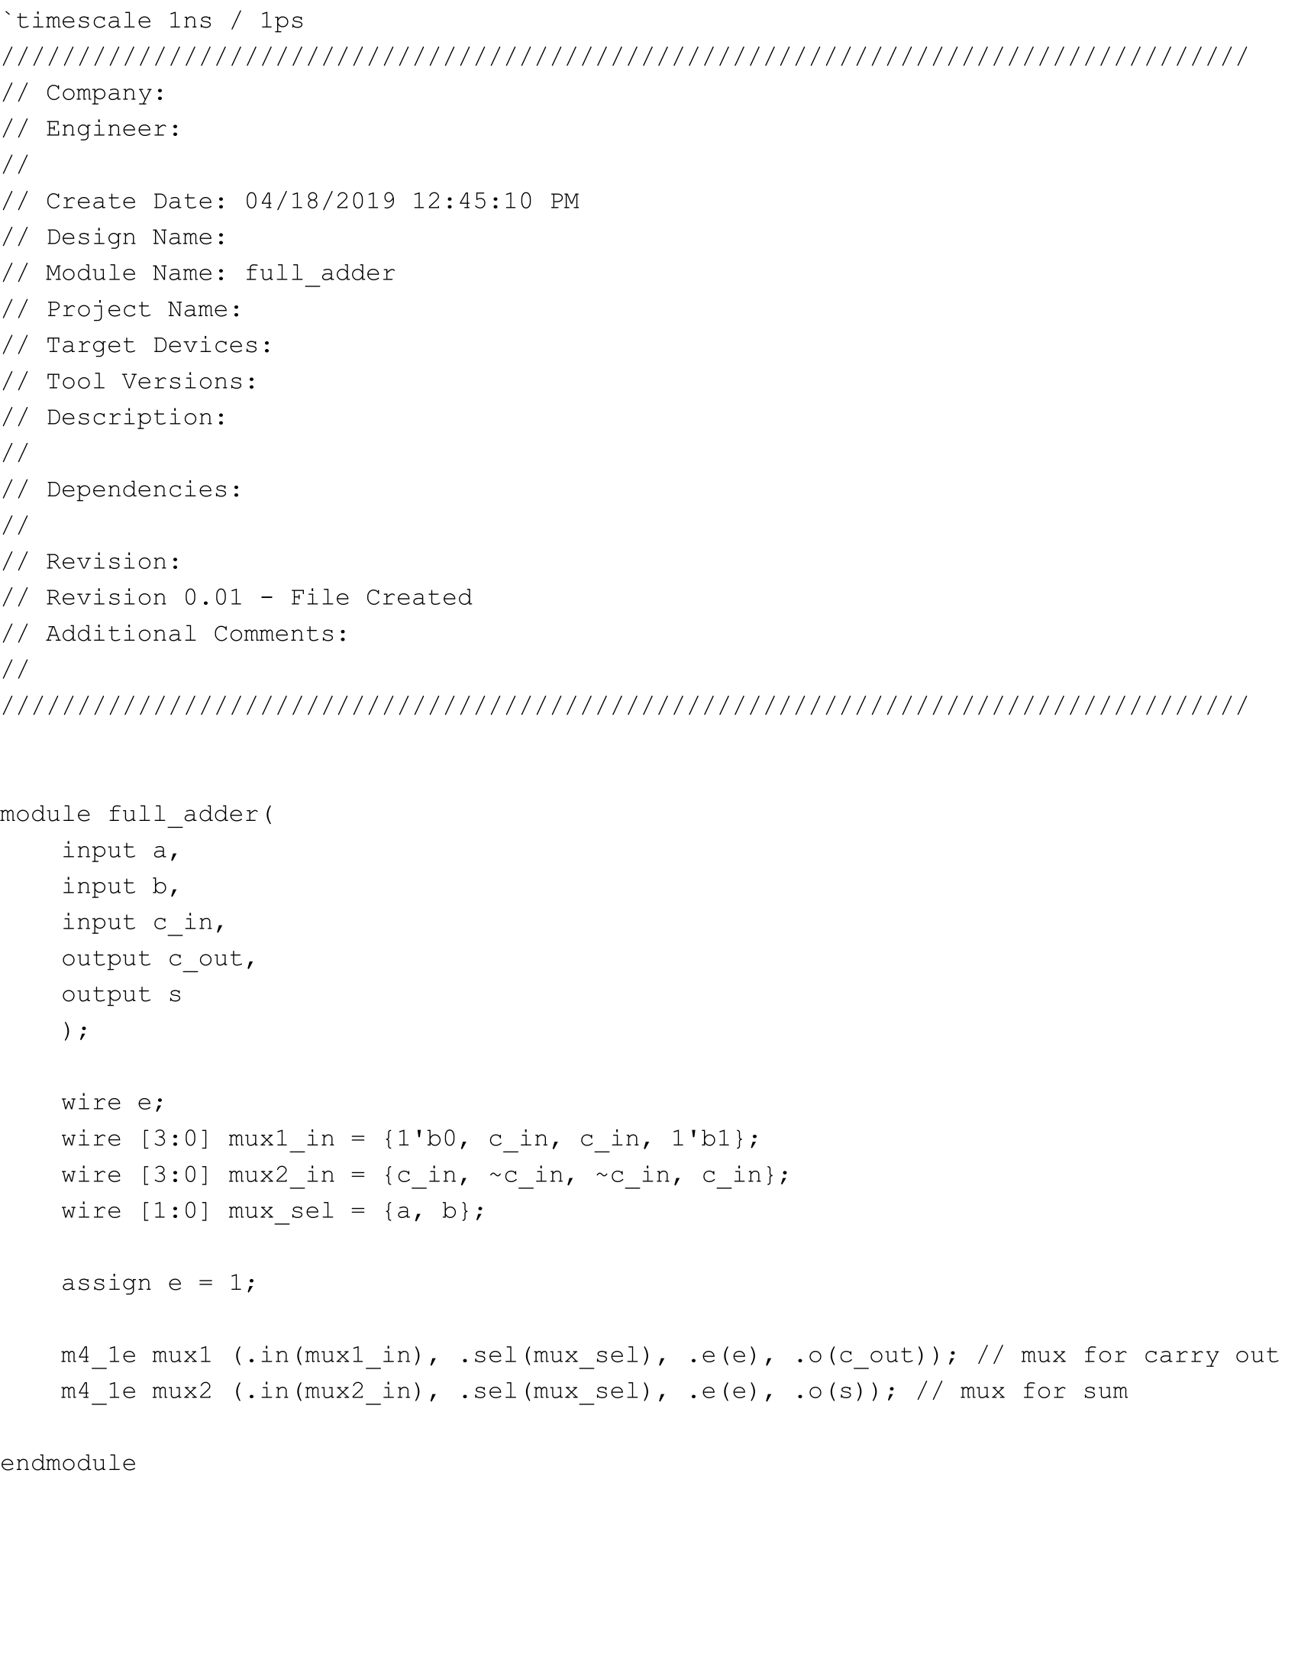

full_adder.v

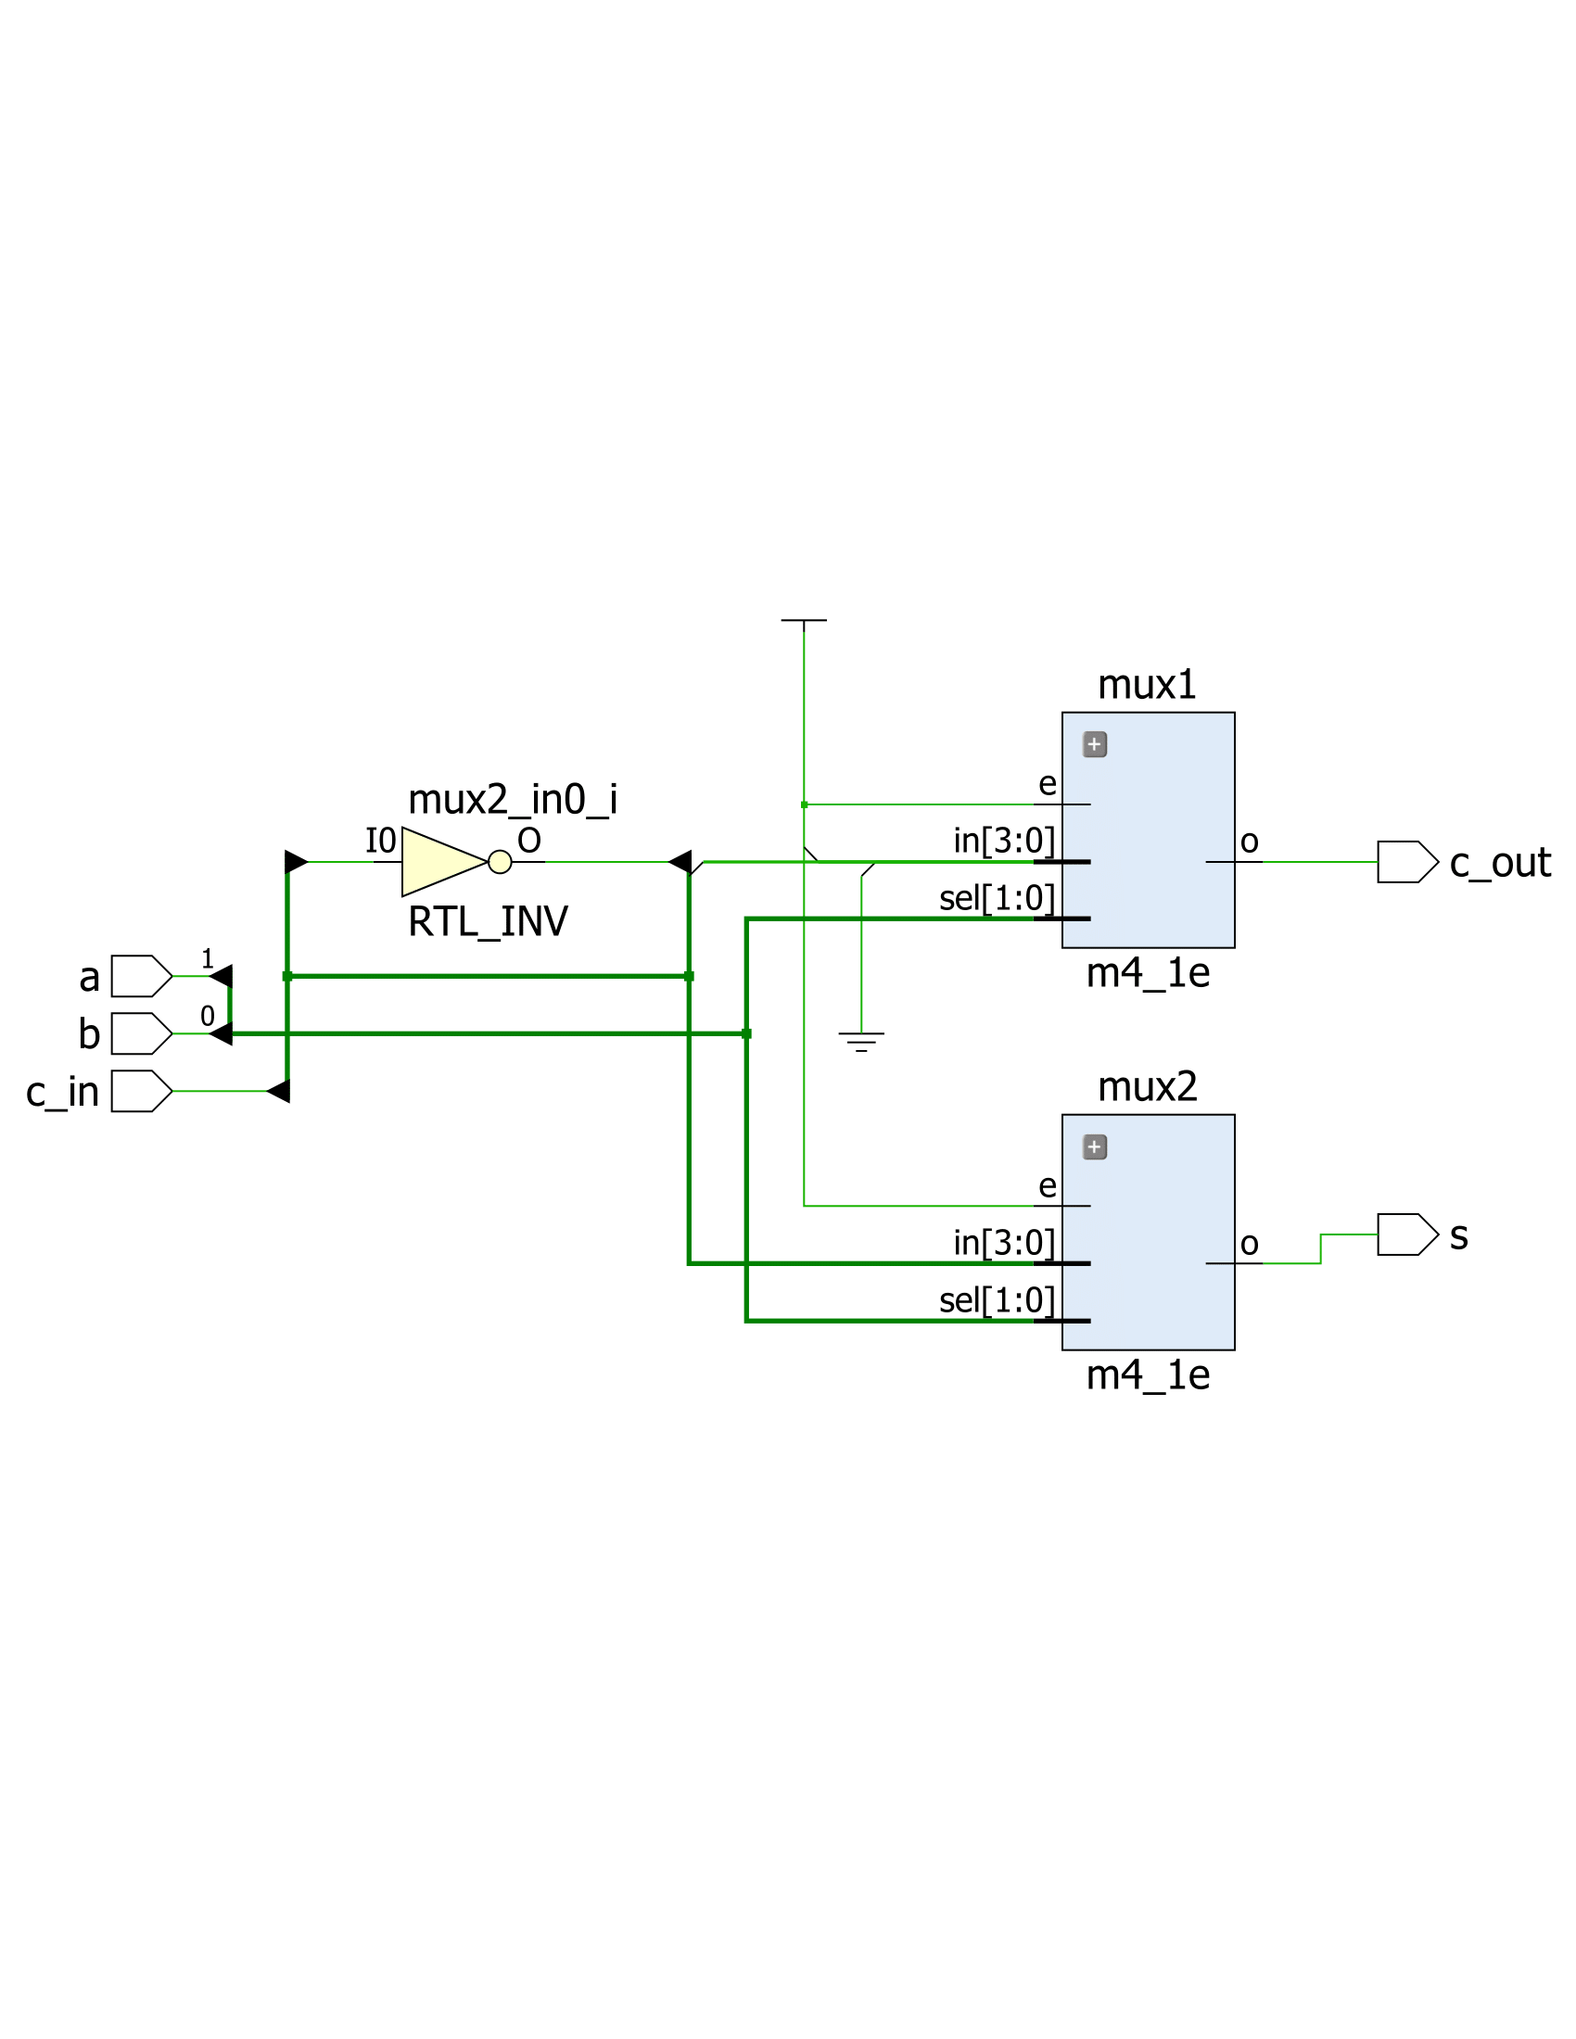

full_adder.v Schematic

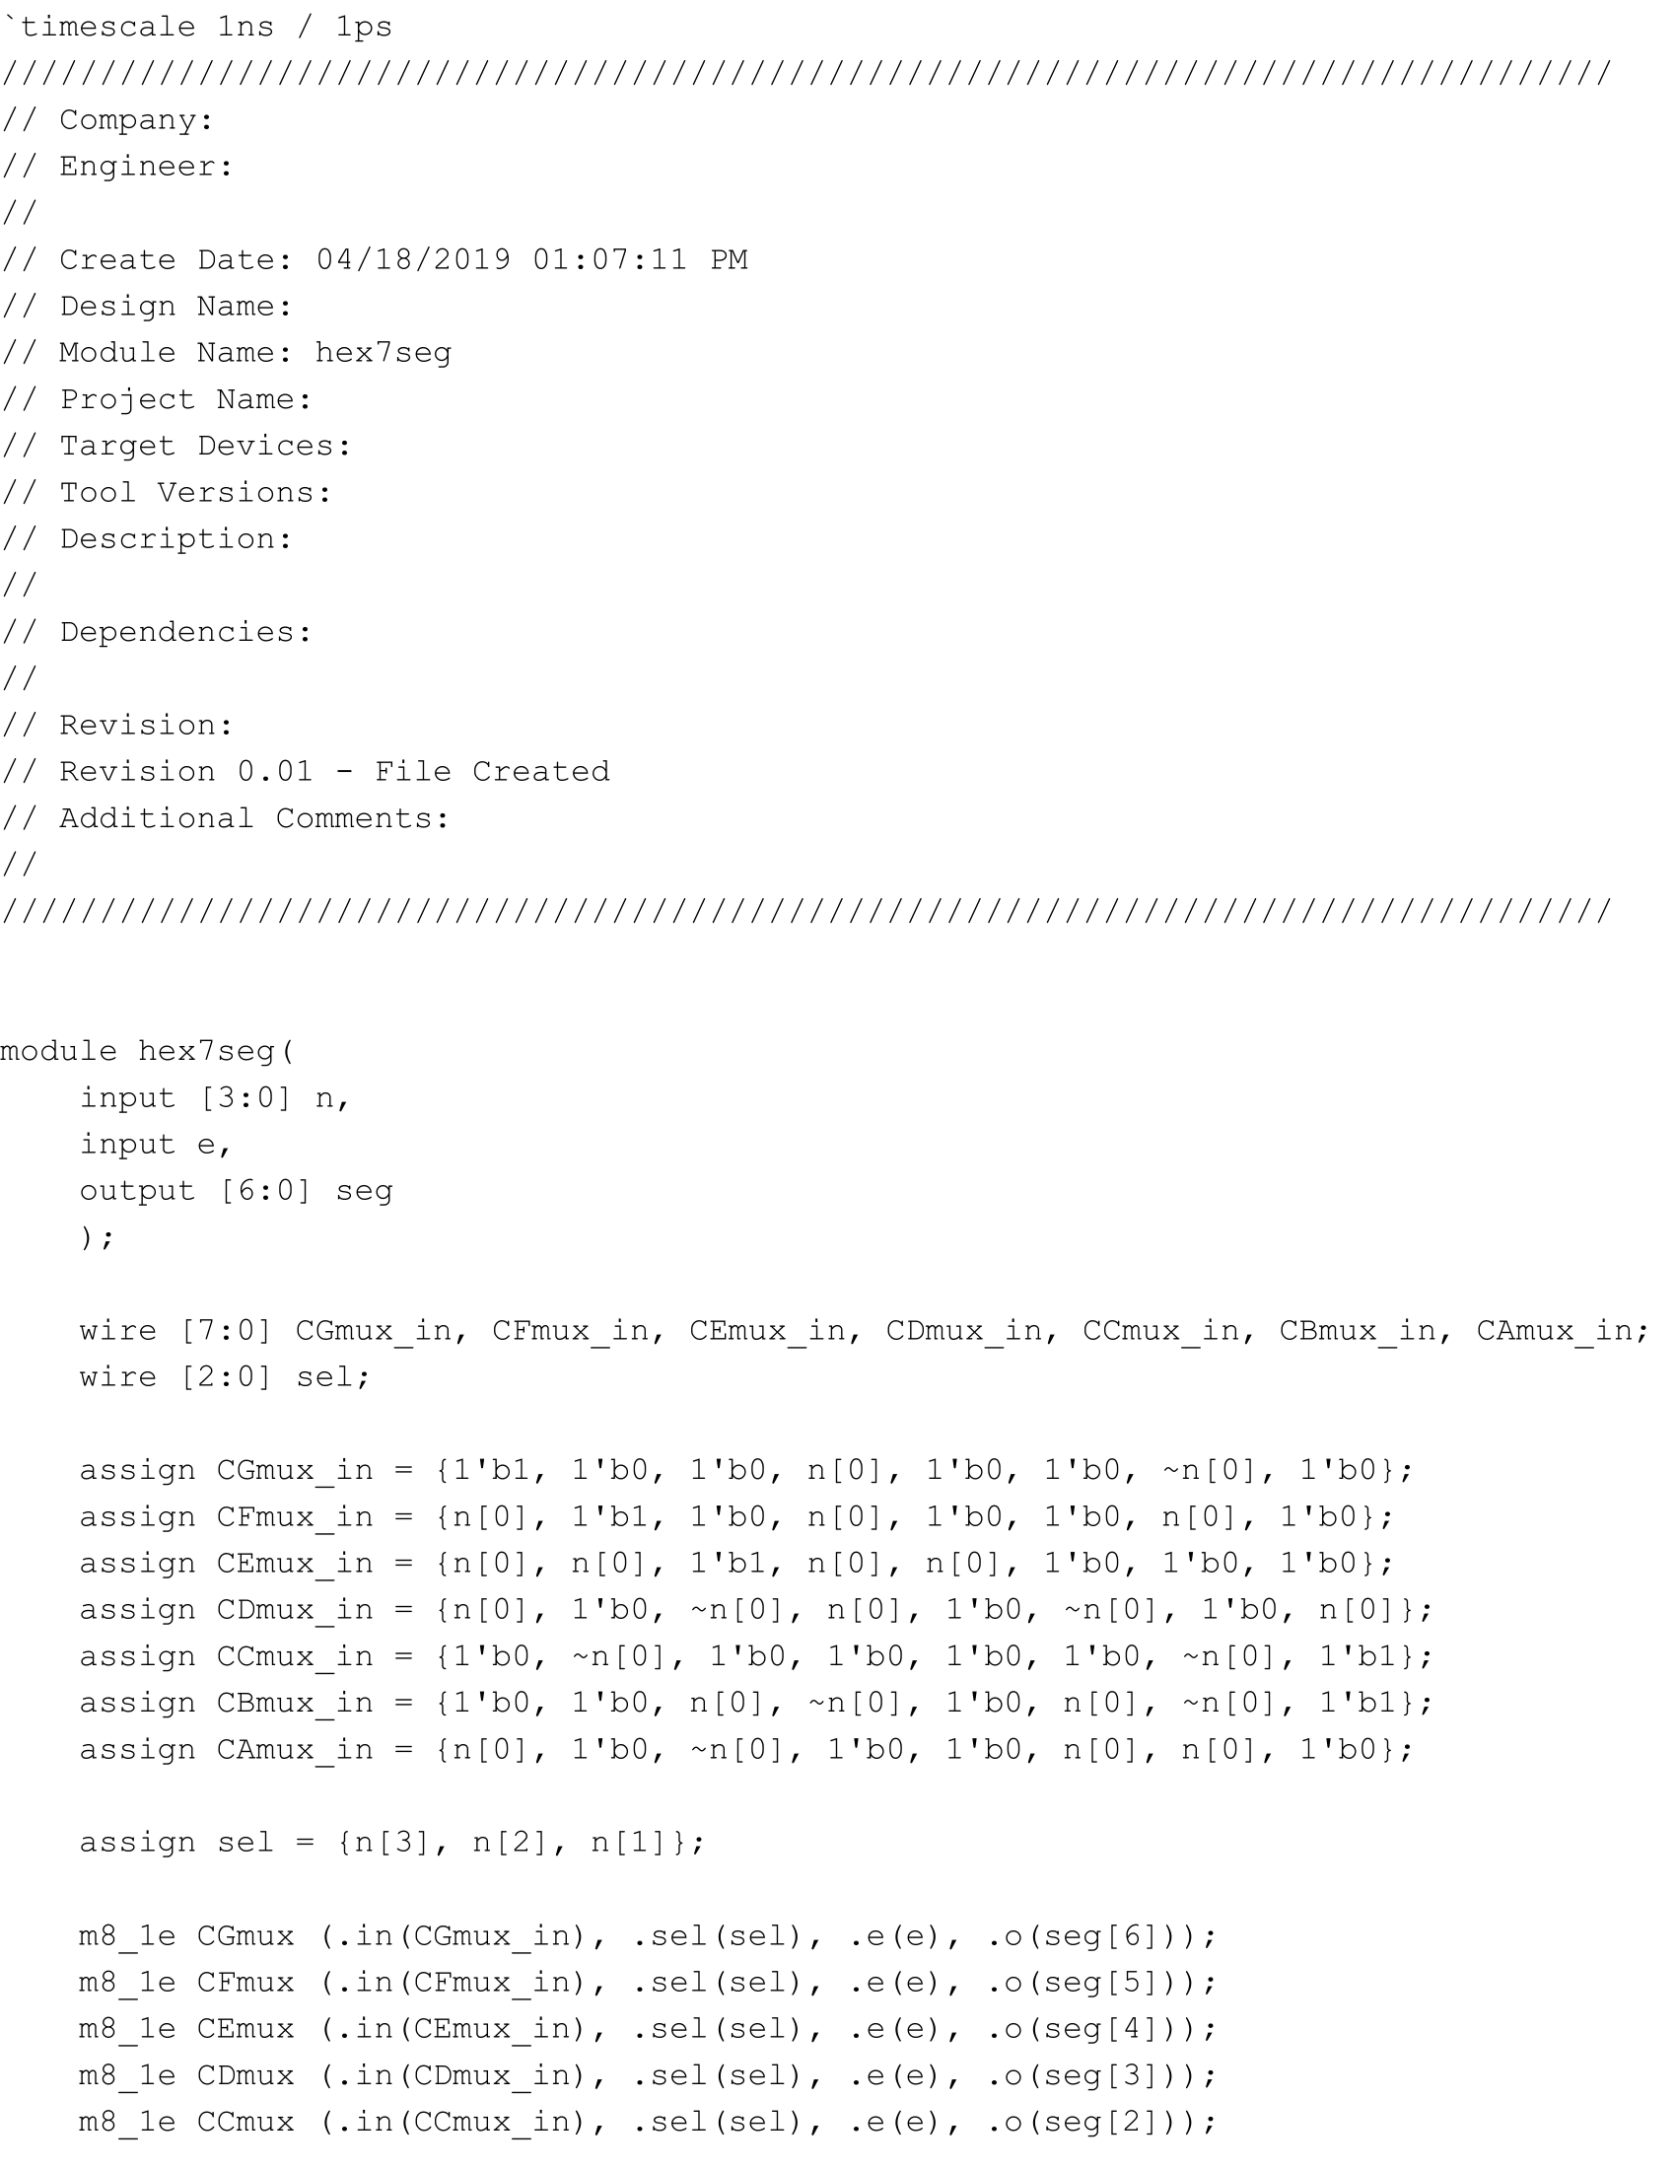

hex7seg.v Part 1

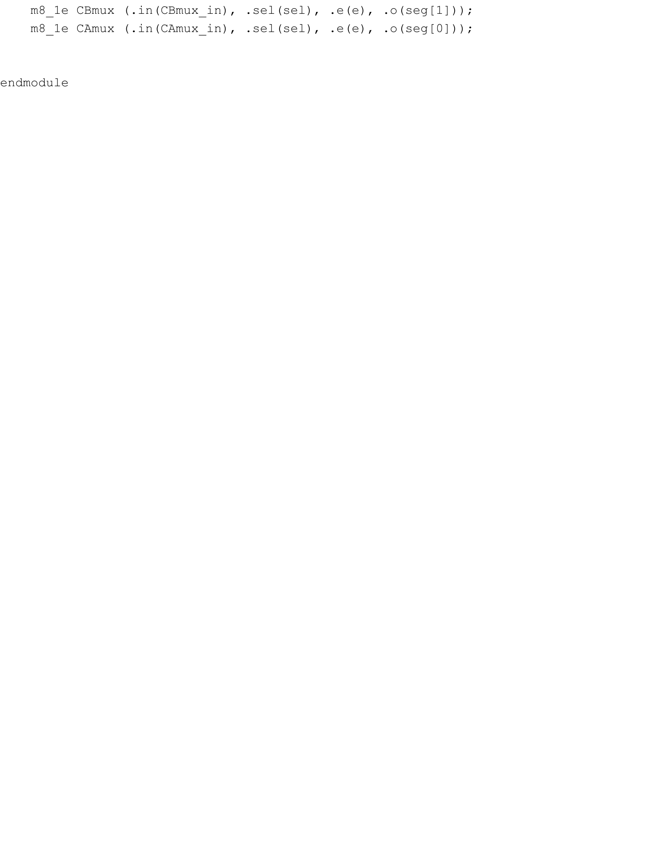

hex7seg.v Part 2

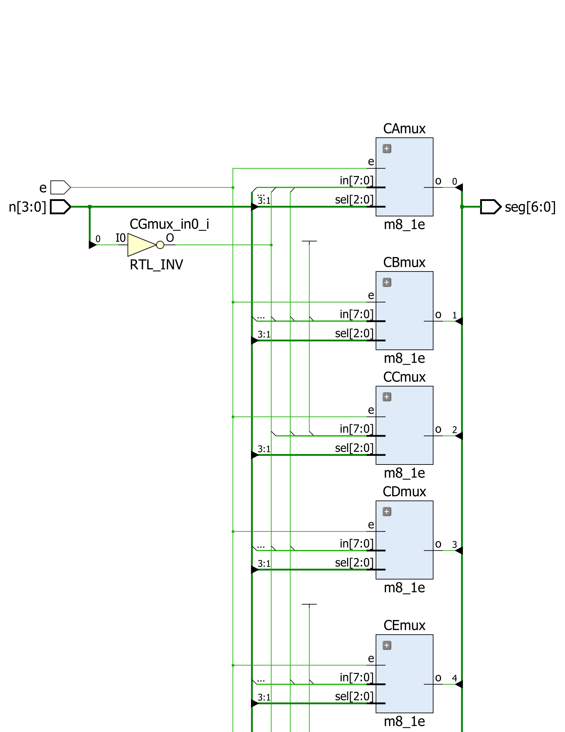

hex7seg.v Schematic Part 1

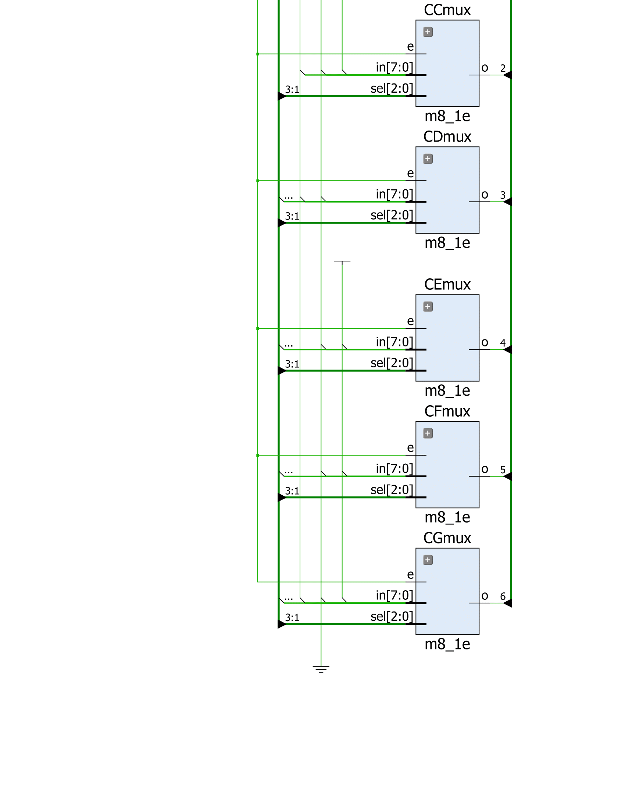

hex7seg.v Schematic Part 2

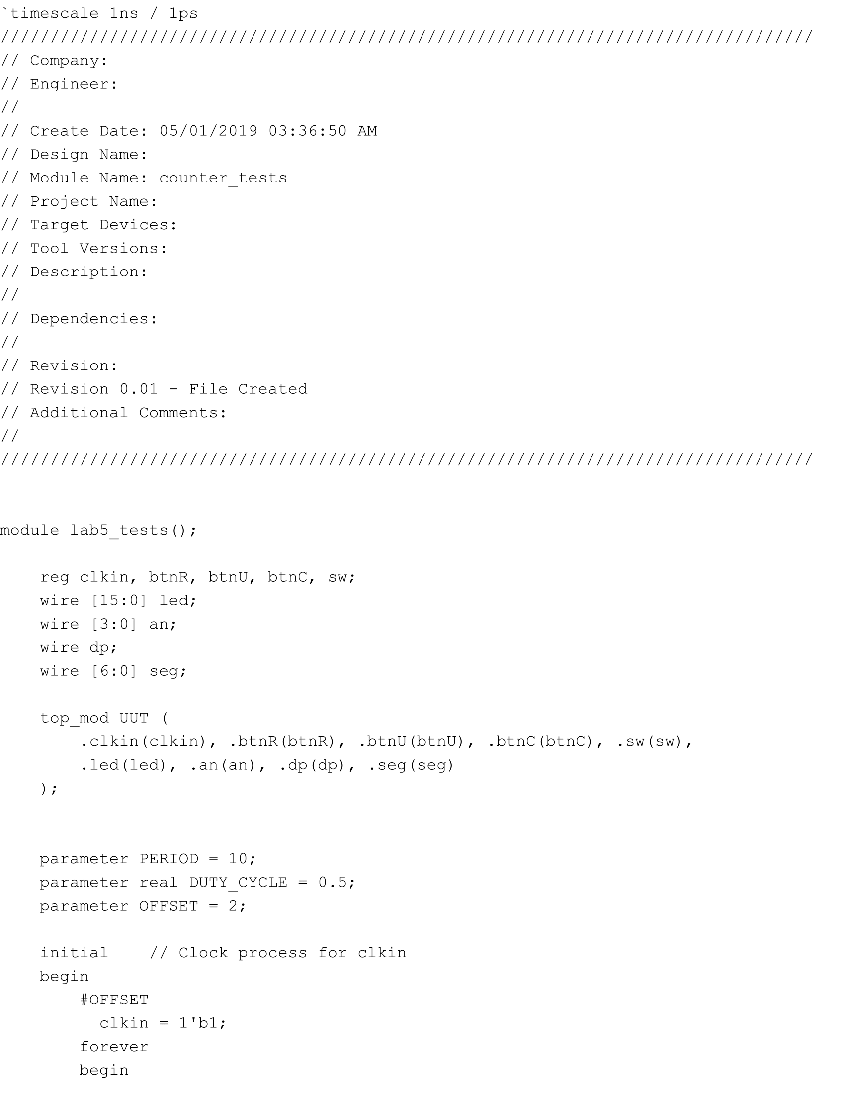

lab5_tests.v Part 1

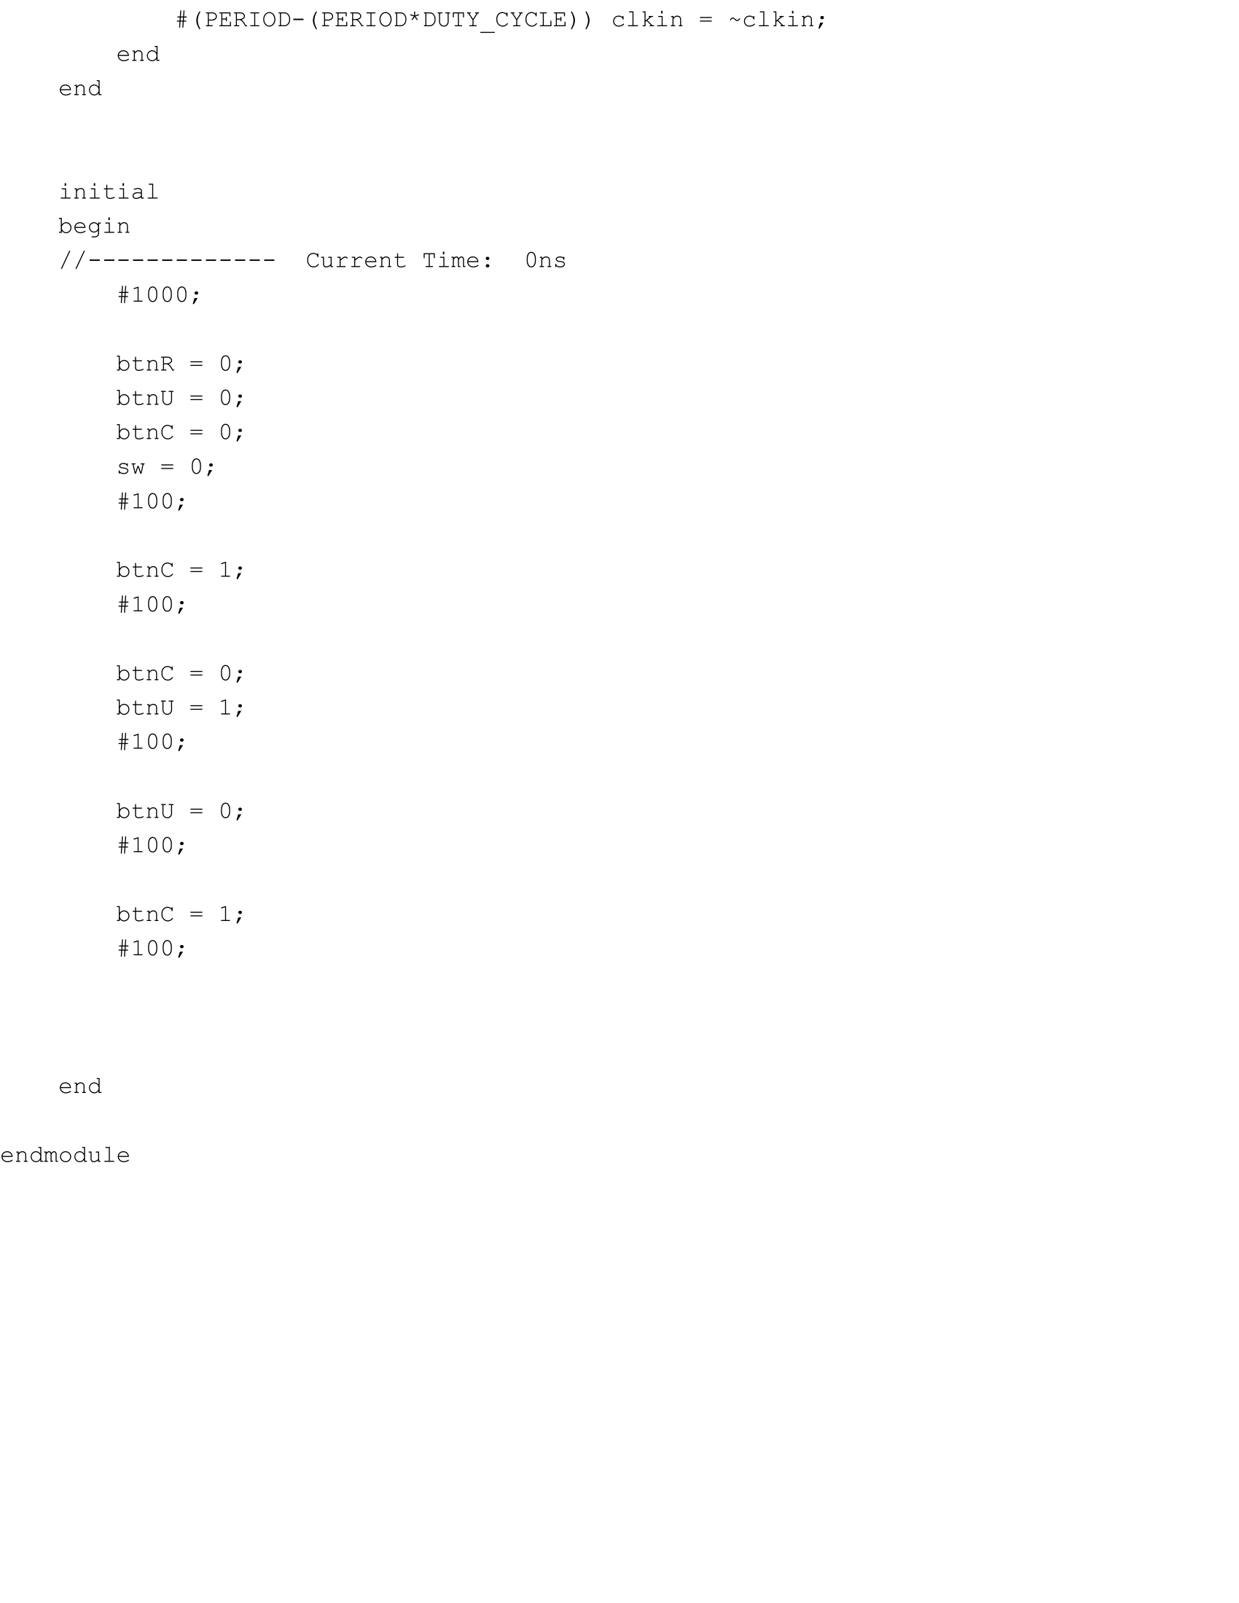

lab5_tests.v Part 2

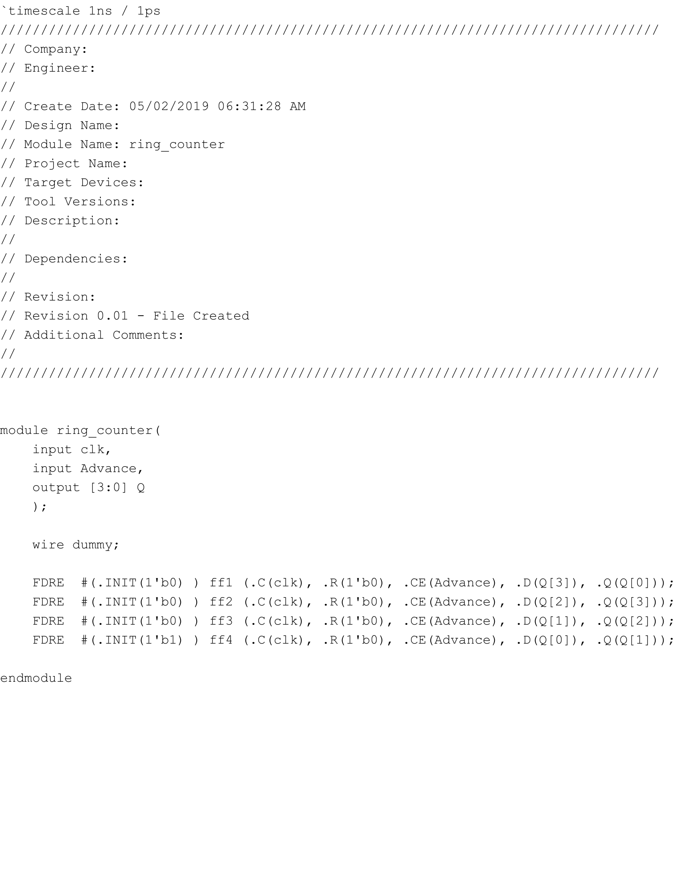

ring_counter.v

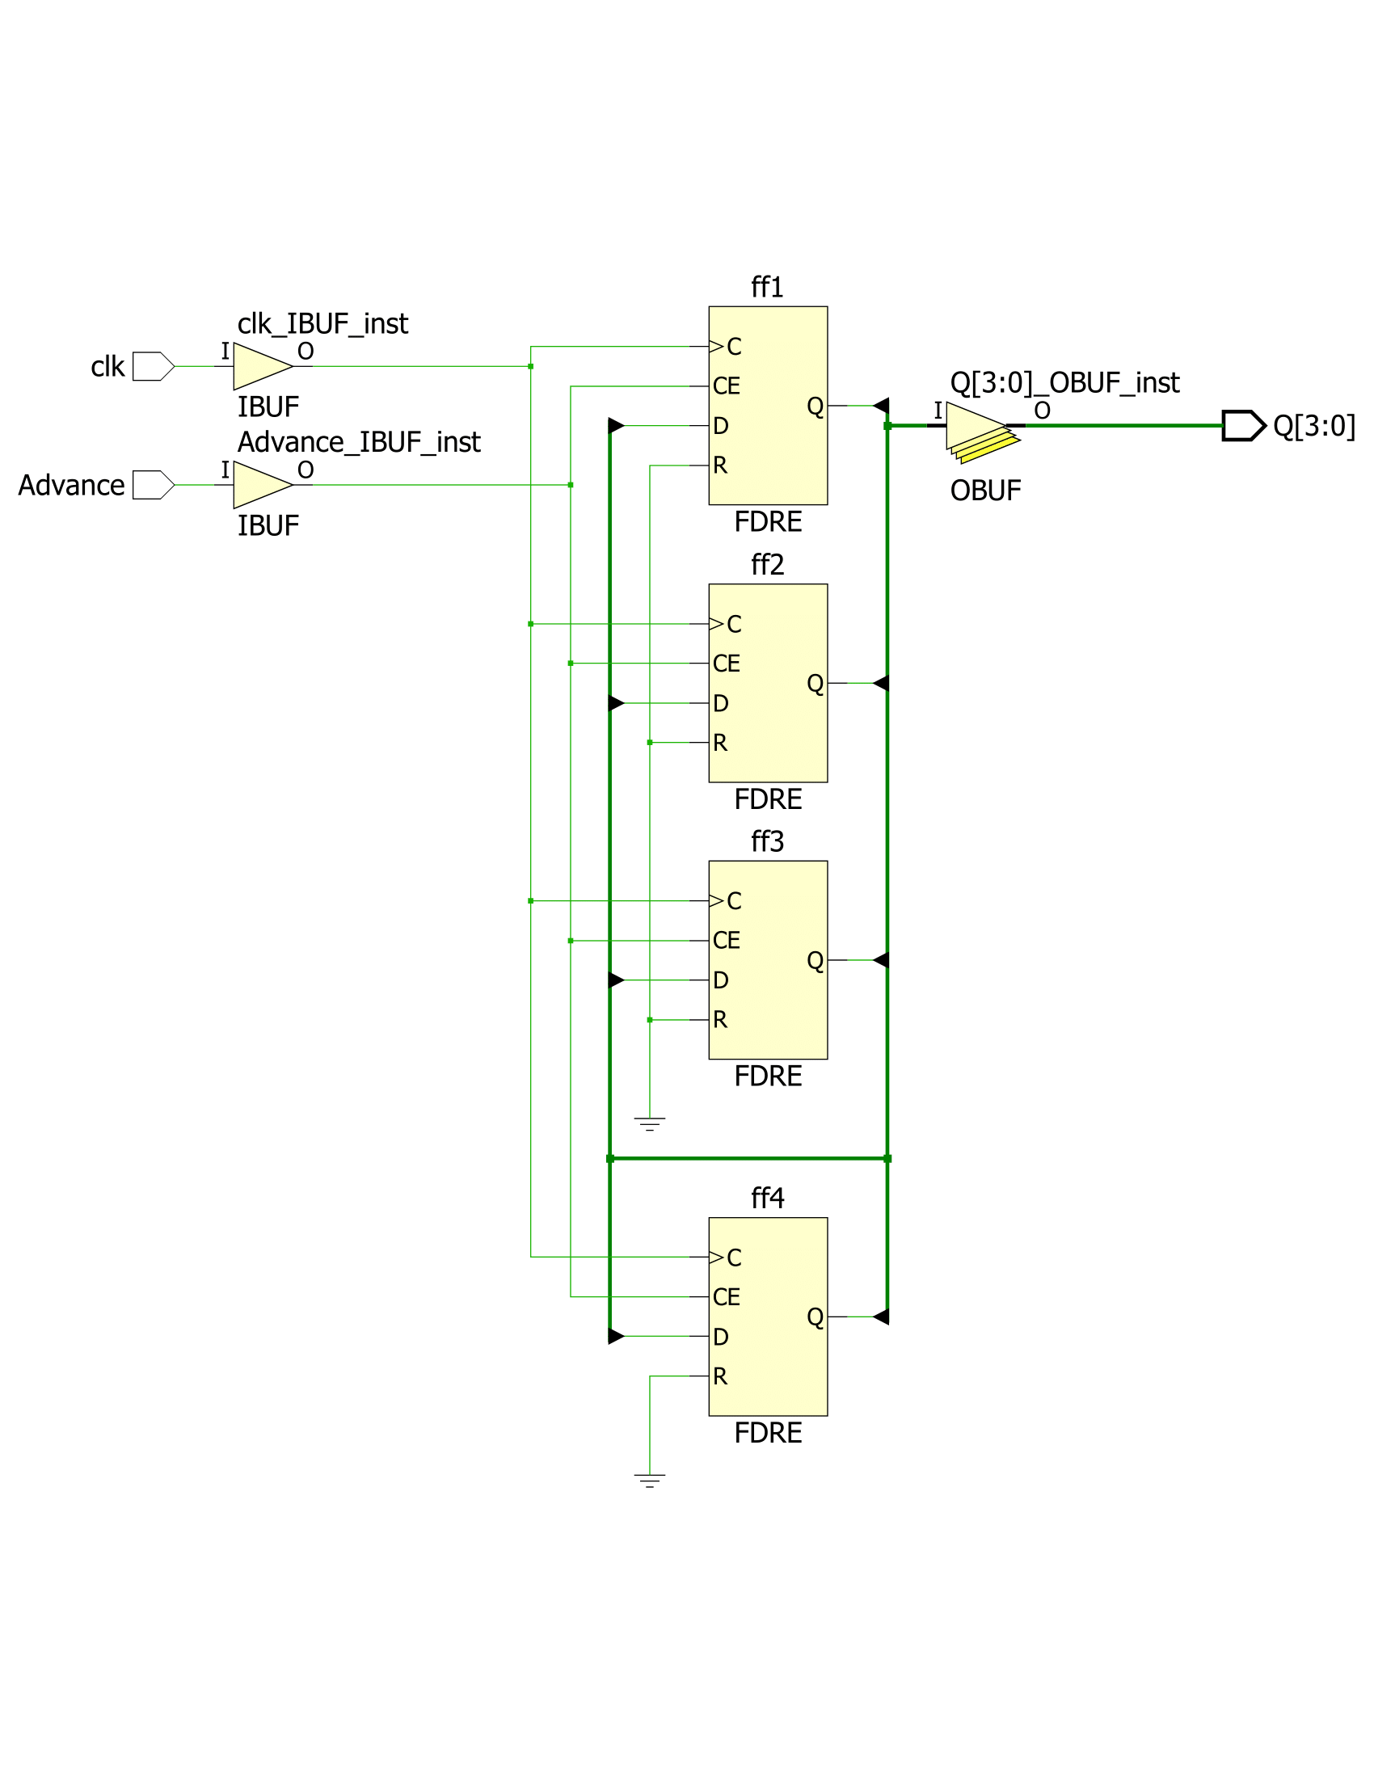

ring_counter.v Schematic

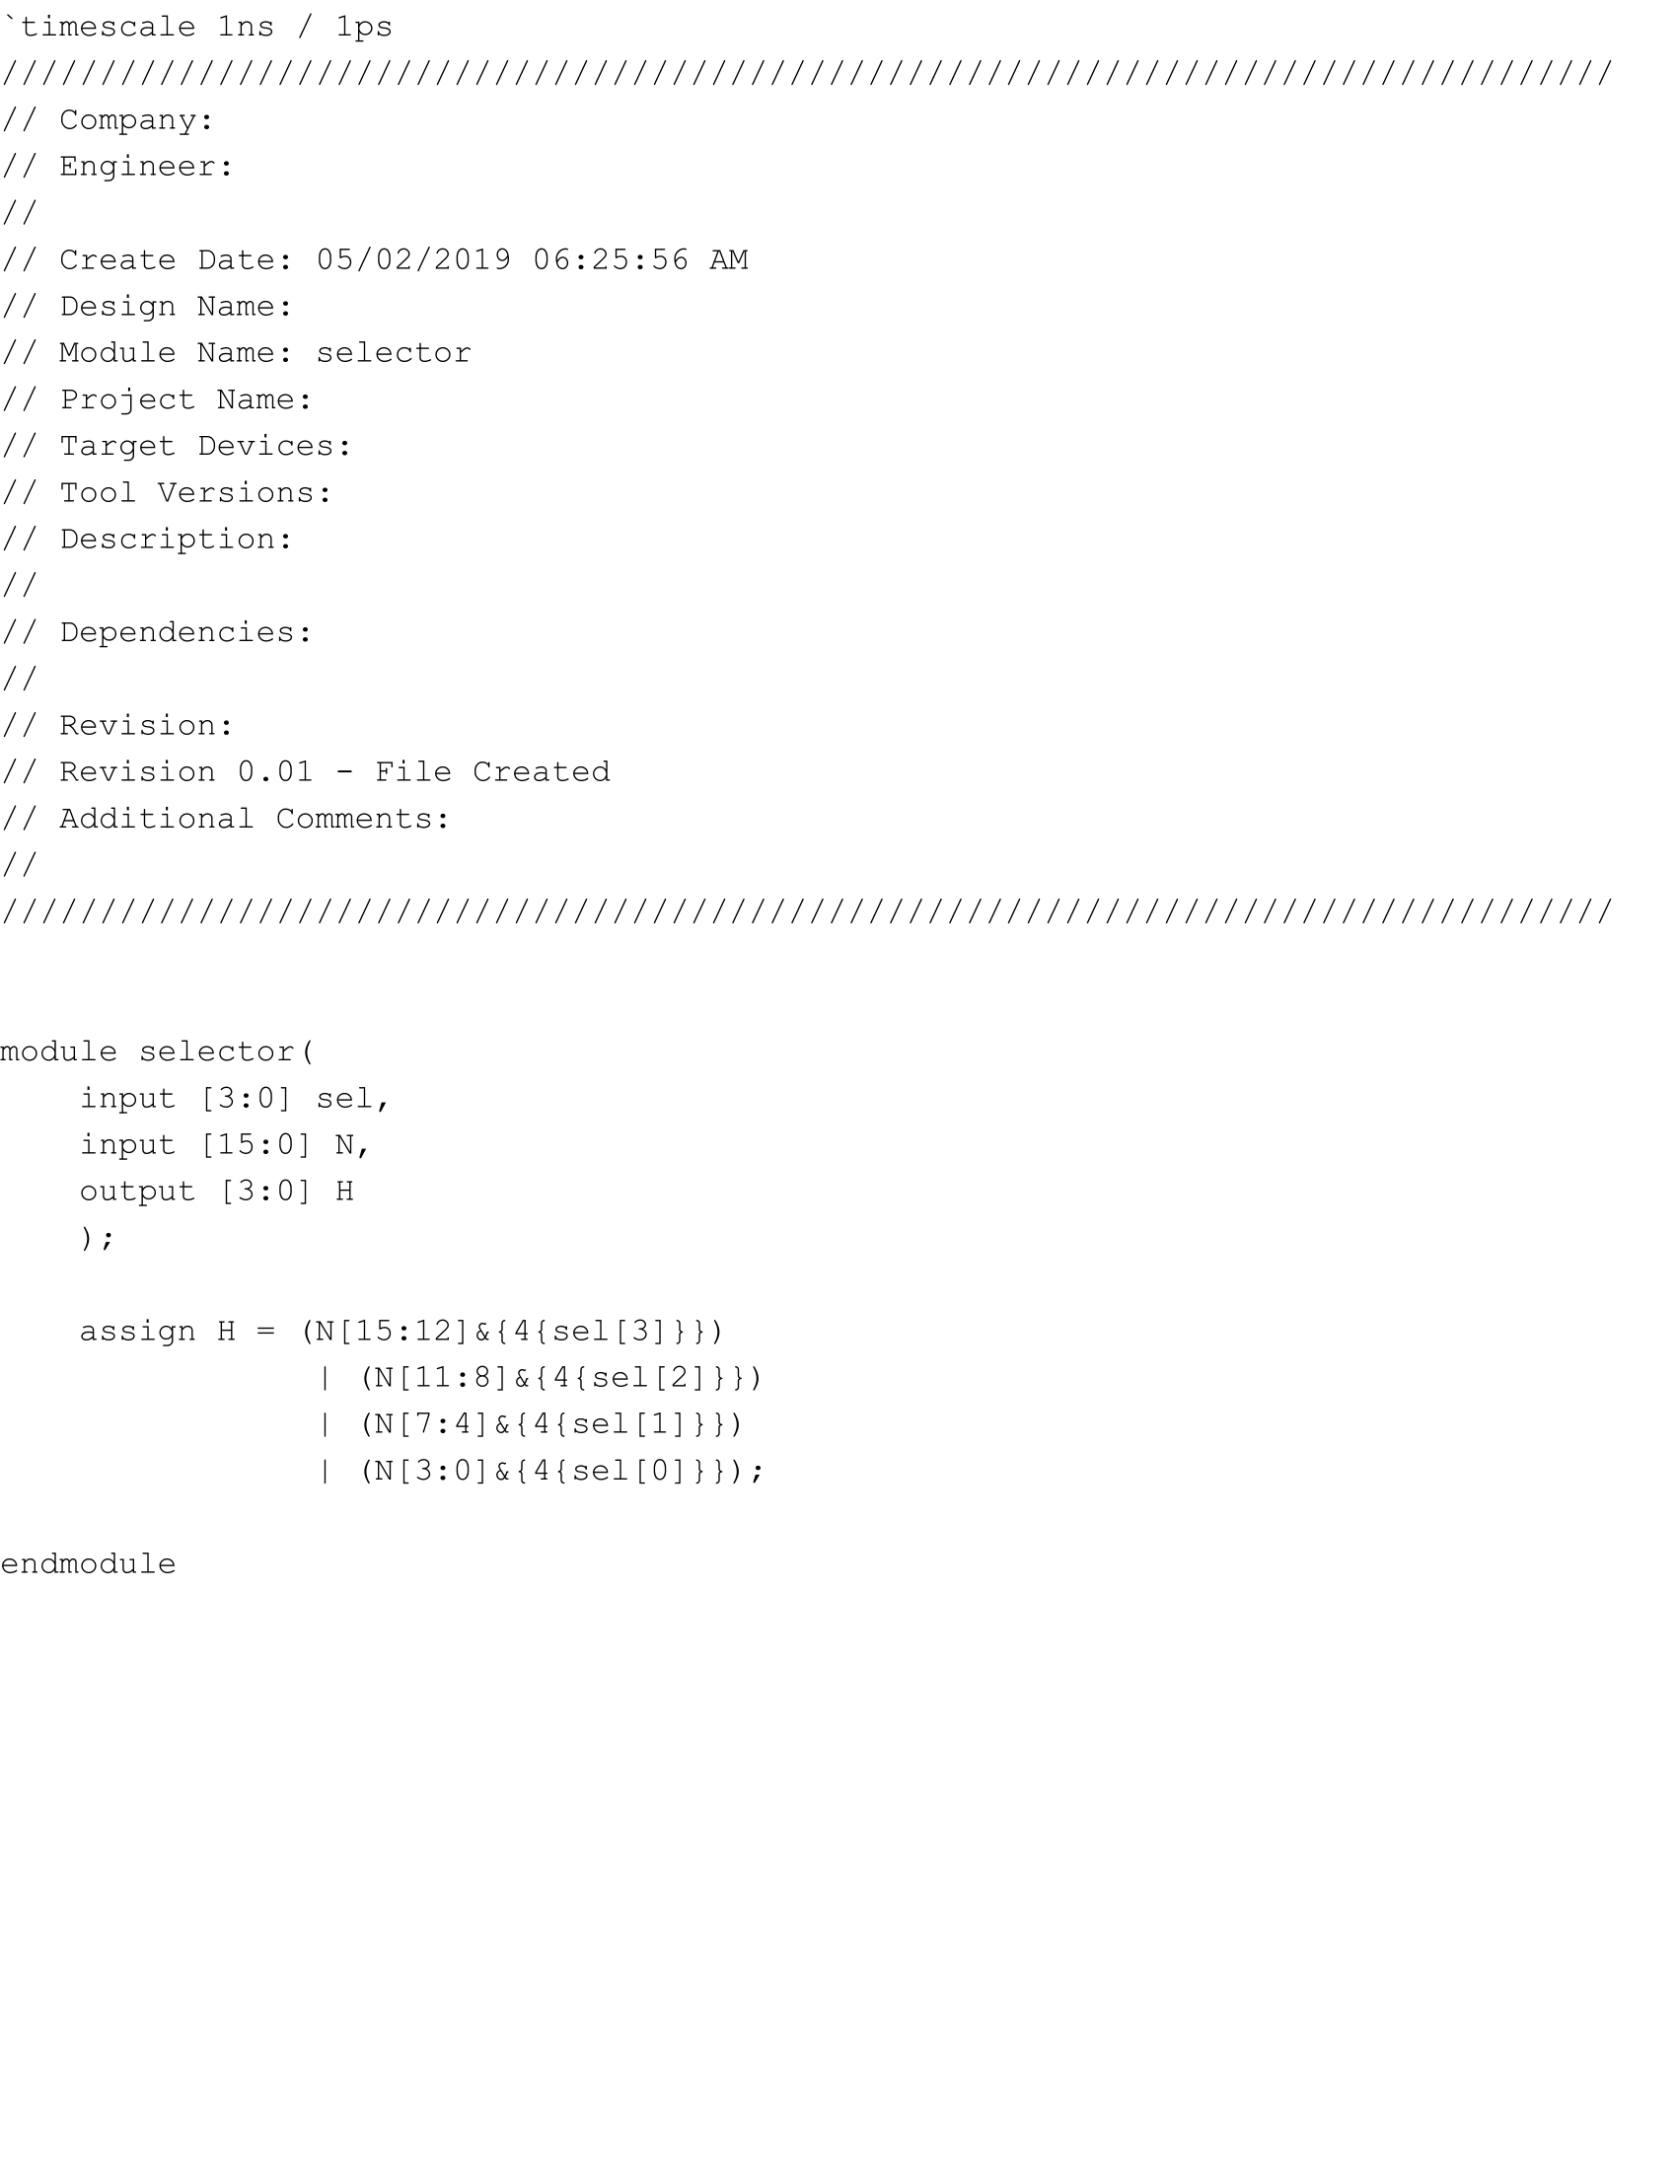

selector.v

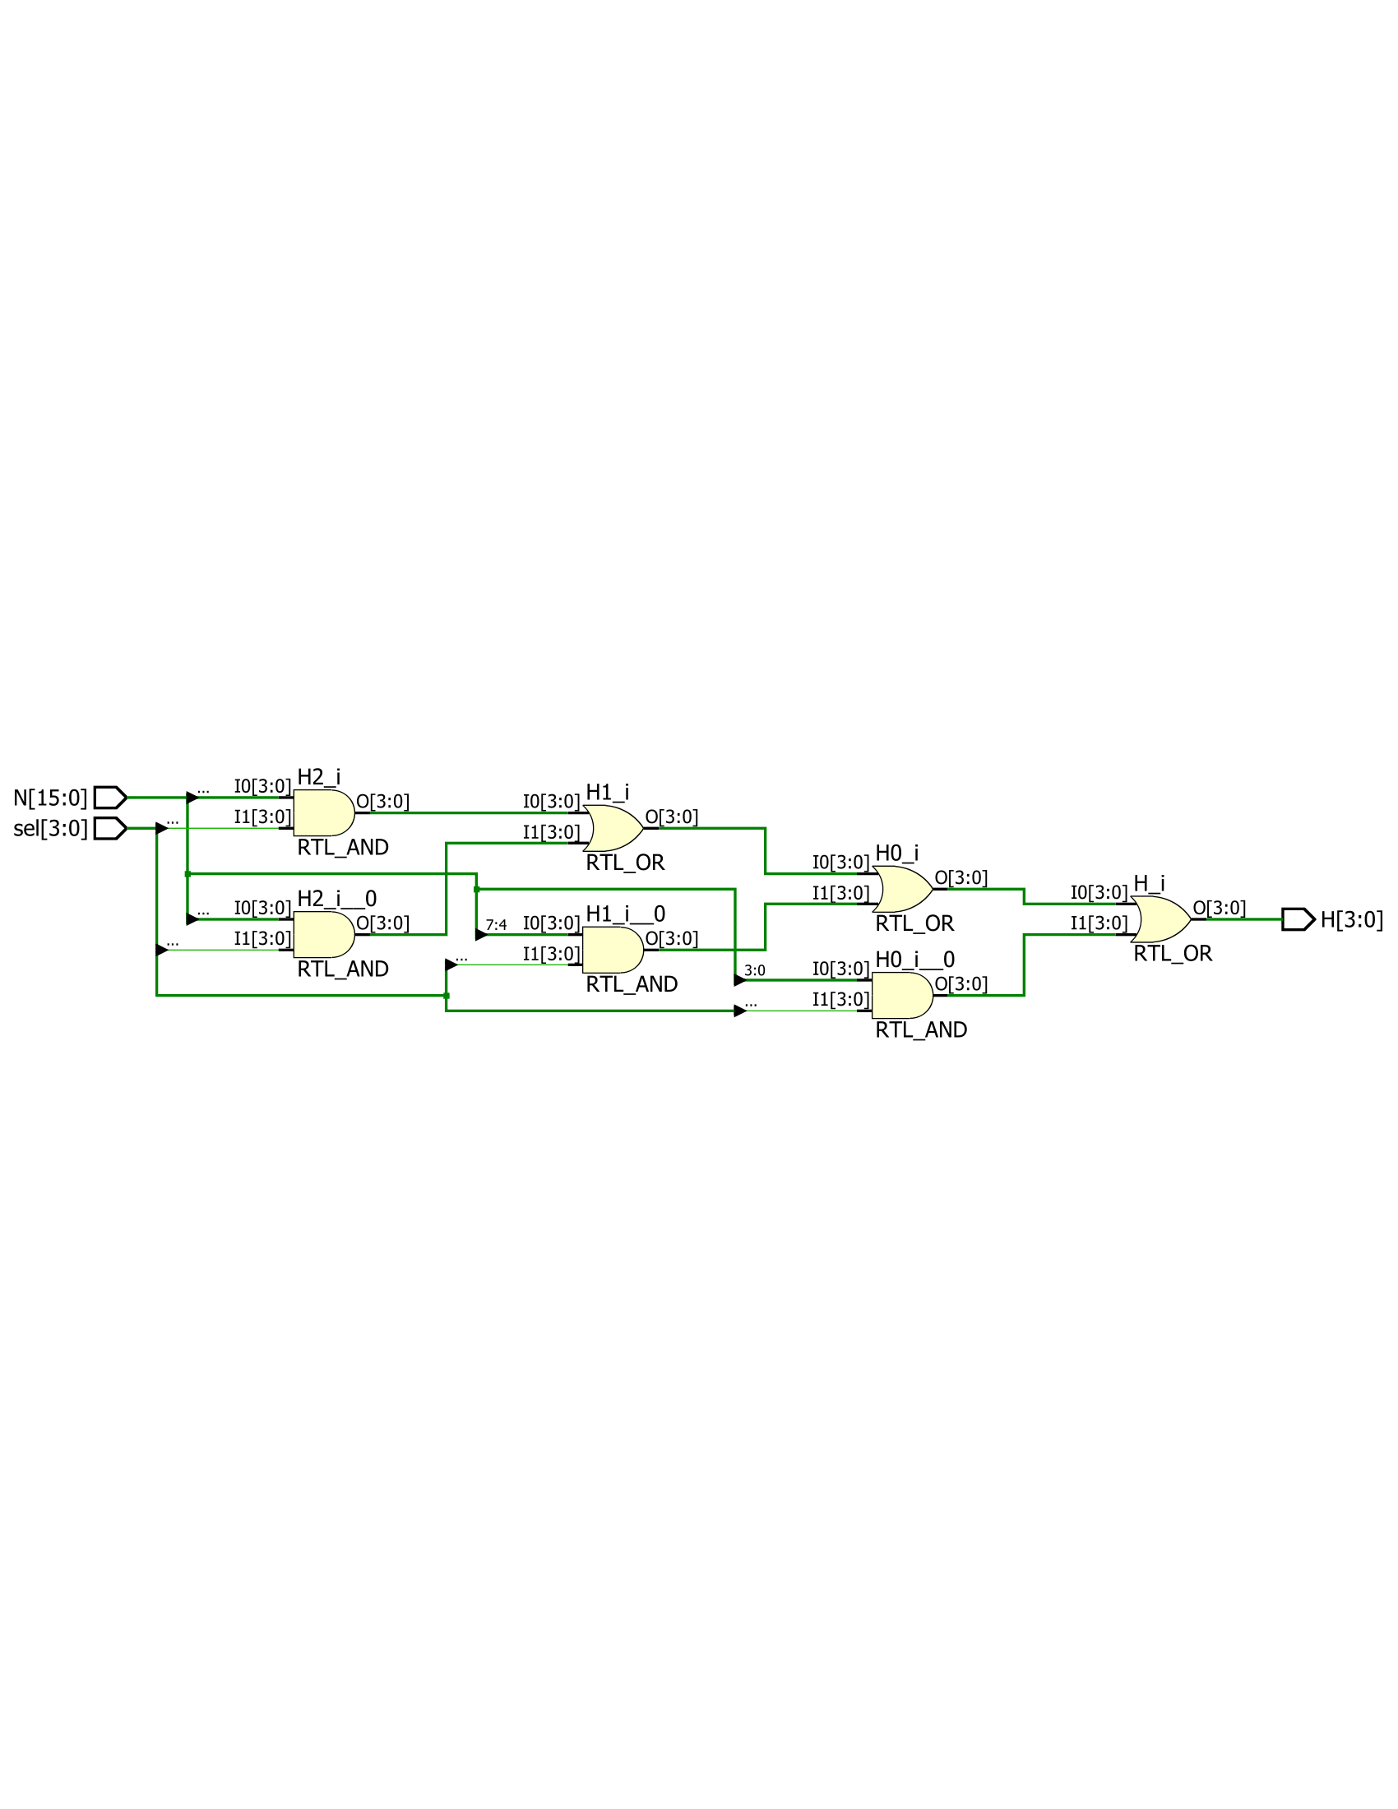

selector.v Schematic



Lab Notebook Page 1

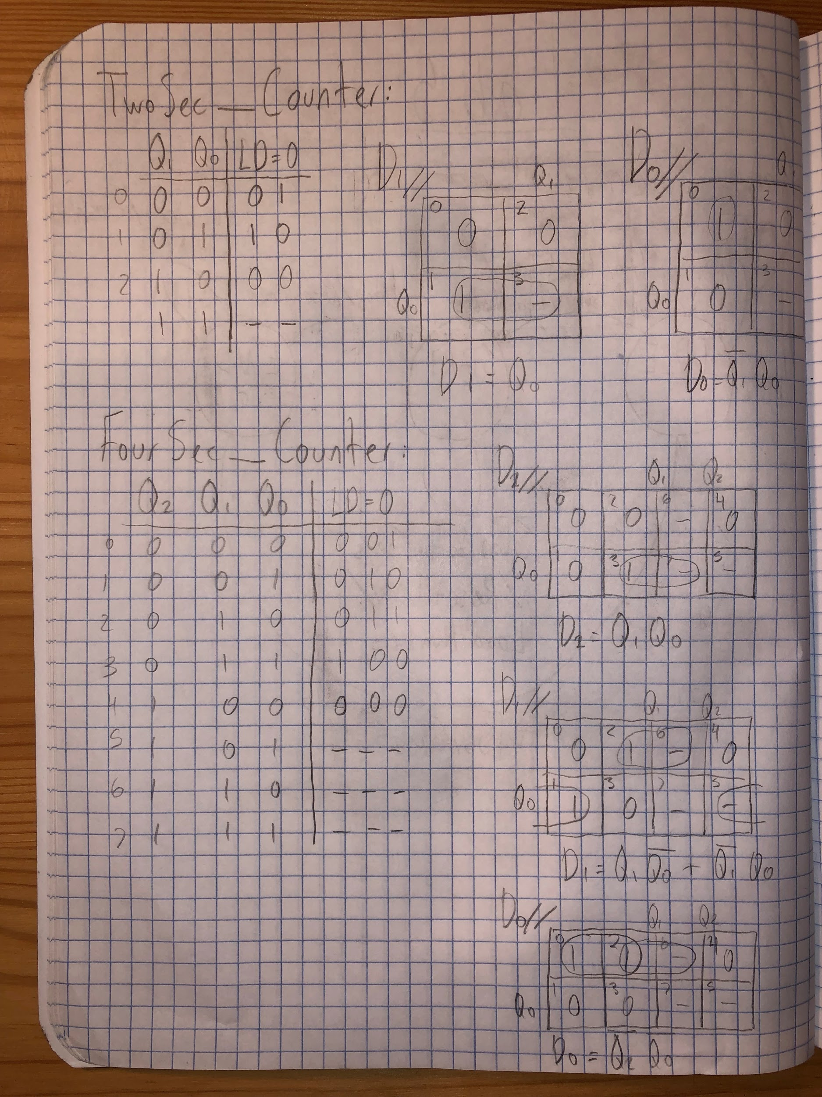

Lab Notebook Page 2

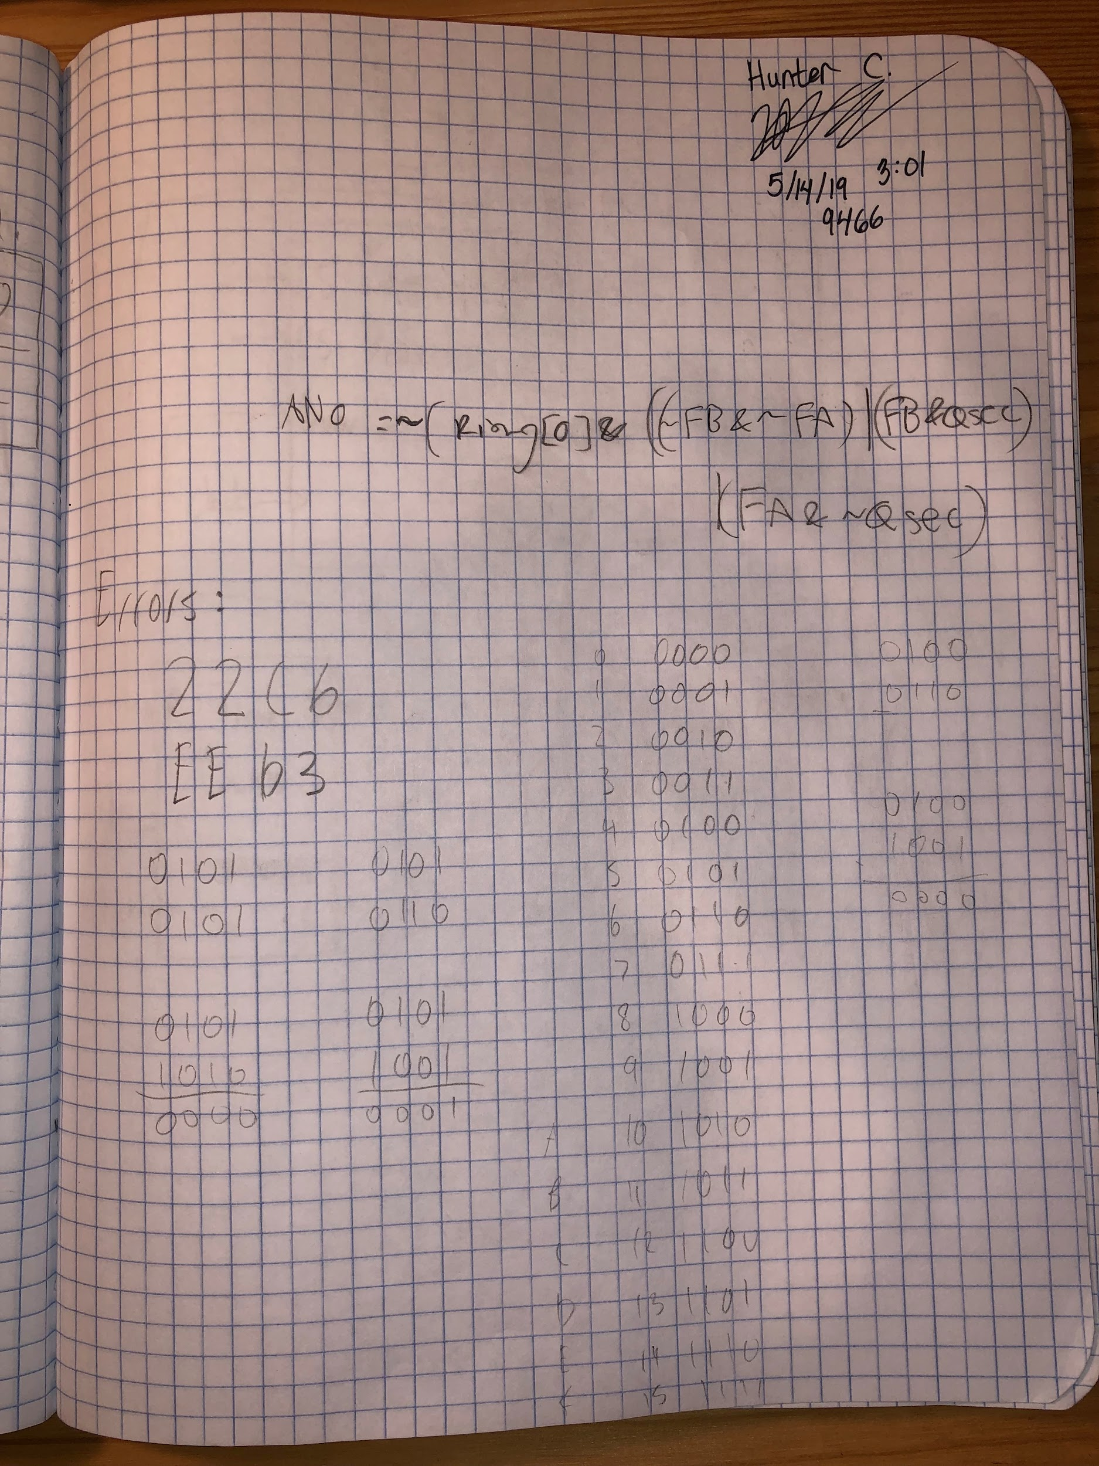

Lab Notebook Page 3